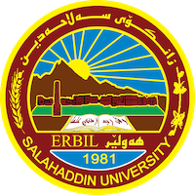

**Academic Curriculum Vitae**

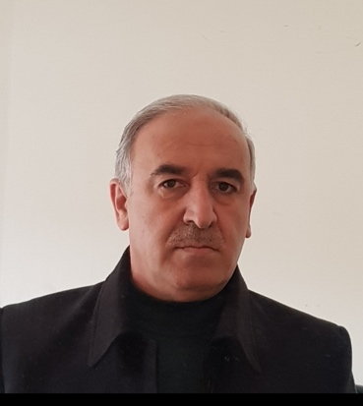**Personal Information:**

Full Name: Abdulkareem Darweesh Mahmood.

Academic Title: Assistant Professor.

Email: (university email) abdulkareem.mahmood@su.edu.krd

Mobile:07504451849

**Education:**

- B.Sc. Civil Engineering, Baghdad University 1981.

- M.Sc. Structures. Mosul University 1989.

- Ph.D. Structures. Baghdad University 2001.

**Employment:**

-1981-1986: supervising military and telecommunication building projects across Ninewa and Erbil provinces.

- 1991 – present: academic staff.

-2006 director of directorate of university projects. (Salahaddin University).

- 2007-2013 Head of Civil Engineering Department, Salahaddin University.

-2021-2022 Head of Geomatic Engineering, Salahaddin University.

**Qualifications**

-Visual basic programming.

-Fortran and basic programming.

-Languages: English, Arabic, and Kurdish.

- March 2006, planning workshop for two weeks, Albalqaa university Amman Jordan with cooperation of Dortmund university, as a DAAD program.

-November 2011, higher education leaders’ workshop, two weeks, Nottingham university, UK.

-August 2012, young leaders’ workshop, Kastle, Germany, for two weeks.

**Teaching experience:**

* undergraduate courses: Engineering Mechanics, Fortran Programming, Building construction, Strength of materials, structural analysis, Design of steel structures. Design of Concrete structures.
* post graduate: Finite Element Method, Theory of Elasticity, Advanced Dynamics of Structures, Advanced theory of plates.
* Supervising: M.Sc. students (Two), and Ph.D. students (two).

**Research and publications**

**-** Nasih Habeeb Askandar**,** Abdulkareem Mahmood and Rawaz Kurda“Behaviour of RC beams strengthened with FRP strips under combined action of torsion and bending”,[European Journal of Environmental and Civil Engineering](https://www.researchgate.net/journal/European-Journal-of-Environmental-and-Civil-Engineering-1964-8189) 2020(6):1-17, <https://doi.org/10.1080/19648189.2020.1847690>. .

- Nasih Askandar and Abdulkareem Mahmood” Comparative Investigation on Torsional Behaviour of RC Beam Strengthened with CFRP Fabric Wrapping and Near-Surface Mounted (NSM) Steel Bar”, Advances in Civil Engineering Volume 2019, Article ID 9061703, 15 pages, <https://doi.org/10.1155/2019/9061703>

-Nasih Askandar and Abdulkareem Mahmood“Torsional Strengthening of RC Beams with Near-Surface Mounted Steel Bars”,March 2020 ,[Advances in Materials Science and Engineering](https://www.researchgate.net/journal/Advances-in-Materials-Science-and-Engineering-1687-8442?_sg=6KFjldEUbNb-1EYferG1lmK2jTHIEi2t7bGAW6ShoiLfpY0uVK4LClI6T2lQ3RVT2I1IjKTvNWAOYHBhUSUj9DEICl3jSg.Ky-XhkI9mgmdzDqVyetAQGzsmx4P0yKE6gUIDG8x5gVxM8E6siq2hQaX0iZ1tN4BVvt5YER9m_FUP4uKU8O_xw) 2020(1):1-11, DOI: [10.1155/2020/1492980](http://dx.doi.org/10.1155/2020/1492980).

-Nasih Askandar and Abdulkareem Mahmood,“Torsional Strengthening of RC Beams with Continuous Spiral Near-Surface Mounted Steel Wire Rope”,February 2020,[International Journal of Concrete Structures and Materials](https://www.researchgate.net/journal/International-Journal-of-Concrete-Structures-and-Materials-2234-1315) 14(7):16, DOI: [10.1186/s40069-019-0386-4](http://dx.doi.org/10.1186/s40069-019-0386-4).

-Abdulkareem D. Mahmood and Sherwan M. Zaki **,“**PUNCHING SHEAR STRENGTH OF FIBROUS HIGH STRENGTH REINFORCED CONCRETE FLAT PLATE SLABS WITH ECCENTRIC LOADING”, CESARE’14 International Conference Civil Engineering for Sustainability and Resilience

Amman, 24-27.04.2013.

- 

**Conferences and courses attended**

CESARE’14 International Conference Civil Engineering for Sustainability and Resilience

Amman, 24-27.04.2013.

**Professional memberships**

* Iraqi Engineers Association, 1981.
* Kurdistan Engineer Union.

**Professional Social Network Accounts:**

- ﻿<https://www.researchgate.net/profile/Abdulkareem-Mahmood-2/research>

- ﻿<https://twitter.com/abdulka32116552?t=Xk0t9eZbDBDM3KNjKFmyRA&s=09>

- <https://www.linkedin.com/in/abdulkareem-mahmood-0106b1164/>

-