Effect of hump Transition on UP-Stream Free-Surface Elevation for Both Subcritical and Supercritical Flow Regime using CFD
Hayder T. Abo A. A.
ABSTRACT
The aim of this study is to compute the effect of hump height on upstream flow depth. For this purpose the computational fluid dynamics code FLOW3D was used. Firstly the code validated against experimental data of (bla bla). Then two kind of flow subcritical and supercritical are arranged with different hump height. the results show that bla bla.

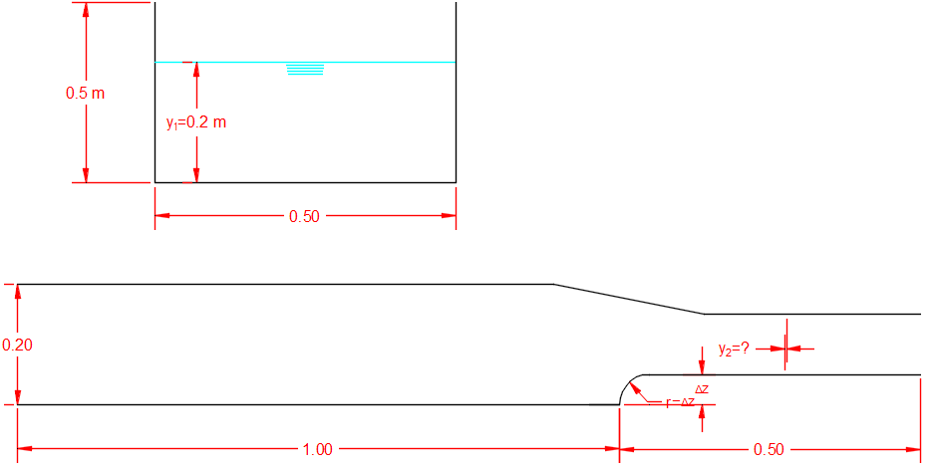

cases | y₁ m | v₁ m²/s | q m²/s | Critical depth (y_{c}) m | Hump height m
subcritical | 0.2 | 0.5 | 0.1 | 0.1 | 0.05
 |  |  |  |  | 0.06
 |  |  |  |  | 0.07
 |  |  |  |  | 0.08
 |  |  |  |  | 0.09
 |  |  |  |  | 0.1
supercritical | 0.2 | 2.5 | 0.5 | 0.29 | 0.05
 |  |  |  |  | 0.06
 |  |  |  |  | 0.07
 |  |  |  |  | 0.08
 |  |  |  |  | 0.09
 |  |  |  |  | 0.1

