Flow Turbulence Characteristics in an Open Channel with Periodically Variable Mobile Bedforms
Ahmad B. M., Shawnm M. S., Abo A. A.

ABSTRACT
Flow turbulence over mobile bedforms in natural open channels is still a mystery. In this work, the effect of naturally produced mobile bedforms on velocities, turbulence intensities, and turbulent stresses is investigated, using computational fluid dynamic code FLOW3D. Firstly the code is validated by experimental data of (bla bla bla). Then the code applied on sixty four models as tabulated below. Finally vertical distribution of velocity, turbulence intensities, and Reynolds shear stress are all documented. The velocity distributions reveal a significant drop in velocity along the bed when the bedform mobility increases due to increased friction.
Keywords: Turbulence; Open channel; Bedforms; CFD, FLOW3D.

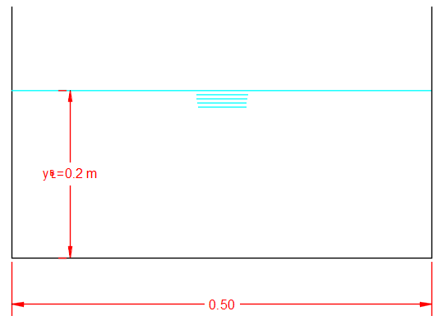

Case # | Discharge m³/s | Roughness coefficient (n) | Bed slopes (S₀)
1 | 0.2 | 0.018 | 0.0004
 |  |  | 0.001
 |  |  | 0.006
 |  |  | 0.01
 |  | 0.035 | 0.0004
 |  |  | 0.001
 |  |  | 0.006
 |  |  | 0.01
 |  | 0.05 | 0.0004
 |  |  | 0.001
 |  |  | 0.006
 |  |  | 0.01
 |  | 0.15 | 0.0004
 |  |  | 0.001
 |  |  | 0.006
 |  |  | 0.01
2 | 0.25 | 0.018 | 0.0004
 |  |  | 0.001
 |  |  | 0.006
 |  |  | 0.01
 |  | 0.035 | 0.0004
 |  |  | 0.001
 |  |  | 0.006
 |  |  | 0.01
 |  | 0.05 | 0.0004
 |  |  | 0.001
0.006
0.01
 |  | 0.15 | 0.0004
 |  |  | 0.001
 |  |  | 0.006
 |  |  | 0.01
3 | 0.3 | 0.018 | 0.0004
 |  |  | 0.001
 |  |  | 0.006
 |  |  | 0.01
 |  | 0.035 | 0.0004
 |  |  | 0.001
 |  |  | 0.006
 |  |  | 0.01
 |  | 0.05 | 0.0004
 |  |  | 0.001
 |  |  | 0.006
 |  |  | 0.01
 |  | 0.15 | 0.0004
 |  |  | 0.001
 |  |  | 0.006
 |  |  | 0.01
4 | 0.4 | 0.018 | 0.0004
 |  |  | 0.001
 |  |  | 0.006
 |  |  | 0.01
 |  | 0.035 | 0.0004
 |  |  | 0.001
 |  |  | 0.006
 |  |  | 0.01
 |  | 0.05 | 0.0004
 |  |  | 0.001
 |  |  | 0.006
 |  |  | 0.01
 |  | 0.15 | 0.0004
 |  |  | 0.001
 |  |  | 0.006
 |  |  | 0.01

