زانكؤى سةلاحةددين – هةوليَر
Salahaddin University - Erbil

Effect of row direction on growth, yield and quality of wheat (Triticum aestivum L.) crops

Research Project
Submitted to the department of (Field Crops) in partial fulfillment of the requirements of the degree of BSc. In (Field Crops)

By:
Elaf Muthafar Khalid

Supervised by:
Lana Dhahir Mohammed
April - 2023

ABSTRACT
Wheat (Triticum aestivum L.) is one of the most important agricultural crops in the world. In addition to the yield, the grain quality of wheat is central to the well-being of humans. Currently, increasing grain quality is becoming a widely discussed topic in crop sciences. In the first research the result was showed that all the growth characters like plant height, dry matter accumulation, number of tillers, leaf area index were significantly higher under East-West direction of sowing over North-South direction of sowing. In the second research the results in this review showed that Leaf area, LAI, weight of leaf, light extinction coefficient, flag leaf length, fertility, number of spike and harvest index significantly increased in EW (East-West) compared to SN (South-North) row direction. While, the spike weight, spike length, number of kernels, grain yield and biological yield significantly increased in SN compare to EW row direction. The aims of this review are to show the general principles underlying how the row directions effect on vegetative and reproductive growth characters of wheat.

- INTRODUCTION
One of the most serious crops in the world are wheat crop (Triticum aestivum L.) that is essential grain crops for the human and animal consumption. The ultimate yield of the wheat crop is controlled by a number of external factors and genetics (FAO, 2018). Wheat is one of the cheapest exporters of food that supplies 72% calories and protein with other important ingredients in the normal life of humans.
In any case of the convenient role of the row direction in influencing the yield of crops, they also have a direct role in preserving soil water from evaporation. The results also by Hozayn et al. (2012), showed that the influence of row directions, and the spacing of grade in the agricultural process is very important in increasing crop production and controlling weed-related with wheat crops. The impact of row direction on crop yields is different, depending on the farming system, is likely to vary from crop cultivars (Catherine et al., 2010). Also, several published papers on this point confirm that set the row direction of crops with row spacing is very serious to increase the yield of crops (Grichar et al., 2004; Connor et al., 2009; Chauhan and Johnson, 2010; Chauhan and Johnson, 2011). The rows direction that has impact on the adequacy of photosynthesis and the temperature of the canopy influenced by the challenge of solar radiance and the canopy of crops (Drews et al., 2009).
The results by Grichar et al. (2004) pointed that the East-West row direction of the wheat crops is the best compared to the North-South row direction, this result does not exactly mean that it is a standard case in all researches assumed in this gaps. At the same time, some researchers have published that the EW row direction of crops is the best in suppressing weed growth in wheat and increasing the yield of crops (Borger et al., 2010). Other researchers have stated that the NS of row direction is also better in suppressing weed growing with wheat and increasing the yield crops. While, the result of research on row direction of wheat crops showed that North-South row direction is optimal for growth, yield and quality of wheat, because row direction provides proper distance for optimum sun light penetration for photosynthesis (Singh and Rakesh, 2019).
The aim of this review to investigate the effect of better direction of sowing to improve productivity and the quality of wheat crops.

- MATERIAL AND METHODS
The first research was conducted by Ravikesh et al. (2021) to investigate the effect of different wheat cultivar and direction of sowing at Agromet Research Farm of Narendra Deva University of Agriculture & Technology, Narendra Nagar (Kumarganj), Ayodhya (U.P.) during season of 2016-2017. The experiment was laid out in Factorial randomized block design with (A) three cultivars viz., HUW-234 (V1), PBW-343 (V2) and NW-1012 (V3) and two direction of sowing East-West direction (S1) and North-South direction (S2) and replicated at four times.
The second research was conducted by Marofi (2019) was conducted the experiment in Grdarasha experimental station, College of Agricultural Engineering Sciences, Salahaddin University, Kurdistan Region, Erbil, during the winter season 2018-2019. Three newly introduced bread wheat cultivars (V1: FLORKWA, V2: BAJ and V3: FRANKOLIN) were used in this research. The wheat (V1, V2 and V3) certified from Erbil Agricultural Experimental Station were distributed in ordinance on plots of area 1m × 2m (area of each plot about 2 m⁻²), The experiment was laid out in Factorial randomized block design with (A) three cultivars and two direction of sowing East-West direction (EW) and North-South direction (NS) and replicated at three times.

- RESULTS AND DISCUSSIONS
  - Response of some wheat cultivars to row directions (First research)
The data pertaining to initial plant population as affected by different treatments recorded at 20 days after sowing are presented in Table 1 and result revealed that the initial plant population was non-significantly influenced by cultivars and direction of sowing due to sowing was almost uniform under all the varieties, indicating thereby the uniform seed viability and germination capacity. The germination totally depends on soil temperature, soil moisture and seed germinability. Similar findings were reported by (Mishra, 2000).
Table 1: Effect of direction of initial plant population of wheat cultivars.
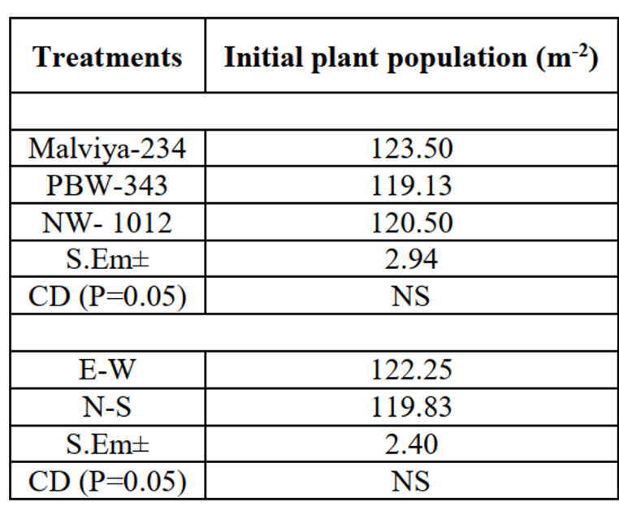

(Ravikesh et al., 2021)
3.2 Effect on Number of tiller dry matter accumulation (m⁻²)
The number of tillers m⁻² at 60, 90 days after sowing and at harvest stage were influenced significantly by direction of sowing except 30 DAS having non-significant effect (Table 2). The number of tillers m⁻² was influenced significantly by different cultivars. Maximum number of tillers was recorded in cultivar PBW-343 and minimum number of tillers was recorded in cultivars Malviya-234. Variation in plant height among cultivars might also be probably due to their genetic characters as well as climatic requirement of the different cultivars. Maximum numbers of tillers were recorded under E-W direction at all the crop growth stages. Variation in number of tillers among direction of sowing might also be probably due to reduction in weed growth in the east-west orientation as the result of better light interception compared to a north-south orientation. The results are corroborated with (Tripathi et al., 2009; Sandhu et al., 2018).
The data pertaining to dry matter accumulation as affected by different treatments recorded at 30, 60, 90, and harvesting stage have been presented in Table 2 significant increase in dry matter accumulation by plants was because of more number of tillers per m⁻². Maximum dry matter accumulation recorded with PBW-343 due to healthy tillers lead to higher nutrients absorption capacity, more number ofspike bearing tillers due to less mortality resulted higher dry matter production at harvest stage. Minimum dry matter accumulation recorded with Malviya-234 at harvest stage,which reflected due to less number of spikes bearing tillers m⁻² resulted less dry matter production. Similar findings were reported by Singh, 1998; Sardana et al., 1999). The Dry matter accumulation influenced significantly due to different direction of sowing at all the stages, except 30 days after sowing. Significant increase in dry matter accumulation was recorded with E-W direction. This might be attributed due to more LAI lead to higher photosynthesis and synthesis of food material in plants. The results are corroborated with (Pandey et al., 2015; Sandhu et al., 2018).
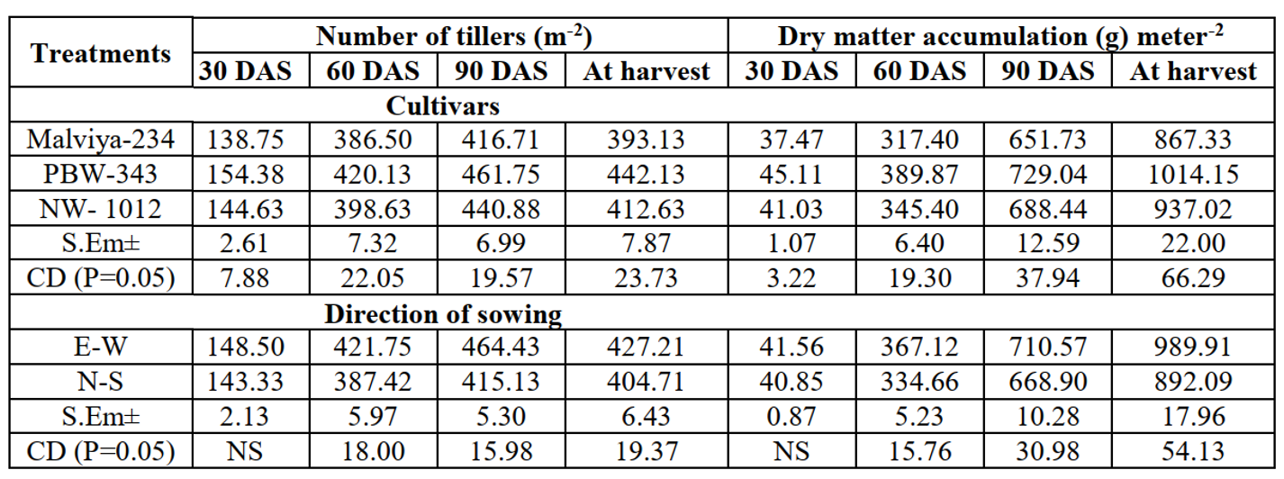
Table 2: Effect of direction on number of tiller m⁻² and dry matter accumulation m⁻² of wheat cultivars.

(Ravikesh et al., 2021)

3.3 Effect on plant height (cm)
The plant height taken at 30, 60, 90 days after sowing and at harvest stage have been presented in Table 3. Also, Leaf area index influenced significantly due to different wheat cultivar and direction of sowing at all stages of crop growth except 30 DAS having non-significant effect (Table 3). In general, plant height showed an increasing trend from 30 days after sowing to harvest stage. There was rapid increased in height of plant from 30 to 90 days after sowing thereafter increased in height of plant rather slow. Maximum plant height was recorded cultivar NW-1012 and minimum plant height was recorded in cultivar Malviya-234 at all the crop growth stages. Variation in plant height among cultivars might also be probably due to their genetic characters. As per direction of sowing maximum plant height was recorded with E-W direction which was significantly superior over the N-S direction of sowing at 60, 90 DAS and at harvest stage of the crop.
Table 3: Effect of direction of sowing on plant height and leaf area index of wheat cultivars.
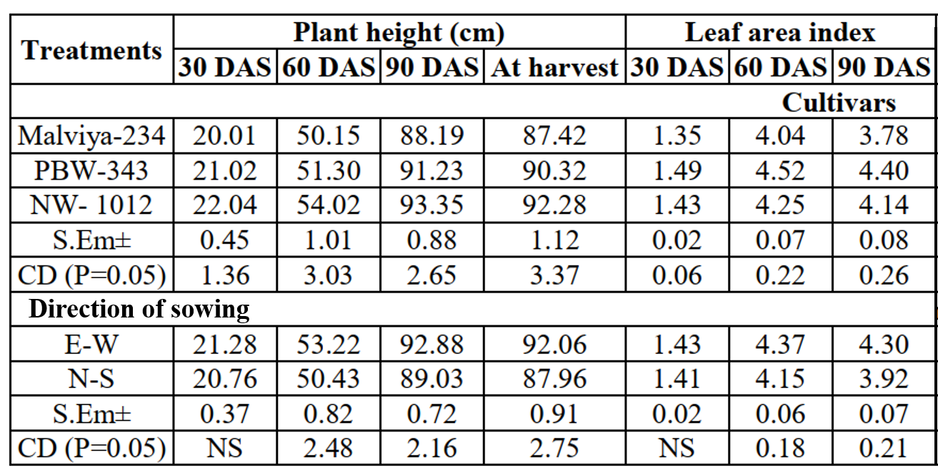

(Ravikesh et al., 2021)
3.4 Effect on grain yield, straw yield and harvest index
The results revealed that the grain and straw yield was affected significantly due to cultivars and direction of sowing. The reason behind this may be because of good plant stand, more number of spike bearing tillers, long shoots head and more number of grains spike⁻¹ with more test weight. Minimum grain and straw yield recorded with cultivar Malviya-234 might be due to less number of spike bearing tillers, small shoots head and less number of grains spike⁻¹ and poor grain development. Similar findings were obtained by (Singh, 1998; Maurya et al., 2014). The grain straw yield significantly increased by direction of sowing having higher yield in E-W direction (44.87 ha⁻¹) than the N-S direction (37.75 ha⁻¹). This might be due to more spike length, number of grains spike⁻¹, grain weight spike⁻¹, 1000 grain weight, maximum solar radiation interception and cooling effect. Similar findings were reported by Pathan et al. (2006) Straw yield also significantly influenced by direction of sowing having higher yield in E-W direction than the N-S direction. This may be probably due to higher tillers and increased rate of dry matter accumulation. It collaborated with Pathan et al. (2006).
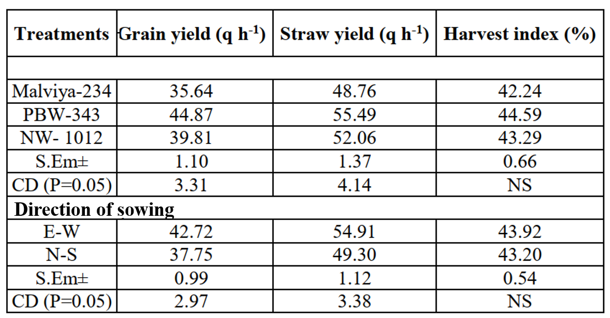
Table 4: Effect of direction of sowing on grain yield, straw yield and harvest index of wheat cultivars.

(Ravikesh et al., 2021)
3.5 Effect on vegetative traits in field experiment (Second research)
Table 5 showed that there were no significant (P>0.05) differences among treatments on number of tillers plant⁻¹ between cultivars and row orientations at 122 DAS. While, the number of tillers plant⁻¹ were increased significantly with interactions of V2 × SN compared with V3 × SN row orientation. The data presented in table 5 also showed that leaf area index and weight of leaf at 122 DAS increased significantly (P<0.05) in EW compared with SN row orientation. The light extinction coefficient at 122 DAS that improved significantly (P<0.05) in EW compared with SN row orientation. While, there were no significant (P>0.05) differences among wheat cultivars. Also, Increase of leaf area index and leaf weight of wheat in EW due to decreasing light extinction coefficient and absorbed a large amount of the sun light radiation and in photosynthesis process. Because the relation between light extinction coefficient and leaf area reversed.
Table 5. Response of some wheat cultivars to plot orientation and their interactions on vegetable traits at 122 DAS.
Treatment | No. of Tillers Plant⁻¹ | LAI | Weight of Leaf (g) |  | K
Direction
South-North (SN) | 1.60 a | 3.21 b | 1.92 b |  | 1.14 a
East-West (EW) | 1.64 a | 3.71 a | 2.13 a |  | 0.78 b
Cultivar
V1 (Florkwa) | 1.67 a | 3.29 a | 2.22 a |  | 1.00 a
V2 (Baj) | 1.68 a | 3.64 a | 2.28 a |  | 0.91 a
V3 (Frankolin) | 1.51 a | 3.46 a | 2.13 a |  | 0.96 a
Interaction
V1-SN | 1.68 ab | 3.02 b | 1.79 b |  | 1.18 a
V2-SN | 1.73 a | 3.23 ab | 1.92 b |  | 1.14 ab
V3-SN | 1.40 b | 3.39 ab | 2.05 ab |  | 1.08 ab
V1-EW | 1.65 ab | 3.55 ab | 2.65 a |  | 0.82 ab
V2-EW | 1.63 ab | 4.05 a | 2.63 a |  | 0.69 b
V3-EW | 1.63 ab | 3.53 ab | 2.21 ab |  | 0.84 ab
Means within each column had the different subscript were differing significantly (P<0.05).
K= Light extinction coefficient.
Table 6 showed that there were no significant (P>0.05) differences were observed among treatments on plant height between row orientations, While, the plant height was increased significantly (P<0.05) in Baj wheat cultivar (V2) compared with the other cultivars may be due to genetic factors. Hozayn et al. (2012) showed that there were no significant differences between EW and SN row direction in plant height of wheat.
Flag leaf length and fertility increased significantly (P<0.05) in EW compared with SN row orientation. While, there were no significant (P>0.05) differences among treatments on Flag leaf length and fertility between cultivars. The straw yield was increased significantly (P<0.05) in SN row orientation compared with EW row orientation. Straw yield of cultivar one was increased compared to other cultivars. Similar results were obtained by Pandey et al. (2013) showed that there was a significantly (P>0.05) differences observed in straw yield between north-south direction as compared to east-west row orientation.

Table 6. Response of some wheat cultivars to plot orientation and their interactions on vegetative traits in field experiment.
Treatment | Plant Height (cm) | Flag Leaf Length (cm) | Fertility % |  | Straw yield (g/plant)
Direction
South-North (SN) | 84.05 a | 21.22 b | 65.34 b |  | 2.12 a
East-West (EW) | 84.12 a | 23.20 a | 85.68 a |  | 1.44 b
Cultivar
V1 (Florkwa) | 79.25 b | 22.65 a | 72.65 a |  | 2.04 a
V2 (Baj) | 90.65 a | 20.96 a | 75.75 a |  | 1.77 ab
V3 (Frankolin) | 82.36 b | 23.03 a | 78.14 a |  | 1.52 b
Interaction
V1-SN | 71.47 b | 19.23 c | 64.08 b |  | 2.65 a
V2-SN | 90.66 a | 19.63 c | 64.46 b |  | 2.02 b
V3-SN | 90.02 a | 24.80 ab | 67.48 b |  | 1.68 bc
V1-EW | 87.03 a | 26.06 a | 81.22 a |  | 1.43 c
V2-EW | 90.63 a | 22.29 bc | 87.03 a |  | 1.53 c
V3-EW | 74.70 b | 21.26 c | 88.80 a |  | 1.36 c
Means within each column had the different subscript were differing significantly (P<0.05).

3.6 Wheat reproductive traits
Table 7 showed that not significant differences were observed among treatments in a number of spikes plant⁻¹, Spike weight (g), Spike length (cm), number of Kernels Spike⁻¹, Grain yield (g plant⁻¹) between cultivars. While, the number of spikes plant⁻¹ and harvest index (%) was increased in EW row direction compared to SN row direction. Also, all other parameters except 1000 kernels weight were increased in SN row direction compared to EW row direction. The data showed in table 6, indicates that SN direction significantly increased grain yield compare to EW direction. Spike weight (g), Number of Kernels Spike-1, Grain yield (g plant-1) and Biological yield of V1 × SN row direction was significantly (P<0.05) increased compared to other interactions. While, 1000 kernels weight and Harvest index of V2 × EW were significantly (P<0.05) increased compared to other interactions. This positive enhancement in grain yield have also been reported by previous research (Pandey et al., 2013). The row direction can supply a concept to produce a good condition of light-saturated for a crop that cover for the aims of effective harvesting of solar power for the production of agriculture. The research was supported with the previous study at the Miniba Agricultural Center, which showed that seeding in the EW row direction increased the crop yield compared to the SN row direction during the experimental period (Cook et al., 2009).
Table 7. Response of some wheat cultivars to plot orientation and their interactions on vegetative traits in field experiment.
Treatment | No. of Spikes Plant⁻¹ | Spikes weight (g Plant⁻¹) | Spikes length (cm) |  | No. of kernels Spikes⁻¹ | 1000 kernels weight (g) | Grain yield  (g plant⁻¹) | Biological yield (g plant⁻¹) | Harvest index %
Direction
South-North (SN) | 1.04 b | 2.90 a | 8.67 a |  | 41.45 a | 50.46 a | 1.90 a | 5.03 a | 39.00 b
East-West (EW) | 1.40 a | 1.95 b | 6.91 b |  | 31.45 b | 49.38 a | 1.57 b | 3.40 b | 46.68 a
Cultivar
V1 (Florkwa) | 1.21 a | 2.57 a | 7.83 a |  | 39.23 a | 47.02 b | 1.76 a | 4.61 a | 40.40 a
V2 (Baj) | 1.25 a | 2.48 a | 8.10 a |  | 35.95 a | 53.55 a | 1.81 a | 4.26 ab | 43.98 a
V3 (Frankolin) | 1.20 a | 2.23 a | 7.46 a |  | 34.16 a | 49.19 b | 1.64 a | 3.76 b | 44.13 a
Interaction
V1-SN | 1.08 bc | 3.13 a | 8.70 a |  | 48.12 a | 47.11 b | 1.97 a | 5.82 a | 33.98 c
V2-SN | 1.11 bc | 2.84 a | 8.60 a |  | 38.76 b | 52.83 a | 1.86 a | 4.86 b | 38.94 bc
V3-SN | 0.94 c | 2.71 b | 8.72 a |  | 37.46 b | 51.44 ab | 1.88 a | 4.40 bc | 44.07 ab
V1-EW | 1.33 ab | 1.97 c | 6.97 bc |  | 30.35 b | 46.94 b | 1.55 ab | 3.41 d | 46.82 ab
V2-EW | 1.38 a | 2.13 bc | 7.59 ab |  | 33.14 b | 54.27 a | 1.75 ab | 3.66 cd | 49.01 a
V3-EW | 1.46 a | 1.76 c | 6.20 c |  | 30.87 b | 46.94 b | 1.40 b | 3.13 d | 44.20 ab

Means within each column had the different subscript were differ significantly (P<0.05).

- CONCLUSIONS
- The study on effect of direction of sowing on different wheat cultivar doses on wheat crop indicated its usefulness. Based on the results obtained, it can be concluded that E-W direction of sowing with PBW-343 is a better variety and direction of sowing of wheat because it promotes more growth attributes like height, tiller leaf area index, dry matter accumulation, grain and straw yield.
- Leaf area, LAI, weight of leaf, light extinction coefficient, flag leaf length, fertility, number of spike and Harvest index significantly increased in EW compared to SN row direction. While, the spike weight, spike length, number of kernels, grain yield and biological yield significantly increased in SN compare to EW row direction.
- Interactions of EW direction with cultivars were improved the vegetable characteristics compared to the SN directions.

REFERENCES
BORGER, C.P.D., HASEM A. AND PATHAN S. (2010) “Manipulating crop row orientation to suppress weeds and increase crop yield”. Weed Science, 58: 174-178.
CATHERINE, P. BORGER D., HASHEM A. AND PATHAN S. (2010) “Manipulating Crop Row Orientation on Suppress Weeds and Increase Crop Yield”. Weed Science, 58, 174-178.
CHAUHAN, B.S. AND JOHNSON D.E. (2010) “Implications of narrow crop row spacing and delayed Echinochloa colona and Echinochloa crusgalli emergence for weed growth and crop yield loss in aerobic rice”. Field Crops Res., 117(3): 177-182.
CHAUHAN, B.S. AND JOHNSON D.E. (2011) “Row spacing and weed control timing affect yield of aerobic rice”. Field Crops Res., 121(2): 226-231.
10
CONNOR, D.J., CENTENO A. AND GOMEZ-DEL-CAMPO M. (2009) Yield determination in olive hedgerow orchards. II. Analysis of radiation and fruiting profiles. Crop Pasture Sci., 60: 443-452.
COOK, A., SHEPPERD W. and HANCOCK J. (2009) Row Direction and Stubble Cover. EPFS Summary, p114-115.
DREWS, S. NEUHOFF D. AND KOPKE U. (2009) “Weed sup- pression ability of three winter wheat varieties at different row spacing under organic farming conditions”. Weed Research, 49, 526-533.
FAO, (2018) Food and Agriculture organization, “Food Outlook - Biannual Report on Global Food Markets”. P. 3.
GRICHAR, W.J., BESLER B.A. AND BREWER K.D. (2004) “Effect of row spacing and herbicide dose on weed control and grain sorghum yield”. Crop Prot., 23(3): 263-267.
HOZAYN, M., EL-SHAHAWY T. A. AND SHARARA F. A. (2012) “Implication of Crop Row Orientation and Row Spacing for Controlling Weeds and Increasing Yield in Wheat”. Australian Journal of Basic and Applied Sciences, 6(3): 422-427.
MAROFI, L. D. (2019) Response of some bread wheat (Triticum aestivum L.) cultivars to plot directions and boron levels. Master Thesis. College of Agricultural Engineering Sciences, Salahaddin University.
MAURYA P, KUMAR V, MAURYA KK, KUMAWAT N, RAKESH KUMAR R, YADAV MP. (2014). Effect of potassium application on growth and yield of wheat varieties, Department of Agronomy, CSAU & T, Kanpur, India;9(4):1371-1373.
MISHRA, DK, KHAN RA, BAGHEL MS. (2000). Stability of wheat varieties under various dates of sowing. Annals Agricultural Research, 21(4):564-566.
PANDEY, B.P., BASNET, K.B., BHATTA, M.R., SAH, S.K., THAPA, R.B. and KANDEL, T.P. (2013) Effect of row spacing and direction of sowing on yield and yield attributing characters of wheat cultivated in Western Chitwan, Nepal. Agricultural Sciences, 4(07), p. 309.
11
PANDEY M, SINGH T, SINGH S. (2015). Effect of row orientation and intercropping on dry matter accumulation and growth parameters of bed planted wheat, Department of agronomy, punjab agricultural university, ludhiana- 141004 (punjab), India;7(11):757-761.
PATHAN S, HASHEM A, WILKINS N, BORGER C. (2006). East-West crop row orientation improves wheat and barley grain yields, Department of Agriculture, 1Merredin, 2Northam and 3WAHRI, The University of Western Australia, Agribusiness Crop.
RAVIKESH K., AK SINGH, PRITHVI R., PRAMOD K., KUMAR A., AJAY K. AND PUSHPENDRA Y. (2021) Effect of direction of sowing on growth and yield of different wheat (Triticum aestivum L.) cultivar in Eastern Uttar Pradesh. The Pharma Innovation Journal; 10(10): 917-920.
SANDHU, SK, DHALIWAL LK. (2018). Effect of row orientation on radiation interception and growth dynamics of wheat. International Journal of Agricultural Sciences,14(1):186-191.
SARDANA, V, SHARMA SK, RANDHAWA AS. (1999). Performance of wheat cultivars under different sowing dates and levels of nitrogen under rainfed conditions. Annual Agricultural Research;20(1):60-63.
SINGH, B. (1998). To assess the performance of new wheat varieties under late-sown condition with different nitrogen levels. M.Sc. (Ag) thesis submitted to N.D.U.A.&T., Kumarganj, Faizabad.
SINGH, K. AND RAKESH S. (2019) “Effect of different methods of sowing and row orientation on growth, yield and quality of wheat (Triticum aestivum L.)”. Agricultural Science Digest. 39(1): 51-54.
TRIPATHI, P, SINGH AK, SHABDADHAR (2009). Organizing researches on rice and wheat meteorology. Technical bulletin, Department of Agril. Meteorology, NDUAT, 33.

12

