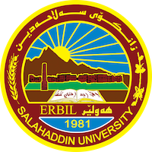
Academic Curriculum Vitae
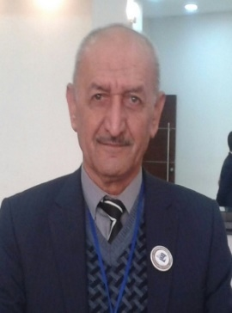
Personal Information:
Full Name: Abdulla khurshid abdulla
Academic Title : Assistant professor
Email: (university email): abdullah.abdullah@su.edu.krd
Mobile: +9647504460987

Education:
- B.A in Sociology ,Baghdad University, College of Arts, Department of Sociology ,1981.
- M.A in Social organization , Sociology, Salahaddin University, College of Arts, Department of Sociology ,1996.
- Phd. in Social organization , Sociology, Salahaddin University, College of Arts, Department of Sociology ,2004.

Employment:
- The Head of Sociology Department. Evening study.
- The Head of Sociology Department.
- Assistant of Manager of Sociology Department.

Qualifications

Teaching experience:

Research and publications

file:///C:/Users/HC/Downloads/33-Article%20Text-66-1-10-20210111.pdf

the concepts of lifestyle: theoretical study

