Practical Cell Biology

Question Bank

2022-2023

Abdullah Abubaker Shareef

Abdullah.shareef@su.edu.krd

Name: Practical Cell Biology

Q1/A. Define cytoskeleton and write its functions? 10 points

Q1/B. Briefly mention the function of the following organelles:

1.SER

2.Vesicle

3.Lysosome

Q2: Write the name of the followings & purpose of using them in Laboratory. 20 points

1. 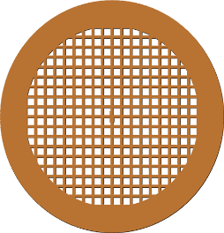 2. 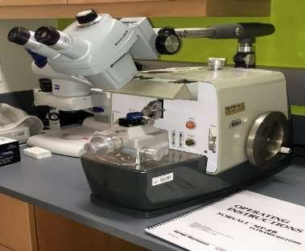

3.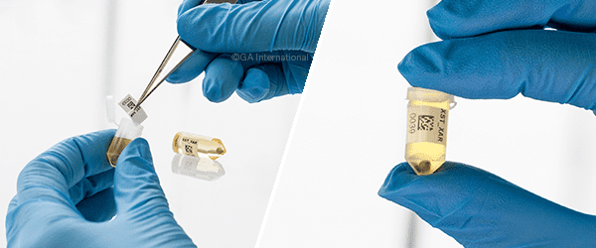 4. 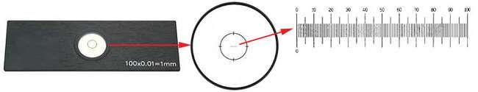

Q3.Write the name of this experiment and explain the results? 10 points

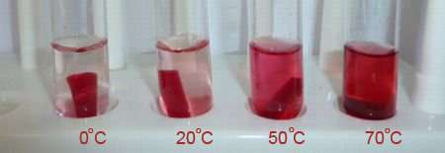

Q4.Write about the relation between the shape of animal cells and their functions? 10pts

Q5: Explain the results with the name of experiment? 10 pts

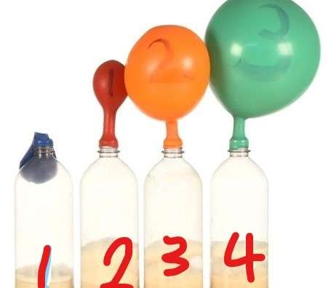

1.

2.

3.

4.

Q 6. Write the steps of sample preparation to examine by TEM ?with the purpose of each steps? 15 pts

Q7. A. Find the actual length of the organism below. 10 pts

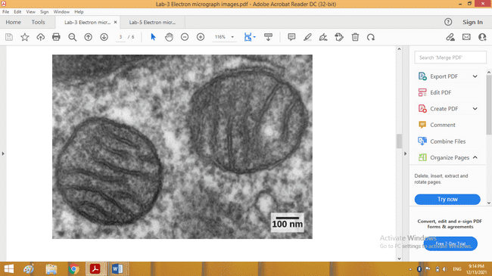

Q7. B. At 40X magnification find the number of yeast cells in 1cm2, if you know the number of cells counted per each field are as following. 15pts

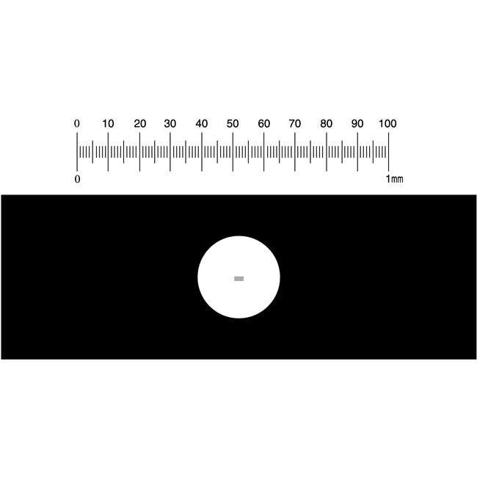

Stage Micrometer

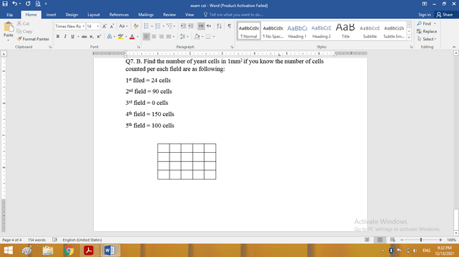



1st field = 90 cells 2nd field = 24 cells 3rd field = 0 cells 4th field = 150 cells 5th field = 100 cells

**Q1/ Complete the following puzzle use the questions below:** (10 pts)

1. A device used for making thin sections for Transmission electron microscopy?
2. It’s the analogue for microscopic glass slide in Electron microscope?
3. Is the property in some kind of cell to alternate their shape?
4. A product used for fixing the proteins in the procedure of preparing the samples for electron microscopy?
5. An abnormality in the cell growth indicated by increasing the number of cells?
6. It’s the Loosely packed form of chromatin?
7. An abnormality in the cell growth indicated by decreasing the size of cells?
8. An indicator for the procedure of showing the effects of various temperature on the cell?
9. A step of cellular respiration in which lowest energy generated?
10. 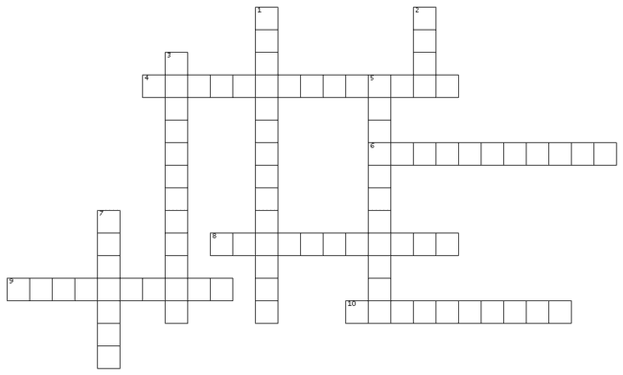It’s the cytoplasm of the nucleus in the eukaryotic cell?

**Q2/ A/ Predict your result after 1 hour if you have 3 flasks with balloons;** (10pts)

1st flask contains 100 ml of H2O + 1 teaspoon of yeast + 1 teaspoon of starch

2nd flask contains 100 ml of H2O + 1 teaspoon of yeast + 1 teaspoon of glucose

3rd flask contains 100 ml of H2O + 1 teaspoon of yeast

**Q2/B/ Write the name of the experiment below and compare between these two test tubes.** (10pts)



25 C

80 C

**Q2/C/ What is the reason of washing the beet root pieces above before adding them in to test tubes?** (5pts)

**Q3/A/ Write the function of the following:** (10pts)

1. SER 2.Centriole 3.Tonoplast 4.Golgi apparatus

**Q3/B/ Define the following:** (5pts)

1. Maternal transformation 2. Catabolism

**Q4/ Identify the images below: Answer only four of them:** (10pts)

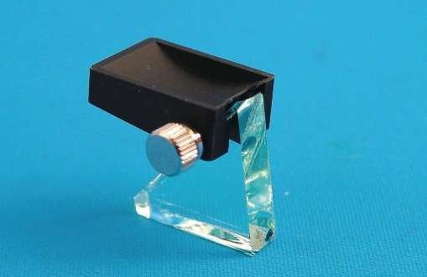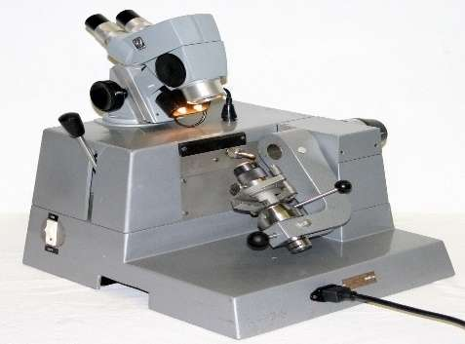

**3**

**2**

**1**



**5**

**4**

**Q5/A/ Find the actual length of the bacterium below.** (5pts)

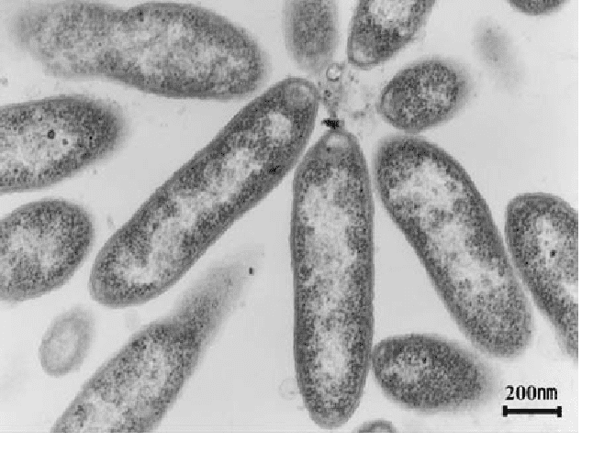

**Q5/B/ At 40X magnification find the number of RBC cells in 1 cm2, if you know the number of cells counted per each field are as following.**

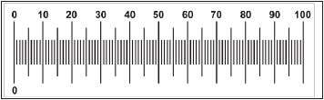

Stage micrometer

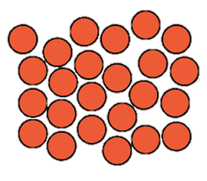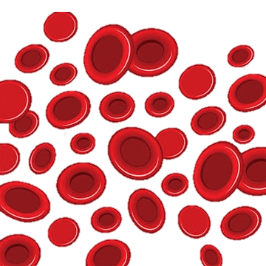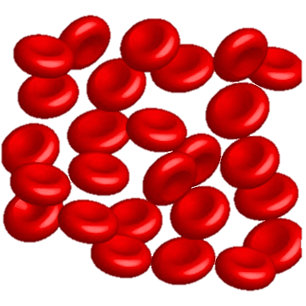

Field 5

Field 4

Field 3

Field 2

Field 1

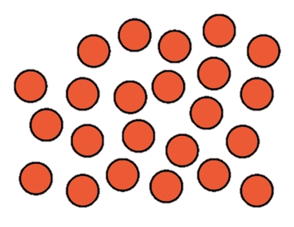

**Q1/Write the function of the followings: 20pts**

1.Lysosome

2.rER

3. Stage micrometer

4.Trimmer

5.Glutar aldehyde

6.Vesicles

7.Nucleolus

8.Mitochondria

9.Intermediate filament

10. Propylene oxide

**Q2/Answer the following questions: 20pts**

1.Write the Importance of different shapes of plant cells.

2. Explain the stages of cellular respiration. Explain each step briefly.

3.Explain the effect of low temperature on beet root.

4. Fixation is the first step in electron microscopy preparation! Why?

**Q3/Define the followings: - 15pts**

1. ATP 2. Anthocyanin 3. Grid 4. Physiologic hyperplasia

5.Anaplasia

**Q4/A/ Find the actual length of the organism below.** (5pts)

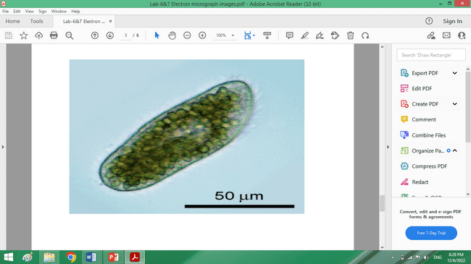

**Q5/B/ At 40X magnification find the number of RBC cells in 1 cm2, if you**

**know the number of cells counted per each field are as following. (10pts)**

Q1/Answer the following questions; - 25pts

1. What is the cytoskeleton? Mention its function.
2. Write the importance of cell counting and its application.
3. Define Pleomorphism.
4. Compare between Hypertrophy and Atrophy.
5. What are the disadvantages of Fermentation Process?

Q2/ Briefly mention the function of the following organelles: 15pts

1.SER

2.Centriole

3.Golgi apparatus

4.Vesicle

5.Nucleolus

Q3. Write the name of experiment and Compare between tube at 0C and tube at 70C? (7pts)



Q4: Write the name of experiment and compare between Flask 1 and flask 4. (7pts)



Q5. Write the steps of sample preparation in TEM? (10pts)

Q6. Find the actual length of the organism below. (6pts)

