Practical Cytogenetics
Question Bank

2022-2023
Abdullah Abubaker Shareef
Abdullah.shareef@su.edu.krd

Salahaddin University Practical cytogenetics exam Name:
College of science Group:
Biology department

Q1/ Define the following terms: 10pts
- ISCN 2005
- Karyotyping

Q2) Explain the following questions briefly (Answer only 7 questions): 35pts
- Different type of cells has different rate of division. Give examples
- Differences between Anaphase I & Anaphase II
- Why use onion roots for viewing mitosis?
- In a karyogram, on which basis chromosomes are classified?
- Dropping of bone marrow sample on a slide above 3 feet during chromosome preparation.
- Using Hypotonic solutions during chromosome analysis.
- Injection Colchicine in to mouse during bone marrow aspiration and its mechanism of action.
- Using of Trypsin in G banding technique.

Q3) Compare G-Banding techniques and R-Banding technique in details. 20pts

Q4) What are the Techniques that Stain Selective Chromosome Regions,
describe one of them briefly. 8pts

Q5) Describe the following karyograms: 15pts
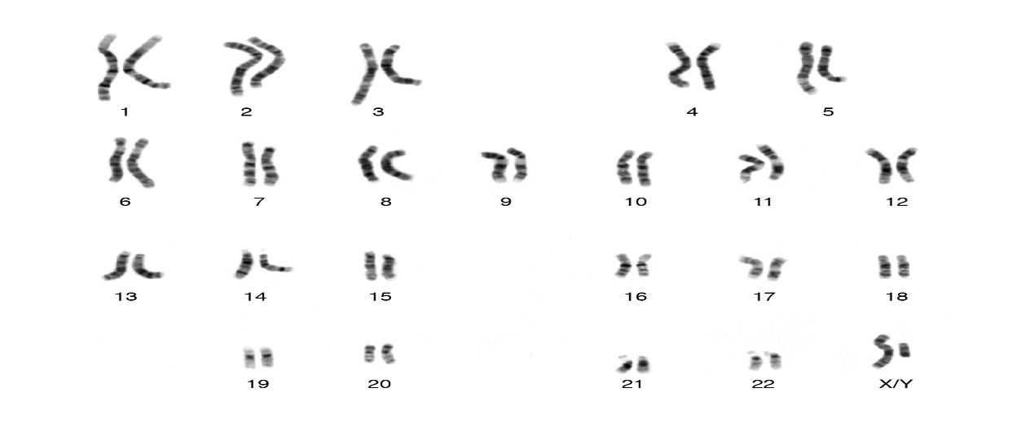
A)

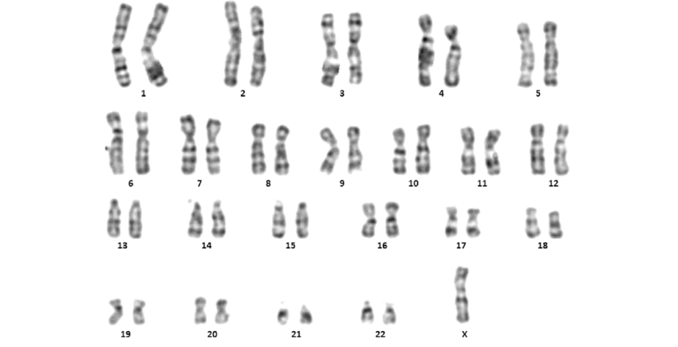
B)

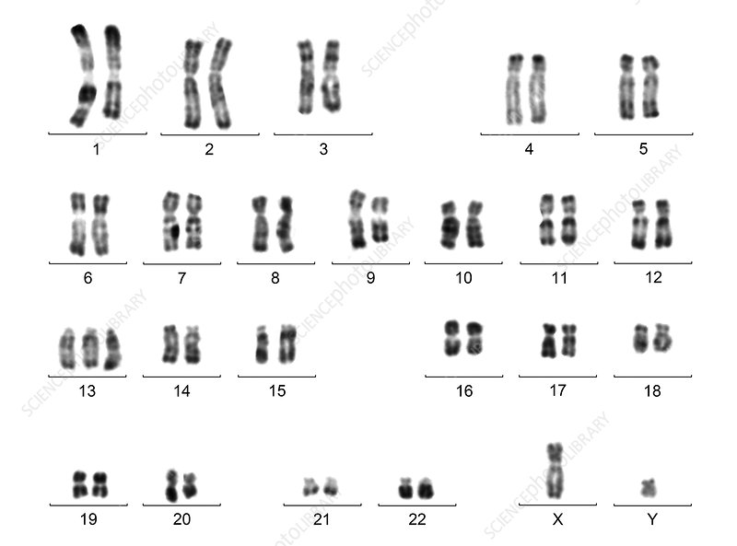
C)

Q1) Explain the following. 20 pts
- Cells divide at different rate. For example, Skin cells divide every 2 weeks while liver cells divide between 300-500 days.
- External factors are important for regulating cell cycle like include physical and chemical signals. Give an example for Physical factors.
- What are the criteria’s that chromosomes are classified in to 7 groups starting from A to G.
- Purpose of Using colchicine and Hypotonic solutions during chromosome preparation.
- What is Whole chromosome probe?

Q2) Compare between the following:
- G banding VS R Banding including all details. 15pts

- Homologous chromosomes VS Chromatids 5pts

Q3) Write the principle and advantage of FISH Technique. 10pts

Q4) What are the Techniques that Stain Selective Chromosome Regions, describe one of them briefly. 5pts

Q5) Write the locus of each gene on the following chromosomes. 10pts

- Growth Hormone Gene B) Epidermal Growth Factor gene

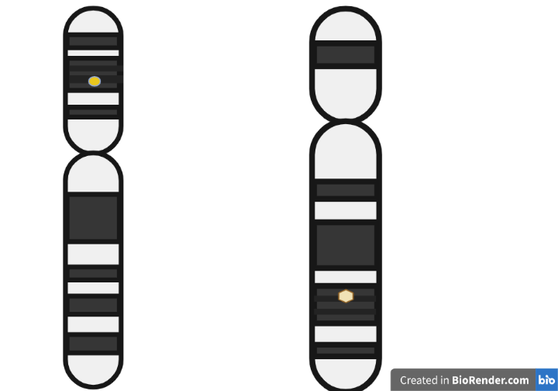

Chromosome Number is 4
Chromosome Number is 17

Q6) Write the karyotypic description of the following karyograms: 15pts
- B)
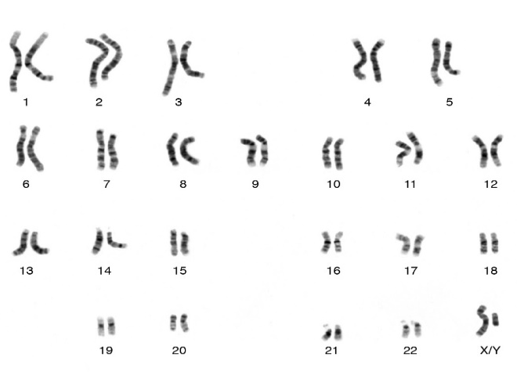

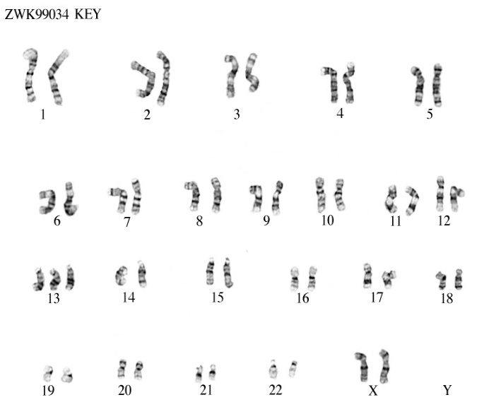
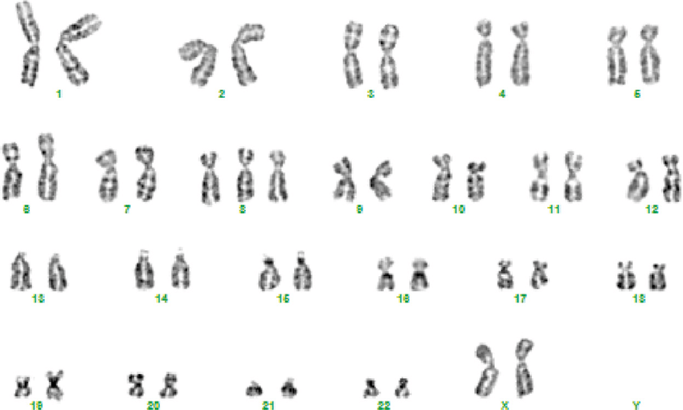
- D)

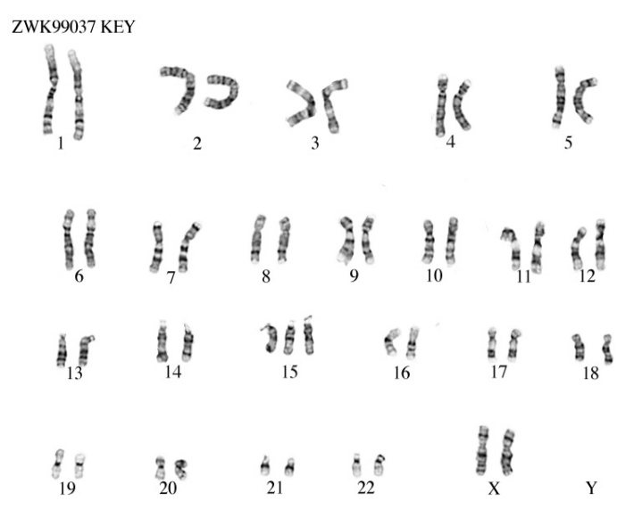
E)

