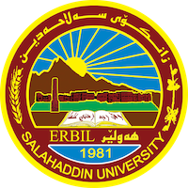
1
Academic Curriculum Vitae

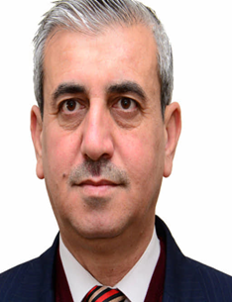Personal Information:
Full Name: Dr.Abdulrahman Zrar Sherwany
Academic Title: assistant professor
Email: abdulrahman.abdulrahman@su.edu.krd
Mobile:0750 4496285

Education:
- 1987, B. Sc, Salahaddin University, College of Administration and Economics, Administration Department. (Erbil - IRAQ).

- 2002, M. Sc, Salahaddin University, College of Administration and Economics, Administration Department. (Erbil - IRAQ).

- 2019, Ph. D, College of Administration and Economics, Salahaddin University Administration Department. (Erbil – IRAQ).
- 11/1/1997 assistant researcher.
- 26/3/2002 assistant lecture,
- 25/6/2012 lecture.
- 29/5/2022 assistant professor.

Employment:
- Head of the Media Unit / Presidency of Salah Al-Din University.
- Head of the Media Unit / College of Administration and Economics.
- Head of the Maintenance and Services Unit / College of Administration and Economics.
- Registrar / College of Administration and Economics.
- Head of Business Administration Department - (two sessions).
- Assistant Dean (two sessions).
- Dean of Student Affairs.
- Chairing and membership of hundreds of permanent and temporary scientific, executive, and financial committees.
- Supervised and participated in many training courses as a teacher.

Qualification:
- - A training course on planning, University of Dortmund, Germany.
- English language course, Language Center, Salahadin University.
- Teaching courses in education colleges, Salahadin University.
- A training course in Store Management - Republic of Egypt.
- Training course for developing teaching skills – Lebanon.

Teaching experience:
- Teaching many scientific subjects in the Department of Management, Accounting, Finance and Banking at Salahadin University and many universities and institutes for twenty years.
- Supervising master's theses.
- Discussing master's theses.

Research and publications
- التحليل الاستراتيجي للبيئة التنافسية وأثره في تحقيق الأداء المتميز
- دور المهارات الشخصية في تسويق الذات.
- دور عمليات إدارة المعرفة في تحقيق التميز في القيادة.
- دور الممارسات الإستراتيجية للموارد البشرية في تشارك المعرفة.
- سلوكيات القيادة البارعة ودورها في تعزيز المناعة التنظيمية
- القيادة الأصيلة ودورها في تعزيز الثقة التنظيمية.
- إدارة التنوع ودورها في تعزيز سلوكيات المواطنة التنظيمية.
- الدور الوسيط للارغونوميا في العلاقة التأثيرية لحوكمة تكنولوجيا المعلومات في السيادة الاستراتيجية.

Conferences and courses attended
- Icabe 2021 certificate of attendance on 29-30-2021 tishk International University.
- Conference on Strategic Awareness and Governance - Middle East University - Amman, Jordan, 1-2 April 2019 Participation by scientific research.
- Conference on Sustainable Higher Education: A Strategic Approach to Managing Sober Universities - Erbil, Iraq, 8-10 May 2018. Participation in Scientific Research

Funding and academic awards
Many books of thanks and appreciation from the Dean of the College, the Presidency of the University, the Minister of Higher Education and Scientific Research, and the Prime Minister.

Professional memberships
- Member of the Kurdistan Teachers Syndicate.
- Member of the Economists Syndicate in Kurdistan.
- Member of the Board of Directors of the Kurdistan Center for Information and Strategic Research.
- Member of the Cultural Center at Salah al-Din University.

