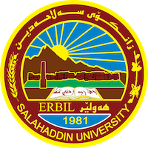

**Academic Curriculum Vitae**

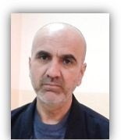

**Personal Information:**

Full Name: abdulrahman Khaleel Suliman

Academic Title: Assist Professor

Email: (abdulrahman.suliman@su.edu.krd)

Mobile: 0750 143 82 16

**Education:**

1- Diploma in radiograph, higher medical institute, Erbil, Iraq, 1986-1985.

2- B.Sc, physics, college of Science, Salahaddin University, Erbil, Iraq, 1993-1994.

3- M.Sc , physics (semiconductor nanowire), college of science, Salahaddin

university, Erbil, Iraq 2006.

4- IBRO Course {International Brain Organization} in neuroscience-Erbil, 2014

5- Lecturer in physics, college of science, Salahaddin

university, Erbil, Iraq 2012

6- Assist professor in physics, college of science, Salahaddin

university, Erbil, Iraq 2019

**Employment:**

1-Erbil education hospital radiation department, Erbil, Iraq, 1986.

2- Nuclear medicine department, Erbil education hospital, Erbil, Iraq, 1994-1995.

3- physiset in physics department, college of science, Salahaddin university, Erbil, Iraq, 1996.

4- lecture in physics department, college of science, Salahaddin university, 2006.

**Qualifications**

* Assist professor in nano-science, academic staff in physics department,
* IT qualifications
* Certificate of proficiency in the English language, College of Arts, English Department
* First aid trainer
* Physics of ear , IBRO Course {International Brain Organization} in neuroscience- 2014

**Teaching experience:**

**THEORITICAL PHYSICS**

1-HEAT AND THERMODYNAMIC. Second stage, physics, department, (10 years).

2-MEDICAL PHYSICS. Third stage, medical physics branch , physics department, (14 years).

3- METHOD OF RESEARCH. Forth stage, general physics, medical physics branch, physics of communication branch, physics department, (7 years).

4-Medical instrument, forth stage medical physics branches, (1 year).

5-ACOUSTIC PHYSICS, forth stages, physics communication branch, (1 year).

6- Anatomy and physiology, third stages, medical physics branch, (2 years).

**PRACTICAL PHYSICS**

1-ELECTRICITY LABROTARY, first stage, physics department, (8-year).

2- ELECTRICAL MEASURMENT LABROTARY, second stage, physics department, (8-year).

3- PHYSIOLOGY LABROTARY, third stage, medical physics beanch (11 year).

4-ATOMIIC LABROTARY, second stage, physics department, (1 year).

5- NUCLEAR LABROTARYm 4 stage, physics department, (1 year).

6-GENERAL PHYSICS LABROTERY, first stage, biology department, (2 year).

7- OPTIC LABROTERY, third stage, physics department, (1 year).

8- HEAT AND THERMODYNAMIC LABROTERY, second stage, physics department, (8 year).

**Research and publications**

1-تاثير اشعة السينية على بعض محتويات الدم في الفئران المختبرية / مجلة زانكو/ المؤتمر العلمي لجامعة صلاح الدين في اربيل/ (1997)

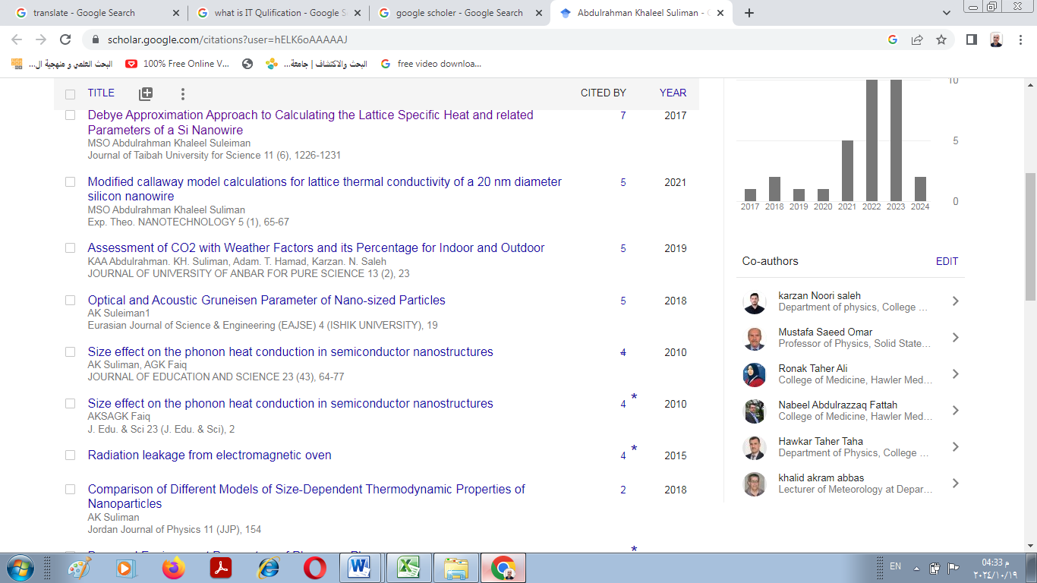

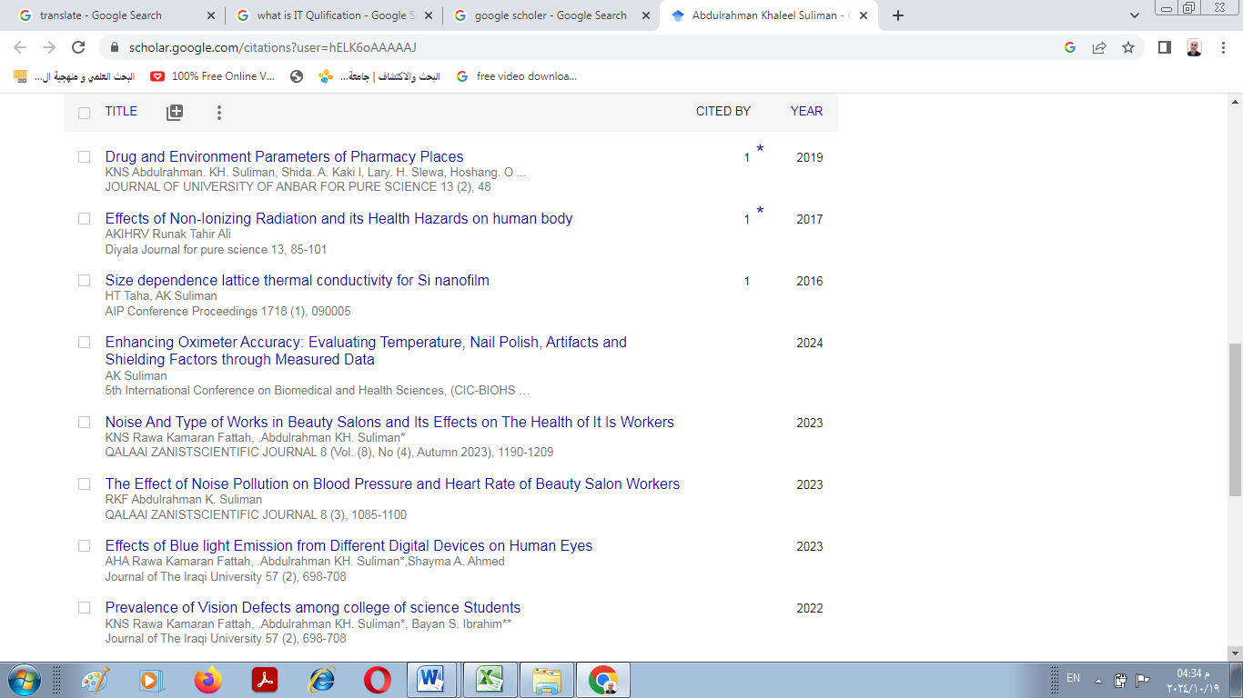

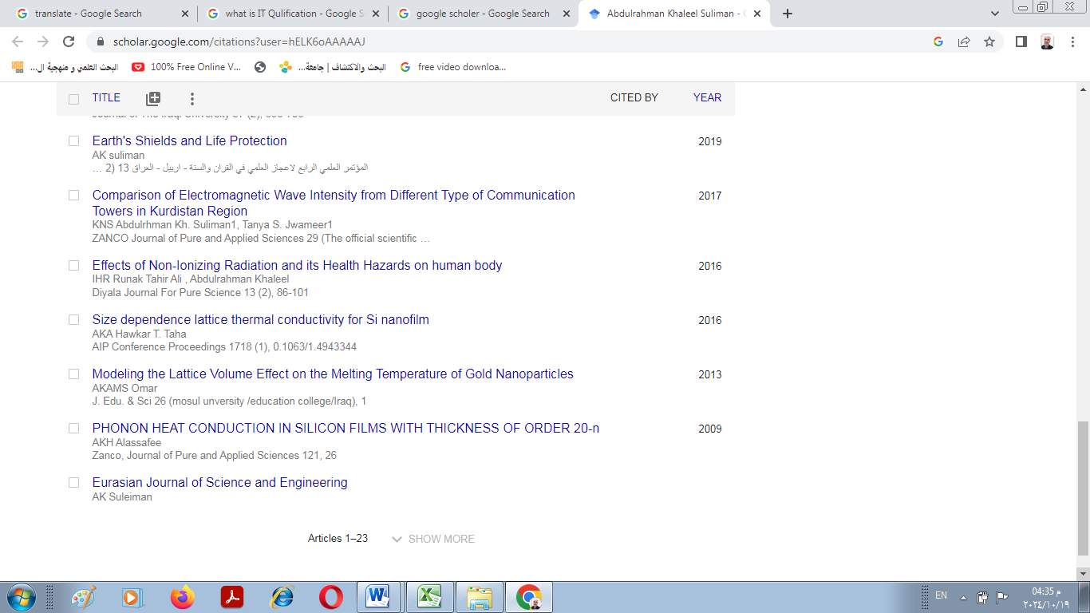

**Conferences and courses attended**

مؤتمر المعاهد التكنولوجية- بغداد -1985 1- مؤتمر المعاهد التكنولوجية- بغداد -1985(presenter)

2- First international conference of natural science Erbil-1997 (presenter)

3- First international conference for Basic and Applied Sciences-Kirkuk-2010.( presenter)

4- مؤتمر الدفاع عن القران- سليمانية-2011(attendance)

5- Scientific conference- Erbil -2013 , ( people awareness for the bottled water consumption in terms of the scientific guiltiness) (attendance)

6- First international conference of natural science (ICNS2016).CHARMO UV.( poster)

7- 5th scientific conference of College of Education University of Garmian-2017 (presenter).

8- 5th International Conference and Workshop on Basic and Applied Sciences (ICOWOBAS 2015 (presenter)

9- First international conference for Quran - Sunnah and sciences- Sulimania 2017 (presenter.)

10- March 18th-19th 2017, Erbil-KRG-IRAQ International Conference and Workshop on Basic and Applied Sciences 2017

(presenter)

11- Second International Conference of Mathematics SCIM-Erbil 2018.( presenter)

12- المؤتمر العلمي الدولي الرابع-اربيل تحت عنوان (اشارت علمية في القران الكريم والسنة النبوية) 16-10-2019 (presenter)

13- International Conference on Nanotechnology and its Applications22-23 January 2020Salahaddin University-Erbil, Iraq

14- 6th international conference of applied science, energy and environment ICASEE-2022. (presenter)

15-دووه مين كونفرانسى (به خشينى كرانت بو باشترين بروزه ى ده رجوونى وئايدياى بو قوتابيانى زانكوى سه لا ح الدين هه ولير) (presenter)

16- 5th International Conference on Biomedical and Health Sciences, (CIC-BIOHS’2024).

17- شەشەمین کۆنفرانسی پێشبڕکێی ساڵانەی قوتابیانی زانکۆ بۆ باشترین پرۆژەی دەرچوون و باشترين پۆستەری ئەكادیمی قوتابيان

18- چوارەمین کۆنفرانسی بەخشینی گرانت بۆ باشترین پرۆژەی دەرچوون و ئایدیا بە قوتابیان-

**Funding and academic awards**

Funding source provided by Huawei obtained for research projects

Professional memberships

**Professional memberships**

Member ship ("modern physics journal"

Member of the Saudi Society for Medical Physics

Invitation Letter

Dear Dr. A. KH. Alassafee,

The 4rd International Congress on Optics, Electronics, and Optoelectronics 2023 (ICOEO-2023) which is slated to held during Jun. 2-4, 2023 in Xiamen, China. The theme of this conference is "Innovation, Development, Progress and Sharing", We sincerely invite academicians, professors, experts and young students in the field of optics and optoelectronics at home and abroad to attend the conference and give wonderful reports. The congress is aimed to provide a platform for experts and scholars in the industry to share technological progress and business experience, focus on cutting-edge research in optics and optoelectronics. On behalf of the Organizing Committee, we would extend you a warm invitation to attend as a speaker.

**Professional Social Network Accounts:**

1-<https://www.researchgate.net/profile/Abdulrahman-Suliman/stats>

2-<https://www.facebook.com/abdulrahman.alassafee>

3-<https://scholar.google.com/citations?user=hELK6oAAAAAJ>

4-<https://twitter.com/ComAbdulrhman>

5-<https://accounts.google.com/v3/signin/identifier?dsh=S1695215541%3A1684411282223373&continue=https%3A%2F%2Fdrive.google.com%2Fdrive%2Fmy-drive%3Flfhs%3D2&followup=https%3A%2F%2Fdrive.google.com%2Fdrive%2Fmy-drive%3Flfhs%3D2&ifkv=Af_xneFYj5aREBhSIh-ZTTM01SVKUK8r9fQ-i4zCDeOgjHl_WrCwfFVbf8lDosv4Ycco6yrPkbQn&osid=1&passive=1209600&service=wise&flowName=GlifWebSignIn&flowEntry=ServiceLogin>

6-<https://orcid.org/0000-0002-3320-2237>

7- <https://academics.su.edu.krd/profile-admin/ORCID>