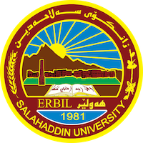
Academic Curriculum Vitae

Personal Information: 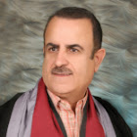
Full Name:abdulwahid musheer mahmood dizayee
Academic Title: Professor
Email: (abdulwahid.mahmood@su.edu.krd)
Mobile: 07504481613

Education:
P.H.D Pragmatics College of Art V .good 2002 -6-15
M.A Pragmatics College Art V .good 1999 -12-11
B.A Kurdish language V .good 1996 -7-2
Employment:
Head of the Department Kurdish language 2008 2009 Salahaddin University erbil
Assistant Den language 2007 2008 Salahaddin University erbil
Qualifications
Teaching methods 14-19-9-2002 Salahaddin University erbil
Participate Microsoft Power Point 27-2-2010 3-3-2010 Center of Information &Communication Technology Participate
Teaching experience:
Teaching methods 14-19-9-2002 Salahaddin University erbil
Participate Microsoft Power Point 27-2-2010 3-3-2010 Center of Information &Communication Technology Participate

Research and publications
- State all researches, publication you made.

Conferences and courses attended
- Give details of any conferences you have attended, and those at which you have presented delivered poster presentations.

Funding and academic awards
- List any bursaries, scholarships, travel grants or other sources of funding that you were awarded for research projects or to attend meetings or conferences.

Professional memberships
- List any membership you hold of any professional body or learned society relevant to your research or other life activities.

Professional Social Network Accounts:

- List your profile links of ReserchGate, LinkedIn, etc.

It is also recommended to create an academic cover letter for your CV, for further information about the cover letter, please visit below link:
https://career-advice.jobs.ac.uk/cv-and-cover-letter-advice/academic-cover-letter/

