Kurdistan Regional Government -Iraq
Ministry of Higher Education & Scientific Research
Salahaddin University- Erbil (SUE)
College of Science
Department of Chemistry

Nickel(II) schiff base complexes

A Project Submitted to the department of Chemistry in partial fulfillment of the requirements for the degree of B.A or BSc. in Chemistry science

Prepared by:
Rozhin Nyaz Mohammed

Supervised by:
Mr. Adnan Qadir

April, 2022 Newroz, 2722 Ramadan, 1443

﴿ وَمَا بِكُم مِّن نِّعْمَةٍ فَمِنَ اللَّهِ ۖ ﴾

[ 53: سورة النحل]

And whatever you have of favor –it is from Allah.

Dedication:

I dedicate this report with great love to my family. I would not have succeeded in preparing it without their constant support, especially my mother, and I also dedicate it to my supervisor, Mr. Adnan Qadir , thanks for his efforts. I dedicate it to the department of Chemistry and to everyone who contributed to my support and help, thank you everyone.

Acknowledgement:

First of all, I would like to give thanks and glory to Allah for the opportunity to complete the work on my research. I would like to express my special appreciation and thanks to my supervisor (Mr. Adnan Qadir) for providing me with valuable guidance and expertise. .Thanks to my lovely family for their support, help and motivation. Thanks to the friends who surrounded me with kindness. My warmest thanks for Chemistry Departmen and all the academic staff.

No. | Title | page
1. | Introduction | 1
2. | Application | 2
3. | complexes | 3
3.1. | synthesis, spectral characterization and in vitro microbiological evaluation of novel glyoxal, biacetyl and benzil bis-hydrazone macrocyclic Schiff bases and their Co(II), Ni(II) and Cu(II) complexes. | 3
3.2. | Synthesis, spectroscopic characterization and antimicrobial studies of Co(II), Ni(II), Cu(II) and Zn(II) complexes with Schiff bases derived from 5-bromo-salicylaldehyde. | 5
3.3. | Synthesis, characterisation and antimicrobial activity of new palladium and nickel complexes containing Schiff bases. | 6
3.4. | Co(II), Ni(II) and Cu(II) complexes of bidentate Schiff bases. | 7
3.5. | Schiff bases functionalized with PPh2 and SPh groups and their Ni(II) and Pd(II) complexes: Synthesis, crystal structures and applications of a Pd complex for Suzuki–Miyaura Coupling. | 8
3.6. | Structural and antimicrobial studies of coordination compounds of VO(II), Co(II), Ni(II) and Cu(II) with some Schiff bases involving 2-amino-4-chlorophenol | 11
3.7. | Salicylaldimine Schiff bases – Generation of self-assembled and chiral complexes with Ni(II) and Zn(II) ions. An unusual antiferromagnetic interaction in a triply bridged Ni(II) dimer. | 12
3.8. | Ni(II) complexes with Schiff bases derived from amino sugars. | 13
3.9. | Spectroscopic, electrochemical and biological studies of the metal complexes of the Schiﬀ base derived from pyrrole-2-carbaldehyde and ethylenediamine. | 15

List of contents:
No. | Title | Page
3.10. | Synthesis, characterization and thermogravimetric analysis of Co(II), Ni(II), Cu(II) and Zn(II) complexes supported by ONNO tetradentate Schiﬀ base ligand derived from hydrazino benzoxazine. | 16
3.11. | Synthesis and binding mode of N, N’-bis(4 methoxybenzylidene)ethan-1,2-diamine with Co(II), Ni(II) and Hg(II). | 17
3.12. | Theoretical and electrochemical studies on organometallic symmetrical Schiff base complexes of Zn(II), Cu(II), Ni(II) and Co(II). | 18
3.13. | Another step toward DNA selective targeting: Ni^{II} and Cu^{II} complexes of a Schiﬀ base ligand able to bind gene promoter G-quadruplexes. | 19
3.14. | Synthesis and characterizations of NiO nanoparticles via solid-state thermal decomposition of nickel(II) Schiff base complexes. | 21
3.15. | Synthesis, characterization and equilibrium study of the dinuclear adducts formation between nickel(II) Salen-type complexes with diorganotin(IV) dichlorides in chloroform. | 22
3.16. | N/N Bridge Type and Substituent Eﬀects on Chemical and Crystallographic Properties of Schiﬀ-Base (Salen/Salphen) Niii Complexes. | 23
3.17. | Synthesis, Characterization, Antioxidant, and Antibacterial Studies of Some Metal(II) Complexes of Tetradentate Schiff Base Ligand: (4E)-4-[(2-{(E)-[1(2,4Dihydroxyphenyl)ethylidene]amino}ethyl)imino]pentan-2-one. | 24
3.18. | synthesis,X-ray structural characterization and solution studies of a mononuclear Ni(II)-Schiff base complex bearing free formyl groups. | 25
4. | Refrences | 26

List of figure:

No.of figure | Name of figure | page
1 | Structures of the hexadentate Schiff bases H2L¹, H2L² and H2L³, five coordinated square pyramidal geometry of the Co(II) (1, 2 and 3) and Cu(II) (7, 8 and 9) complexes and six coordinated octahedral geometry of the Ni(II) (4, 5 and 6) complexes. | 4
2 | the general scheme of the complexes. | 5
3 | Synthesis of Schiff base ligands L1H and L2H and complexes [M(L1–2)2]( 1–4). | 6
4 | The structural formulas of the complexes | 7
5 | Structures of L1 to L5 | 9
6 | synthetic scheme of the ligands and the complexes | 10
7 | ORTEP diagram of 1 (thermal ellipsoids are drawn with 30% probability). | 10
8 | Structures of the synthesized complexes with Schiff base (ligand): a) A (n = 1,2,3; x = 0,1,2) and b) B (n = 0,1,2 ; x = 0,1,2). | 11
9 | Showing the ligands used in this study. | 12
10 | ORTEP diagram of 1 at 50% probability showing the ﬁnal structure and the labelling scheme used. Lattice water has been removed. | 13
11 | Enol-imine versus keto-amine and anomeric equilibria of the Schiff base, 2-deoxy-2-(2-hydroxybenzaldimino)-Dglucopyranose, in MeOH or DMSO solution. | 14
12 | Structure of bis-N-[2-deoxy-D-glucopyranosyl-2-(2-hydroxybenzaldiminate)]Ni(II) | 14
13 | Proposed structure of the complex. | 15
14 | Proposed structure of Co(II) and Ni(II) complexes | 16
15 | Proposed structure of Cu(II) and Zn(II) complexes | 17
16 | Proposed geometric structure of the Metal(II) Complexes | 18
17 | Preparation of complexes 1–4 | 19
18 | Structures of (a) the newly synthesized NiII (1) and CuII (2) metal complexes and of (b) the Salnaphen-like NiII complex (3). | 20
19 | Chemical structures of Ni(salbn) (1) and Ni(Me2salpn) (2) | 21
20 | Structural representation of the nickel Schiﬀ base complexes, A = MeO, H, Br and Cl; B, C = MeO. | 22
21 | Chemical structure of the ligands and the complex | 23
22 | Synthesis of Schiff base ligand(H2LL). | 24
23 | Structure of Schiff base ligand(H2LL) | 24
24 | Proposed structure of metal complexes. | 24
25 | Synthetic scheme | 25

- Introduction:

The term <<Schiff base>> comes from the name of Hugo Schiff (1834–1915) , an Italian-naturalized chemist, German by nationality, who synthesized the first so-called Schiff base (SB) in 1864. Schiff bases (SBs), characterized by an imine or azomethine group, are generally synthesized by condensation reactions of carbonyl functionalities (ketone or aldehyde) with primary amines.(Xiang et al, 2018).

2. Application:

SBs have gained considerable attention due to their remarkable biological activities (such as antiapoptotic, antifungal, antibacterial, anti-inflammatory and antiviral activities), catalytic activities , electroluminescent properties , fluorescence properties, nonlinear optical (NLO) properties , and applications in sensors and organic photovoltaic materials . Owing to the easy tunability of their stereo-electronic structures, most SBs are fascinating ligands, because they readily form stable complexes with most of the transition metals. Consequently, during the last decades the symmetrically-substituted SB metal complexes have been intensively studied because of their specific eminent catalytic activities, and this field has been the subject of numerous reviews. (Xiang et al, 2018).
Transition metal complexes of Schiff base ligands have been extensively studied due to their ease of preparation, availability of low cost raw materials, and formation of stable and chelated coordination complexes with most of the transition metals. Applications of Schiff bases and their transition metal complexes have been largely investigated in the fields of biochemistry, catalysis, and medicine.Their transition metal complexes have been evaluated for their variety of biological properties such as antibacterial, antioxidant , antifungal and anti-HIV, anticancer, antiamoebic, herbicidal activities.(C.E. Satheesha et al, 2016).

3.Complexes:

3.1.synthesis, spectral characterization and in vitro microbiological evaluation of novel glyoxal, biacetyl and benzil bis-hydrazone macrocyclic Schiff bases and their Co(II), Ni(II) and Cu(II) complexes:

A series of binuclear Co(II), Ni(II) and Cu(II) complexes were synthesized by the template condensation of glyoxal, biacetyl or benzil bis-hydrazide, 2,6-diformyl-4-methylphenol and Co(II), Ni(II) or Cu(II) chloride in a 2:2:2 M ratio in ethanol. These 22-membered macrocyclic complexes were characterized by elemental analyses, magnetic, molar conductance, spectral, thermal and fluorescence studies. Elemental analyses suggest the complexes have a 2:1 stoichiometry of the type [M2LX2].nH2O and [Ni2LX22H2O].nH2O (where M = Co(II) and Cu(II); L = H2L¹, H2L² and H2L³; X = Cl; n = 2). (B.lakshmi et al , 2011).

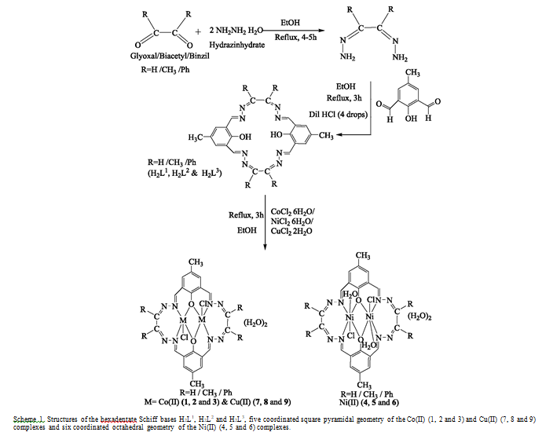
Fig.(1): Structures of the hexadentate Schiff bases H2L¹, H2L² and H2L³, five coordinated square pyramidal geometry of the Co(II) (1, 2 and 3) and Cu(II) (7, 8 and 9) complexes and six coordinated octahedral geometry of the Ni(II) (4, 5 and 6) complexes.

3.2. Synthesis, spectroscopic characterization and antimicrobial studies of Co(II), Ni(II), Cu(II) and Zn(II) complexes with Schiff bases derived from 5-bromo-salicylaldehyde:

In this study, the new Schiff base ligands derived from condensation of amine and 5-bromo-salicylaldehyde were characterized. All compounds, the Schiff bases and the metal complexes, were characterized by elemental analyzes, FT-IR, 1H NMR, 13C NMR and magnetic susceptibility measurements. The synthesized ligands, along with their metal (II) complexes, were screened for their in vitro antibacterial activity.(Ahmed et al, 2013).

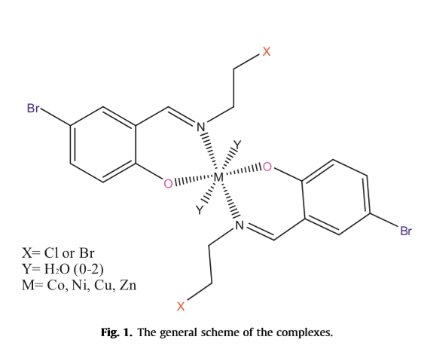
Fig.(2):the general scheme of the complexes.

3.3.Synthesis, characterisation and antimicrobial activity of new palladium and nickel complexes containing Schiff bases:

New Schiff base ligands were synthesized by condensation of 2-(3,4-dimethoxyphenyl)ethanamine with 2-hydroxy benzaldehyde (L1H) and 2'-hydroxy acetophenone (L2H) respectively. Reaction of L1H or L2H with Na2PdCl4 or NiCl2.6H2O in 2:1 ratio obtained four new coordination complexes 1M(L1–2)2] (where M = Pd(II); 1 and 2 and M = Ni(II); 3 and 4). Both the ligands and four complexes were characterised by elemental analysis, FT-IR and UV–Vis, spectroscopy. L1H, L2H, 1 and 2 were also characterised by 1H and 13C{1H} NMR spectroscopy.(C.E. Satheesha et al, 2016).

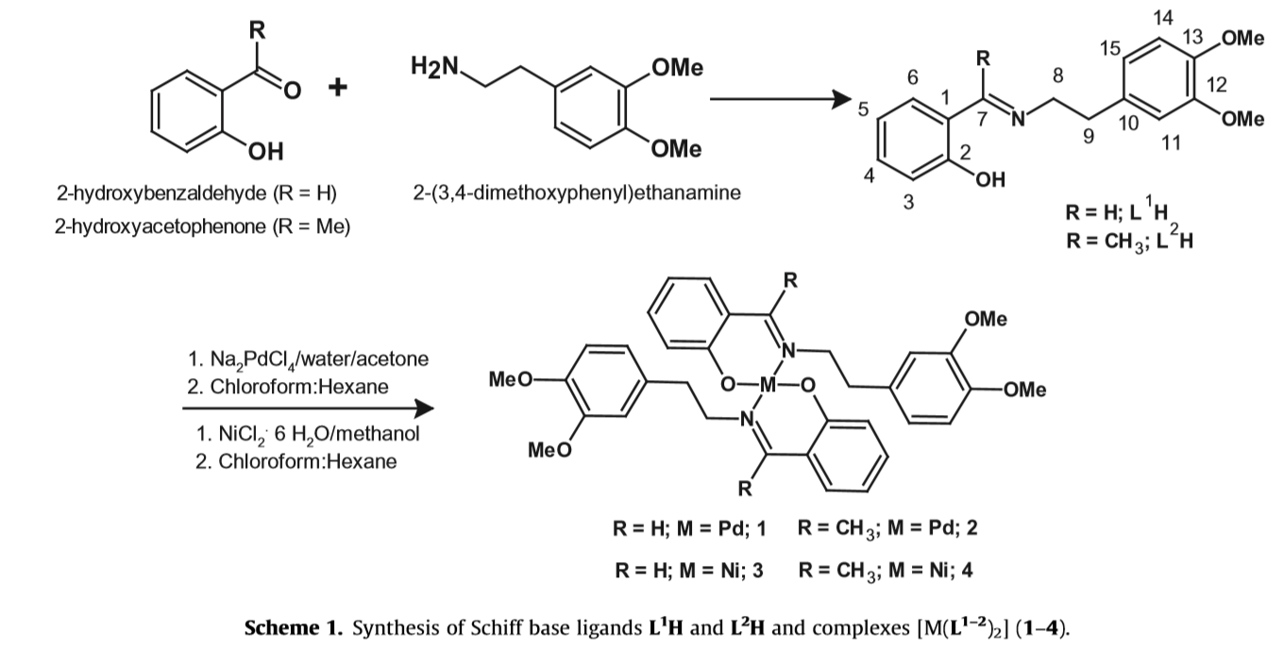
Fig.(3): Synthesis of Schiff base ligands L1H and L2H and complexes [M(L1–2)2]( 1–4).

3.4.Co(II), Ni(II) and Cu(II) complexes of bidentate Schiff bases:

Cobalt (II), nickel (II) and copper (II) complexes of type ML2Cl2, where M is CoII, NiII and CuII, and L is Schiff base formed by condensation of 2-thiophenecarboxaldehyde and propylamine, N-[2-thienylmethylidene]-1-propanamine (TNAP), or ethylamine, N-[2- thienylmethylidene]ethanamine (TNAE), have been prepared and characterised by elemental analysis, magnetic and spectroscopic measurements. Elemental analysis suggests the stoichiometry to be 1:2 (metal:ligand).(Cezar&Angela, 2000).

The proposed structural formulas of these compounds are presented in the figure:
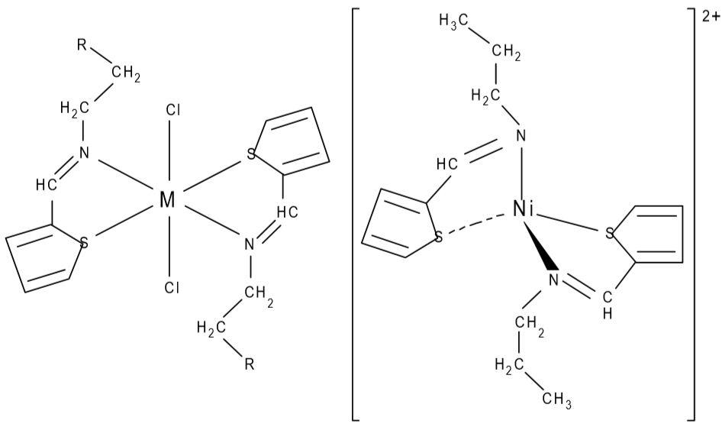

Fig.(4): The structural formulas of the complexes:
a.[ML2Cl2] (M = CoII, NiII, CuII; L = TNAP and TNAE); R=CH3, H
b.[Ni(TNAP)2]Cl2.

3.5. Schiff bases functionalized with PPh2 and SPh groups and their
Ni(II) and Pd(II) complexes: Synthesis, crystal structures
and applications of a Pd complex for Suzuki–Miyaura Coupling:

The reactions of 2-hydroxyacetophenone with NH2CH2CH2SPh and _{NH2CH2CH2PPh2} have resulted in Schiff bases having the chemical formulae , which are potential (N,O,S) and (N,O,P) type ligands. Using an appropriate ketone, the Schiff base has also been synthesized in a similar fashion. L¹, L2, L⁴ and the compounds obtained by borohydride reduction of L¹ and L², viz. 2-HO–C6H4CH(CH3)–NHCH2CH2Y [Y = SPh (L³) or PPh2 (L⁵)] have been explored as ligands.(P. Raghavendra Kumar et al, 2008).

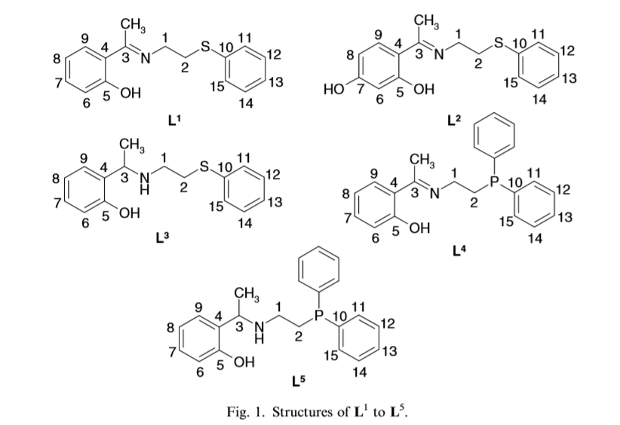
Fig.(5): Structures of L1 to L5.

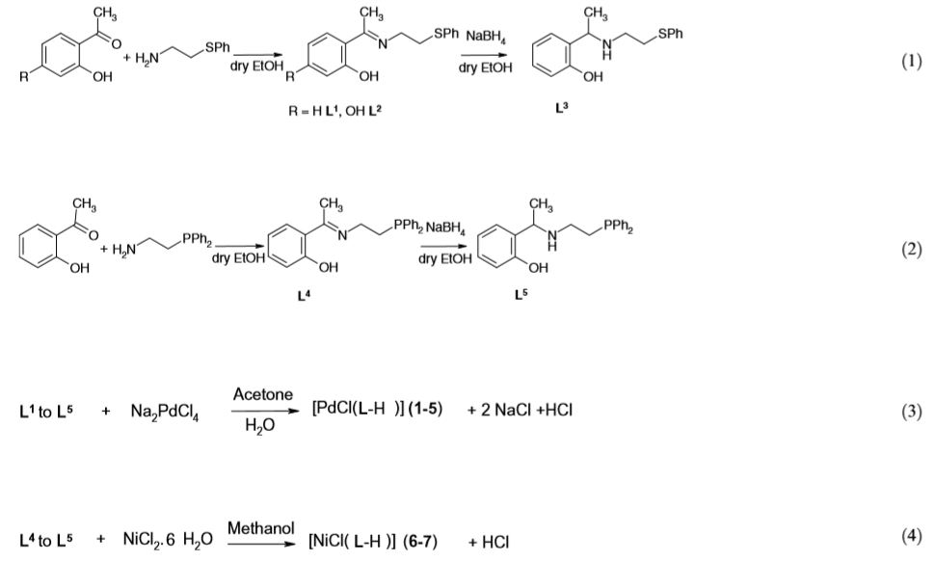 Fig.(6):synthetic scheme of the ligands and the complexes
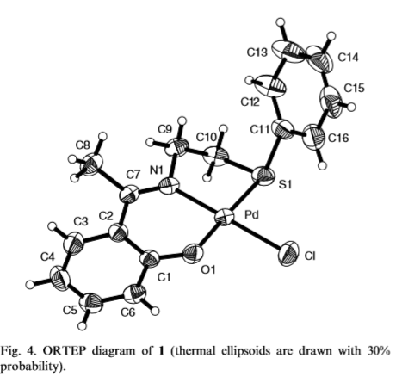
Fig.(7):ORTEP diagram of 1 (thermal ellipsoids are drawn with 30% probability).

3.6. Structural and antimicrobial studies of coordination compounds
of VO(II), Co(II), Ni(II) and Cu(II) with some Schiff bases
involving 2-amino-4-chlorophenol:

The coordination complexes of VO(II), Co(II), Ni(II) and Cu(II) with the Schiff bases derived from 2-hydroxyacetophenone/2-chlorobenzaldehyde with 2-amino-4-chlorophenol were synthesized and characterized by elemental analysis, molar conductance, electronic spectra, FT-IR, ESR, FAB mass, thermal and magnetic susceptibility measurements. The FAB mass and thermal data show degradation of the complexes. The ligand A (2-hydroxyacetophenone-2amino- -4-chlorophenol) behaved as tridentate and ligand B (2-chlorobenzylidene-2- -amino-4-chlorophenol) as bidentate.(A.P. Mishra et al, 2009).

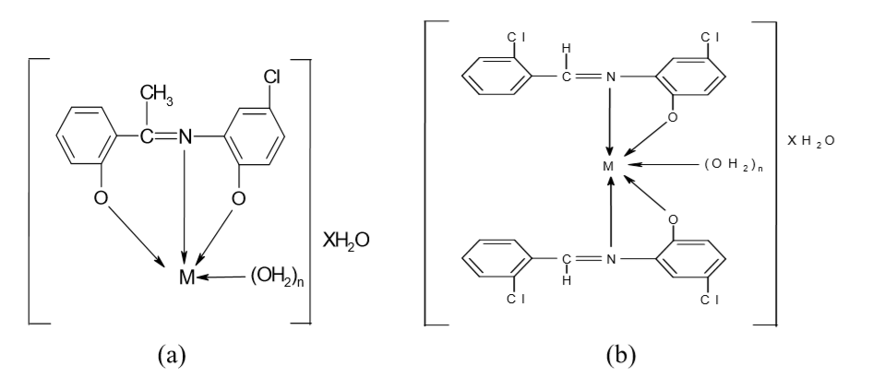
Fig.(8):Structures of the synthesized complexes with Schiff base (ligand): a) A (n = 1,2,3; x = 0,1,2) and b) B (n = 0,1,2 ; x = 0,1,2).

3.7. Salicylaldimine Schiff bases – Generation of self-assembled and chiral complexes with Ni(II) and Zn(II) ions. An unusual antiferromagnetic interaction in a triply bridged Ni(II) dimer:

Four new complexes of nickel(II) and zinc(II) with Schiff bases obtained from the condensation of salicylaldehyde and N,N-dimethyl-ethylene/propylenediamine and their reduced products have been synthesized and characterized by spectroscopic methods and single crystal X-ray structural analysis. Complex 1 is a six coordinated mononuclear complex of Ni(II), having a self assembled 2D structure with alternate cages and cavities running perpendicular to the c axis. The octagonal cavities are occupied by water molecules which are weakly hydrogen bonded to the eight oxygens lining the inner side of these cavities.(Vimal K. Bhardwaj et al, 2012).

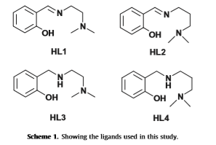
Fig.(9):Showing the ligands used in this study.
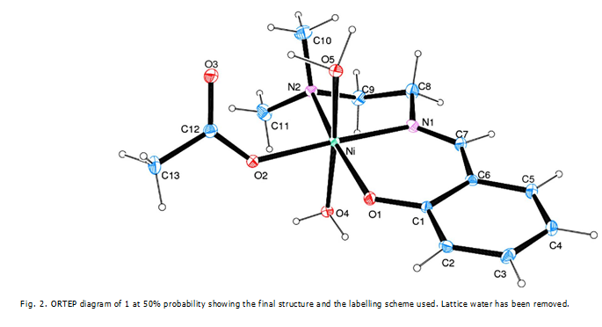
Fig.(10):ORTEP diagram of 1 at 50% probability showing the ﬁnal structure and the labelling scheme used. Lattice water has been removed.

3.8. Ni(II) complexes with Schiff bases derived from amino sugars:

It was found by 1H and 13C NMR spectroscopy that the Schiff base, 2-deoxy-2-(2-hydroxybenzaldimino)-D-glucopyranose exhibits enol-imine/keto-amine and anomeric equilibria in methanolic, and in dimethyl sulfoxide solutions. The reaction of the Schiff base with nickel acetate gave the bidentate, mononuclear Ni(II) complex that was characterized by spectroscopic methods and by cyclic voltammetry.(Juan Costamagna et al, 2003).

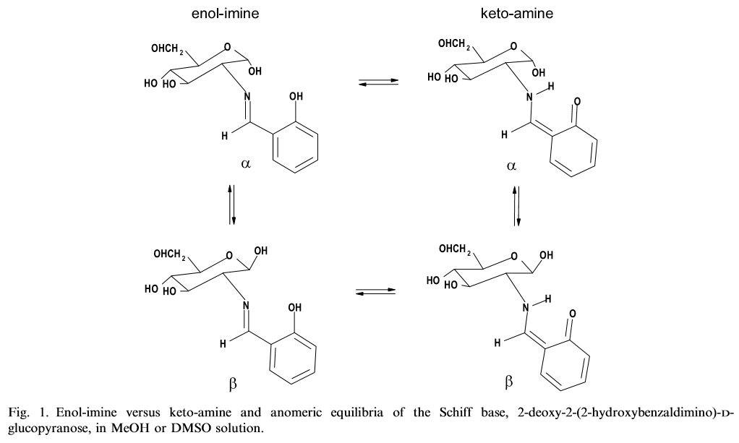
Fig.(11):Enol-imine versus keto-amine and anomeric equilibria of the Schiff base, 2-deoxy-2-(2-hydroxybenzaldimino)-Dglucopyranose, in MeOH or DMSO solution.

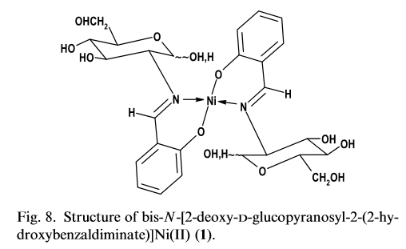
Fig.(12):Structure of bis-N-[2-deoxy-D-glucopyranosyl-2-(2-hydroxybenzaldiminate)]Ni(II)

3.9. Spectroscopic, electrochemical and biological studies of the metal complexes of the Schiﬀ base derived from pyrrole-2-carbaldehyde and ethylenediamine:

The new symmetrical Schiff base bis(pyrrole-2-carbaldehyde)ethylenediamine and its Mn(II), Co(II), Ni(II) and Cu(II) complexes were synthesized and characterized by spectral, magnetic and electrochemical studies.(Bibhesh K. Singh et al, 2017).

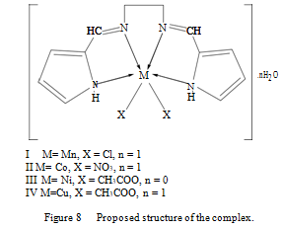
Fig.(13): Proposed structure of the complex.

3.10. Synthesis, characterization and thermogravimetric analysis of Co(II), Ni(II), Cu(II) and Zn(II) complexes supported by ONNO tetradentate Schiﬀ base ligand derived from hydrazino benzoxazine:

A new series of Co(II), Ni(II), Cu(II) and Zn(II) metal complexes of a novel ligand 3-(2-(1-(2,4-DihydroxyPhenyl)ethylidene)hydrazinyl)-2H-benzo[b][1,4]oxazin-2-one, (DPE-HBO) were prepared and characterized.(N. Kavitha&P.V. Anantha, 2017) 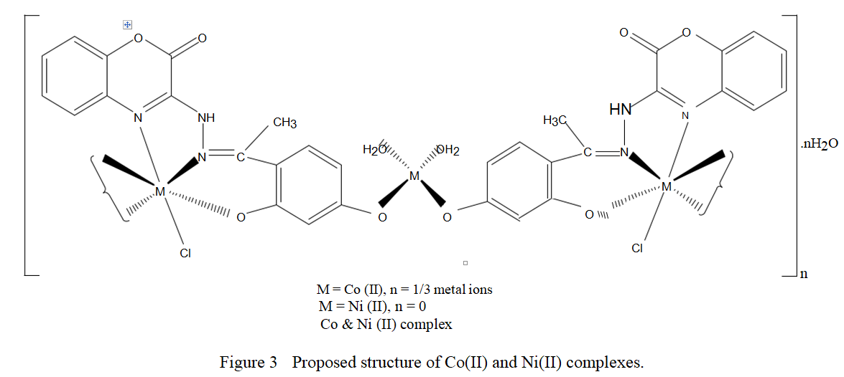
Fig.(14):Proposed structure of Co(II) and Ni(II) complexes

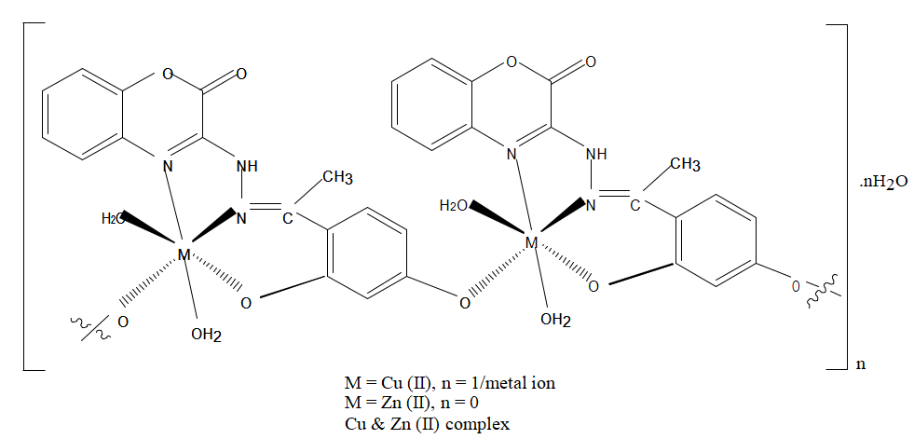 Fig.(15): Proposed structure of Cu(II) and Zn(II) complexes.
3.11. Synthesis and binding mode of N, N’-bis(4-methoxybenzylidene)ethan-1,2-diamine with Co(II), Ni(II) and Hg(II):

The Schiff base ligand, N, N’-bis(4-methoxybenzylidene)ethan-1,2-diamine and its metal complexes of Co(II), Ni(II) and Hg(II) have been successfully synthesized and characterized physicochemically and infrared spectroscopically.(Abubakr Abdullahi Ahmed et al, 2021).

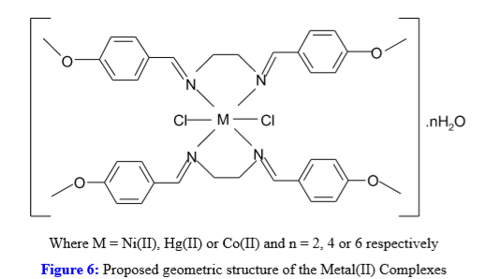
Fig.(16):Proposed geometric structure of the Metal(II) Complexes

3.12. Theoretical and electrochemical studies on organometallic symmetrical Schiff base complexes of Zn(II), Cu(II), Ni(II) and Co(II):

The electronic communication between two redox centres through a Schiff base complex has been investigated in a series of ethylenediimine-bis(1-ferrocenyl-1,3-butanedionate) complexes of Zn(II) 1, Cu(II) 2, Ni(II) 3 and Co(II) 4.(Mauricio Fuentealba et al, 2007).

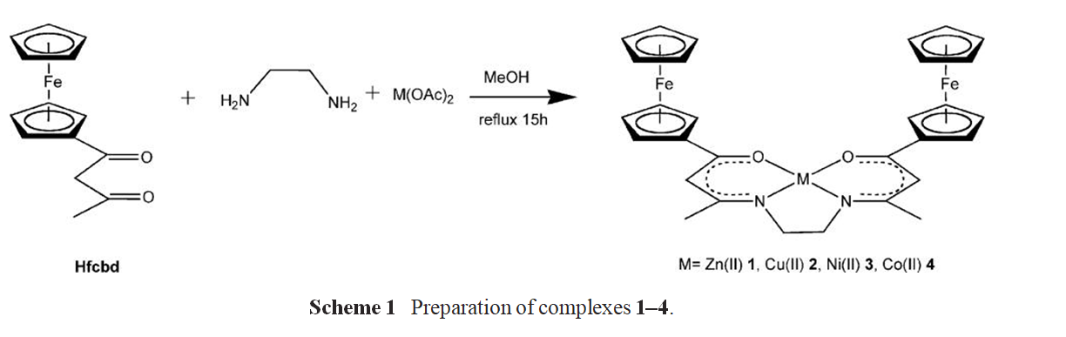
Fig.(17):Preparation of complexes 1–4

3.13. Another step toward DNA selective targeting: Ni^{II} and Cu^{II} complexes of a Schiﬀ base ligand able to bind gene promoter G-quadruplexes:

We have designed, synthesized and characterized a new water soluble Salen-like Schiﬀ base ligand and its Ni^{II} and Cu^{II} metal complexes. The same compound exhibited dose-dependent cytotoxic activity.(Alessio Terenzi et al, 2016).

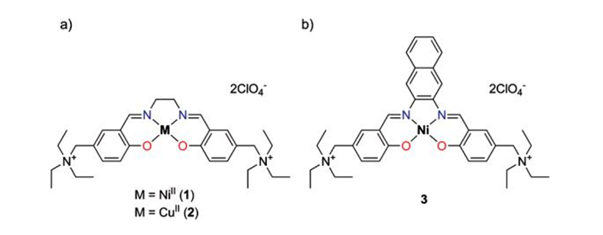

Fig.(18):Structures of (a) the newly synthesized NiII (1) and CuII (2) metal complexes and of (b) the Salnaphen-like NiII complex (3).

3.14. Synthesis and characterizations of NiO nanoparticles via solid-state thermal decomposition of nickel(II) Schiff base complexes:

To raise the need of new precursors in the synthesis of NiO nanoparticles, mononuclear nickel(II) Schiff base complexes, viz. Ni(salbn) and Ni(Me₂-salpn), were employed as precursor in solid-state thermal decom-position.(Aliakbar Dehno Khalaji& Debasis Das, 2014).

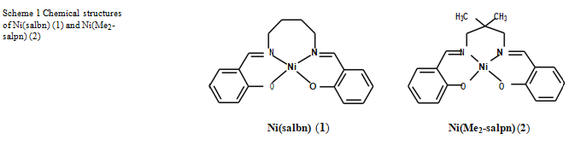

Fig.(19):Chemical structures of Ni(salbn) (1) and Ni(Me2salpn) (2)
3.15. Synthesis, characterization and equilibrium study of the dinuclear adducts formation between nickel(II) Salen-type complexes with diorganotin(IV) dichlorides in chloroform:

nickel(II) complexes of tetradentate Schiﬀ base ligands ([NiL]) where L = [3-methoxysalen, N,N0-bis(3-methoxysalicylidene)ethylenediamine], [4-methoxysalen, N,N0-bis(4-methoxysalicylidene)ethylenediamine], [5-methoxysalen, N,N0-bis(5-methoxysalicylidene)ethylenediamine], [salen, N,N0-bis(salicylaldehydo)ethylenediamine], [5-chlorosalen, N,N0-bis(5-chlorosalicylidene)ethylenediamine] and [5-bromosalen, N,N0-bis(5-bromosalicylidene) ethylenediamine] as donors have been investigated in chloroform as a solvent by means of UV–Vis spectrophotometeric analysis.(Mozaffar Asadi et al, 2007).

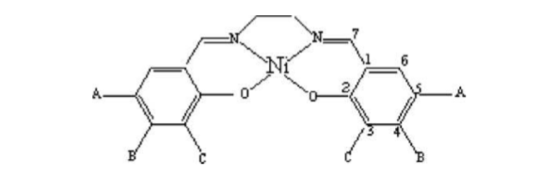

Fig.(20):Structural representation of the nickel Schiﬀ base complexes, A = MeO, H, Br and Cl; B, C = MeO.

3.16. N/N Bridge Type and Substituent Eﬀects on Chemical and Crystallographic Properties of Schiﬀ-Base (Salen/Salphen) Niii Complexes:
In total, 13 ligands R-salen (N,N’-bis(5-R-salicylidene)ethylenediamine (where R = MeO, Me, OH, H, Cl, Br, NO2) and R-salphen (N,N’-bis(5-R-salicylidene)-1,2-phenylenediamine (where R=MeO,Me,OH,H,Cl,Br)and their13 nickel complexes NiRsalen and CuO photocatalytic CuO photocatalytic NiRsalphen were synthesized.(Cynthia S. Novoa-Ramirez et al, 2020).

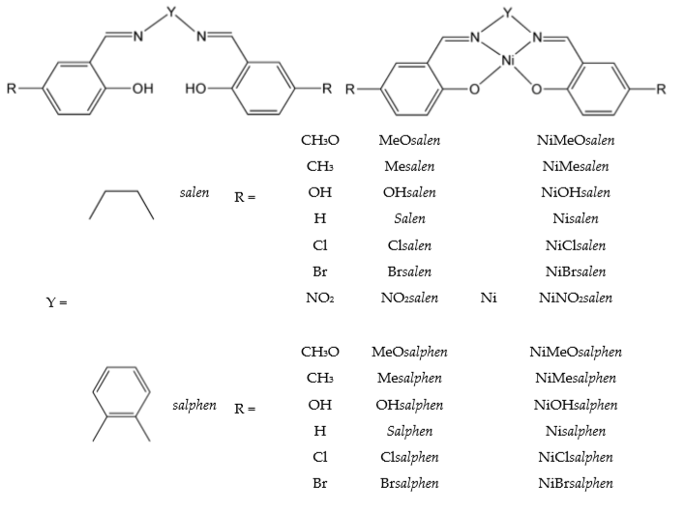
Fig.(21). Chemical structure of the ligands and the complex.

3.17. Synthesis, Characterization, Antioxidant, and Antibacterial Studies of Some Metal(II) Complexes of Tetradentate Schiff Base Ligand: (4E)-4-[(2-{(E)-[1(2,4Dihydroxyphenyl)ethylidene]amino}ethyl)imino]pentan-2-one :
Co(II),Ni(II),Cu(II),andZn(II)complexesof(4E)-4-[(2-{(E)-[1-(2,4-dihydroxyphenyl)ethylidene]amino}ethyl)imino]pentan-2one have been synthesized and characterized by elemental analyses, molar conductance, electronic and IR spectral studies, and XRD.(Ikechukwu P. Ejidike&Peter A. Ajibade, 2015).
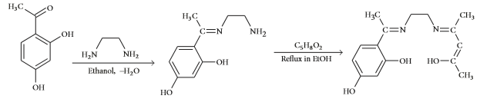
Fig.(22):Synthesis of Schiff base ligand(H2LL).
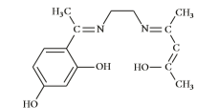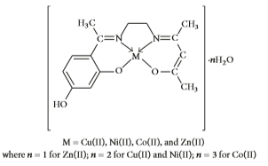

Fig.(23): Structure of Schiff base ligand(H2LL) Fig.(24):Proposed structure of metal complexes.

3.18.synthesis,X-ray structural characterization and solution studies of a mononuclear Ni(II)-Schiff base complex bearing free formyl groups :

A new mononuclear Ni(II)-Schiff base complex has been synthesize and structurally characterized through X-ray crystallograghy.(Shankareswar Gupta et al, 2003).

. 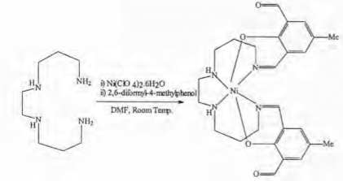

Fig.(25). Synthetic scheme.
- References:

Ahmed, A.A., Hamidu, K.U. and Muduru, I.K., 2021. Synthesis and binding mode of N, N’-bis (4-methoxybenzylidene) ethan-1, 2-diamine with Co (II), Ni (II) and Hg (II). Arabian Journal of Chemical and Environmental Research, 8(2), pp.275-286.
Asadi, M., Jamshid, K.A. and Kyanfar, A.H., 2007. Synthesis, characterization and equilibrium study of the dinuclear adducts formation between nickel (II) Salen-type complexes with diorganotin (IV) dichlorides in chloroform. Inorganica chimica acta, 360(5), pp.1725-1730.
Bhardwaj, V.K., Hundal, M.S., Corbella, M., Gomez, V. and Hundal, G., 2012. Salicylaldimine Schiff bases–Generation of self-assembled and chiral complexes with Ni (II) and Zn (II) ions. An unusual antiferromagnetic interaction in a triply bridged Ni (II) dimer. Polyhedron, 38(1), pp.224-234.
Costamagna, J., Lillo, L.E., Matsuhiro, B., Noseda, M.D. and Villagrán, M., 2003. Ni (II) complexes with Schiff bases derived from amino sugars. Carbohydrate research, 338(15), pp.1535-1542.
Ejidike, I.P. and Ajibade, P.A., 2015. Synthesis, characterization, antioxidant, and antibacterial studies of some metal (II) complexes of tetradentate schiff base ligand:(4E)-4-[(2-(E)-[1-(2, 4-dihydroxyphenyl) ethylidene] aminoethyl) imino] pentan-2-one. Bioinorganic chemistry and applications, 2015.
Fuentealba, M., Garland, M.T., Carrillo, D., Manzur, C., Hamon, J.R. and Saillard, J.Y., 2008. Theoretical and electrochemical studies on organometallic symmetrical Schiff base complexes of Zn (II), Cu (II), Ni (II) and Co (II). Dalton Transactions, (1), pp.77-86.
Gupta, S., Panja, A., Shaikh, N., Goswami, S., Banerjee, P. and Butcher, R.J., 2004. Synthesis, X-ray structural characterization and solution studies of a mononuclear Ni (II)-Schiff base complex bearing free formyl groups. Indian Journal of Chemistry. Section A: Inorganic, Physical, Theoretical and Analytical, 43, pp.63-66.

Kavitha, N. and Lakshmi, P.A., 2017. Synthesis, characterization and thermogravimetric analysis of Co (II), Ni (II), Cu (II) and Zn (II) complexes supported by ONNO tetradentate Schiff base ligand derived from hydrazino benzoxazine. Journal of Saudi Chemical Society, 21, pp.S457-S466.
Khalaji, A.D. and Das, D., 2014. Synthesis and characterizations of NiO nanoparticles via solid-state thermal decomposition of nickel (II) Schiff base complexes. International Nano Letters, 4(3), pp.1-5.
Kumar, P.R., Upreti, S. and Singh, A.K., 2008. Schiff bases functionalized with PPh2 and SPh groups and their Ni (II) and Pd (II) complexes: Synthesis, crystal structures and applications of a Pd complex for Suzuki–Miyaura Coupling. Polyhedron, 27(6), pp.1610-1622.
Kursunlu, A.N., Guler, E., Sevgi, F. and Ozkalp, B., 2013. Synthesis, spectroscopic characterization and antimicrobial studies of Co (II), Ni (II), Cu (II) and Zn (II) complexes with Schiff bases derived from 5-bromo-salicylaldehyde. Journal of Molecular Structure, 1048, pp.476-481.
Lakshmi, B., Avaji, P.G., Shivananda, K.N., Nagella, P., Manohar, S.H. and Mahendra, K.N., 2011. Synthesis, spectral characterization and in vitro microbiological evaluation of novel glyoxal, biacetyl and benzil bis-hydrazone macrocyclic Schiff bases and their Co (II), Ni (II) and Cu (II) complexes. Polyhedron, 30(9), pp.1507-1515.
Liu, X., Manzur, C., Novoa, N., Celedón, S., Carrillo, D. and Hamon, J.R., 2018. Multidentate unsymmetrically-substituted Schiff bases and their metal complexes: Synthesis, functional materials properties, and applications to catalysis. Coordination Chemistry Reviews, 357, pp.144-172.
Mishra, A.P., Mishra, R.K. and Shrivastava, S.P., 2009. Structural and antimicrobial studies of coordination compounds of VO (II), Co (II), Ni (II) and Cu (II) with some Schiff bases involving 2-amino-4-chlorophenol. Journal of the Serbian Chemical Society, 74(5), pp.523-535.

Novoa-Ramírez, C.S., Silva-Becerril, A., Olivera-Venturo, F.L., García-Ramos, J.C., Flores-Alamo, M. and Ruiz-Azuara, L., 2020. N/N bridge type and substituent effects on chemical and crystallographic properties of Schiff-base (Salen/Salphen) Ni II complexes. Crystals, 10(7), p.616.
Satheesh, C.E., Kumar, P.R., Sharma, P., Lingaraju, K., Palakshamurthy, B.S. and Naika, H.R., 2016. Synthesis, characterisation and antimicrobial activity of new palladium and nickel complexes containing Schiff bases. Inorganica Chimica Acta, 442, pp.1-9.
Singh, B.K., Mishra, P., Prakash, A. and Bhojak, N., 2017. Spectroscopic, electrochemical and biological studies of the metal complexes of the Schiff base derived from pyrrole-2-carbaldehyde and ethylenediamine. Arabian Journal of Chemistry, 10, pp.S472-S483.
Spinu, C. and Kriza, A., 2000. Co (II), Ni (II) and Cu (II) complexes of bidentate Schiff bases. Acta Chimica Slovenica, 47(2), pp.179-186.
Terenzi, A., Lötsch, D., van Schoonhoven, S., Roller, A., Kowol, C.R., Berger, W., Keppler, B.K. and Barone, G., 2016. Another step toward DNA selective targeting: Ni II and Cu II complexes of a Schiff base ligand able to bind gene promoter G-quadruplexes. Dalton Transactions, 45(18), pp.7758-7767.

حکومەتی هەرێمی کوردستان ـ عێراق
وەزارەتی خوێندنی باڵا & توێژینەوەی زانستی
زانکۆی سەڵاحەدین ـ هەولێر کۆلێژی زانست
بەشی کیمیا

لەگەڵ شیف بەیس Ni(II) ئاڵۆزەکانی
پڕۆژەی دەرچونە پێشکەش بە بەشی (کیمیا) کراوە ،وەک بەشێک لە
پێداویستیەکانی بەدەستهێنانی بڕوانامەی بەکالۆریۆس لە زانستی کیمیا

ئامادەکراوە لەلایەن
ڕۆژین نیاز محمد

بەسەرپەرشتی
عدنان محمد قادر

نیسان،٢٠٢٢
رەمەزان، ١٤٤٣
نەورۆز،٢٧٢٢

