Salahaddin University Hydrogeology lab Class: 4th year
College of Science 2020-2021 Lab no. (1)
Dep. Of Geology
((Influent and Effluent Stream))
Effluent streams are streams where groundwater flows into them, when the water table is low streams become Influent and water leaks from the stream bed into the ground during dry season. An influent stream is one supplying groundwater and effluent stream is one receiving groundwater discharge.
1- From the data given in the following maps construct groundwater level maps using contour interval 0.2m and show the flow direction of the groundwater.
2- Draw cross sections showing a profile of the groundwater level along lines AB (for map 1) and CD (for map 2).Show the location of the river in each section assuming that the ground surface level is 21m and 10m above sea level at the section lines AB and CD respectively. (Use vertical scale 1cm = 0.4m for cross section AB and 1cm = 1m for cross section CD).
3- Comment on the two sections.

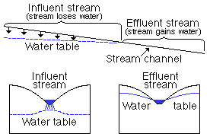

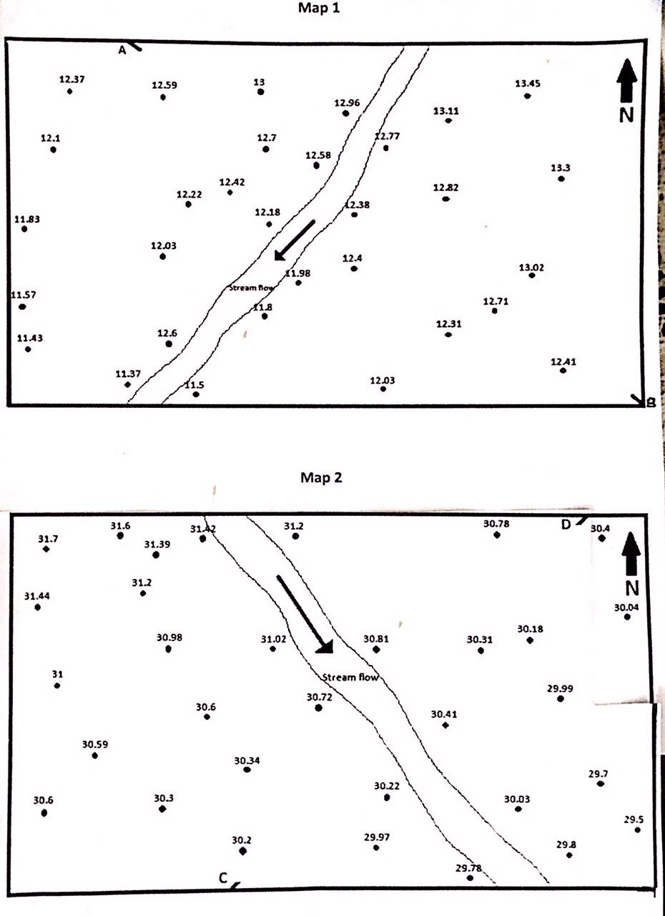

Scale 1:50000
Salahaddin University Hydrogeology lab Class: 4th year
College of Science 2020-2021 Lab no. (2)
Dep. Of Geology

((Type of Aquifers))
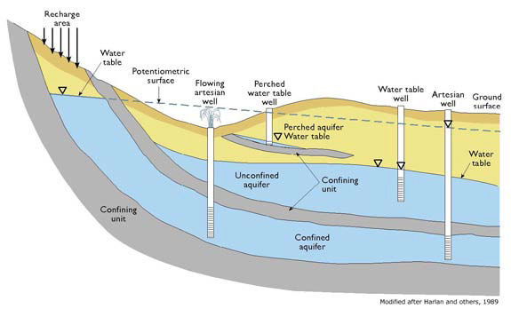

Ex: The table below shows data of 9 wells oriented along E-W, distance between each two wells is 3km.The data are depths of rock units from the ground surface in meter .Draw a stratigraphic cross section considering the ground surface is flat. How many types of aquifer are in this area and where is the recharge area for each aquifer? Discus the type of wells can be drilled in the area?
Use vertical scale1cm =50m, horizontal scale 1cm = 1km.

Rock units | 1 | 2 | 3 | 4 | 5 | 6 | 7 | 8 | 9
Sandstone | - | - | 0-125 | 0-250 | 0-300 | 0-350 | 0-150  175-375 | 0-175  225-375 | 0-150  175-375
Clay | 0-110 | 0-50  275-350 | 125-225  400-475 | 250-275  450-525 | 300-375  525-575 | 350-375  550-600 | 150-175  375-450  575-625 | 175-225  375-450  575-625 | 150-175  375-450  575-625
Limestone | - | 50-275 | 225-400 | 275-450 | 375-525 | 375-550 | 450-575 | 450-575 | 450-575
Water table | - | - | - | 200 | 210 | 220 | 230 | 240 | 250
Pesometric surface | 100 | 103 | 105 | 108 | 110 | 113 | 115 | 118 | 120

Salahaddin University Hydrogeology lab Class: 4th year
College of Science 2020-2021 Lab no. (3)
Dep. Of Geology
((Preparation of Groundwater level maps))
The map below depicts an area underlain by deposits of sand. The sand exposed at the surface in the eastern part of the area east of the dashed line. West of the dashed line a layer of clay overlies the sand. The points on the map indicate the positions of wells. The figure shows the altitude in feet above sea level of the bottom of the clay layer in each well, and the altitude of the ground water level.
1- Draw contour map for the bottom of the clay layer (use contour interval of 5 feet).
2- Draw contour map for the ground water levels (use contour interval of 5 feet).
3- Draw a profile along the line AB showing the bottom of the clay layer and the groundwater level
in the block below the map.
4- Under what conditions water occur along the profile? Draw a line to separate different conditions. 5- Indicate on the profile AB if there are any parts where water flow to ground surface?
6- What is the type of the stream?

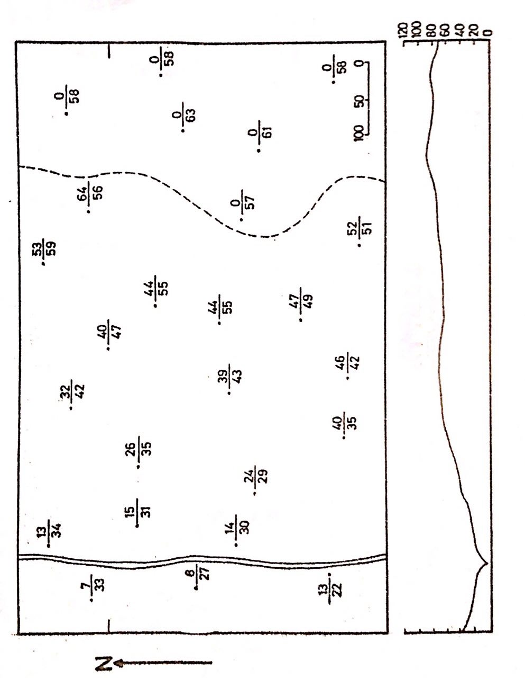

Salahaddin University Hydrogeology lab Class: 4th year
Science College 2020-2021 Lab no. (4)
Geology Department
((Groundwater discharge))

Ex: The wells X, Y and Z in the map below are drilled to a water bearing horizon. Water table in well X is 170 m, in well Y is 210m and in well Z is 185m.Draw a water table map for the groundwater if the aquifer is homogenous and the transmissivity is 2700m²/day.
Calculate:
1-The total discharge.
2-The average rate of water flow from well Y to well X for 1m width.
3-The average rate of water flow from well Y to well Z for 1m width.
4-Explain why there is difference between the two discharges?

X.

.Y

Z.
Scale 1:10000

Salahaddin University Hydrogeology lab Class: 4th year
College of Science 2020-2021 Lab no. (5)
Dep. of Geology
Ex : The topographic map below indicates a homogenous confined aquifer, the formation pressure in well X at (-490m) is 64.05kg/cm², in well Y at (-390m) is 52.50kg/cm² and in well Z at (-360m) is 47.25kg/cm².Specific gravity of water is 1.05 and Transmissivity of the aquifer is 2190 m²/day. Draw a line to separate the area of artesian wells and the area of flowing artesian wells. Determine the average rate of water flow from well X to wells Y and Z.

Salahaddin University Hydrogeology lab Class: 4th year
College of Science 2020-2021 Lab no. (6)
Dep. Of Geology
Ex1: Determine the discharge of an aquifer with 43 m thick and 12 km wide if it is known that the hydraulic conductivity is 1.6 m/day and the hydraulic gradient is 0.04 ?

Ex2: Determine the hydraulic conductivity if the estimated recharge rate to the aquifer 5.6m/day and the different in water table high is 10.3m and the saturated thickness is 5.7m?

Ex3: A constant-head permeameter has a sample of medium grained sand 15cm in length and 25 cm² in cross- sectional area. With a head of 0.5cm, a total of 100mlof water is collected in 12min. find the hydraulic conductivity?

Ex4: The figure shows seepage from a
stream in an unconfined aquifer, determine
the seepage losses from the stream for 1 m
width? Mention the type of the stream
Ex5: If 58 cm³ of water drains from a saturated sample having a total volume of 165 cm³ ,find the specific yield of the sample?

Ex6: How much water will drain from 570 m³ of an aquifer if the specific retention is 0.32 and the effective porosity is 0.48?

Ex7: If the hydraulic head drops 19 m over an area of 8.3 km² in a confined aquifer with storage coefficient of 0.0007, how much water will be lost from storage of the aquifer?

Ex8: How much groundwater flows through a 435 m² section of an aquifer (oriented perpendicular to groundwater flow), under a hydraulic gradient of 0.02 and a hydraulic conductivity of 1.6 m/d?

Ex9: In a constant-head permeameter test, 238 cm³ of water was discharged over 190 seconds. The cross-sectional area of the chamber was 35 cm² and the sample was 19 cm long .Finally, the hydraulic head differential between the inlet and outlet was 6 cm. Estimate the hydraulic conductivity of the sample?

Ex10: Determine the transsmisivity and the
discharge for 1m width for the unconfined
aquifer in the cross section below?
Mention the type of the stream.

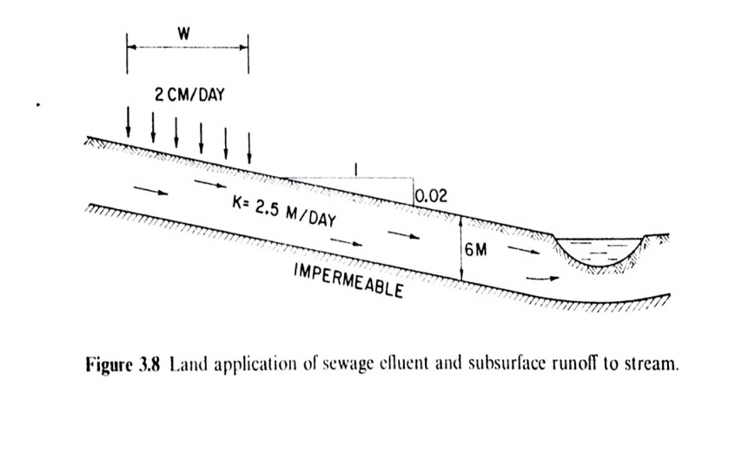

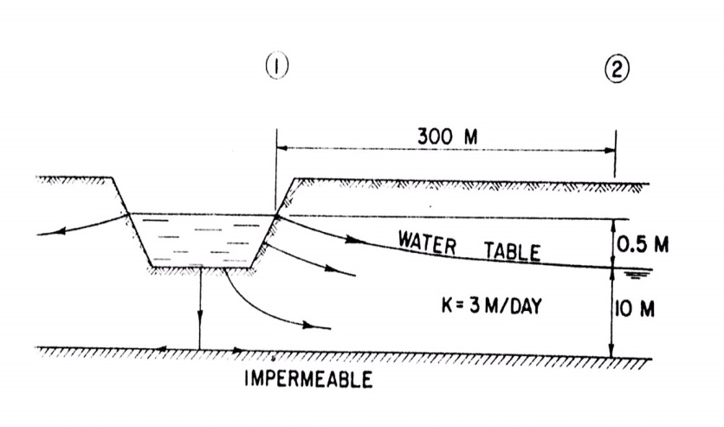

Salahaddin University Hydrogeology lab Class: 4th year
College of Science 2020-2021 Lab no. (7)
Dep. of Geology
(Flow Net)

Ex.1- Determine the thickness of the aquifer in the figure below if the quantity of water flowing in the area is 28640m³/day and the hydraulic conductivity is 22 m/day.

Ex.2- Draw a flow net for the area in the figure below and determine the quantity of water flowing in the area when the hydraulic conductivity is 28 m/day and the saturated thickness of the aquifer is 19 m.

Ex.3- Draw a flow net for the area in the figure below and determine the quantity of water flowing in the area when the transmissivity is 2380 m²/day and find the hydraulic conductivity if the saturated thickness of the aquifer is 31 m.
Ex.4-Prepare a water level contour map in the figure below then draw the flow net for the area and determine the quantity of water flowing in the area when the transmissivity is 48000 m²/day and determine the hydraulic conductivity if the saturated thickness of the aquifer is 42 m.(use contour interval 20 m)

r²/t(ft²/day) | Time(day) | h_{o}-h(ft) | Time(m) | r²/t(ft²/day) | Time(day) | h_{o}-h(ft) | Time(m)
 |  | 2.36 | 24 |  |  | 0.66 | 1
 |  | 2.49 | 30 |  |  | 0.87 | 1.5
 |  | 2.65 | 40 |  |  | 0.99 | 2
 |  | 2.78 | 50 |  |  | 1.11 | 2.5
 |  | 2.88 | 60 |  |  | 1.21 | 3
 |  | 3.04 | 80 |  |  | 1.36 | 4
 |  | 3.16 | 100 |  |  | 1.49 | 5
 |  | 3.28 | 120 |  |  | 1.59 | 6
 |  | 3.42 | 150 |  |  | 1.75 | 8
 |  | 3.51 | 180 |  |  | 1.86 | 10
 |  | 3.61 | 210 |  |  | 1.97 | 12
 |  | 3.67 | 240 |  |  | 2.08 | 14
 |  |  |  |  |  | 2.20 | 18
Salahaddin University Hydrogeology lab Class: 4th year
College of Science 2020-2021 Lab no. (8)
Dep. of Geology
((Well Hydraulic –Pumping Test))

A well in a confined aquifer was pumped at a rate of 490ft³/min for 240min.The aquifer is 52ft thick .Time- Drawdown data from an observation well located 220ft away are given in the table below. Find T, K and S values by using the equations of Theis method.

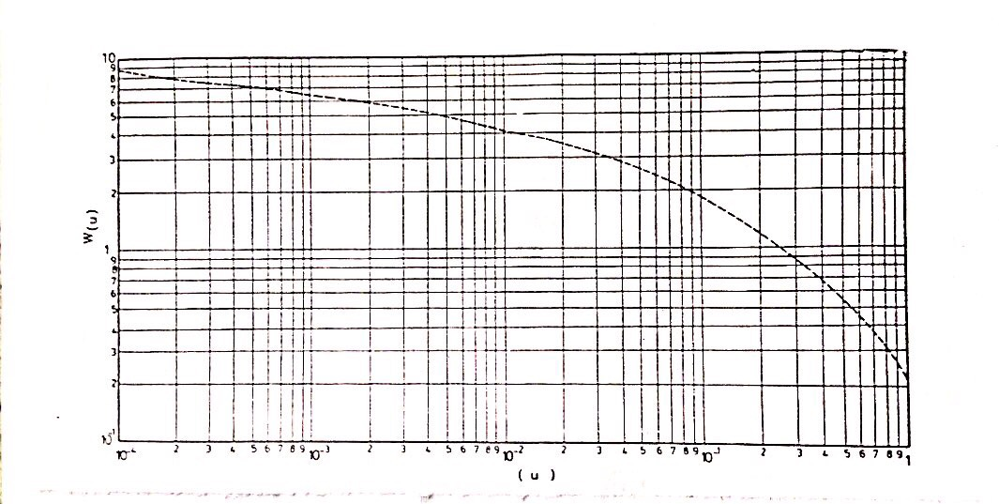

Salahaddin University Hydrogeology lab Class: 4th year
College of Science 2020-2021 Lab no. (9)
Dep. of Geology
((Well Hydraulic –Pumping Test))
A well in a confined aquifer was pumped at a rate of 48500ft³/min for 400 min .The aquifer is 46 ft thick .Time- Drawdown data from an observation well located 890ft away are given in the table below. Find Transsmisivity, hydraulic conductivity and storage coefficient values by using the equations of Jacob and Chow methods.
Drawdown(ft) | Time after pumping starting(min)
2 | 4
3 | 5
4 | 7
5 | 9
5.5 | 10
8.2 | 20
9.8 | 30
11 | 40
11.8 | 50
13 | 70
14 | 90
14.4 | 100
15.8 | 150
17 | 200
18 | 250
18.8 | 300
19.2 | 350
20 | 400

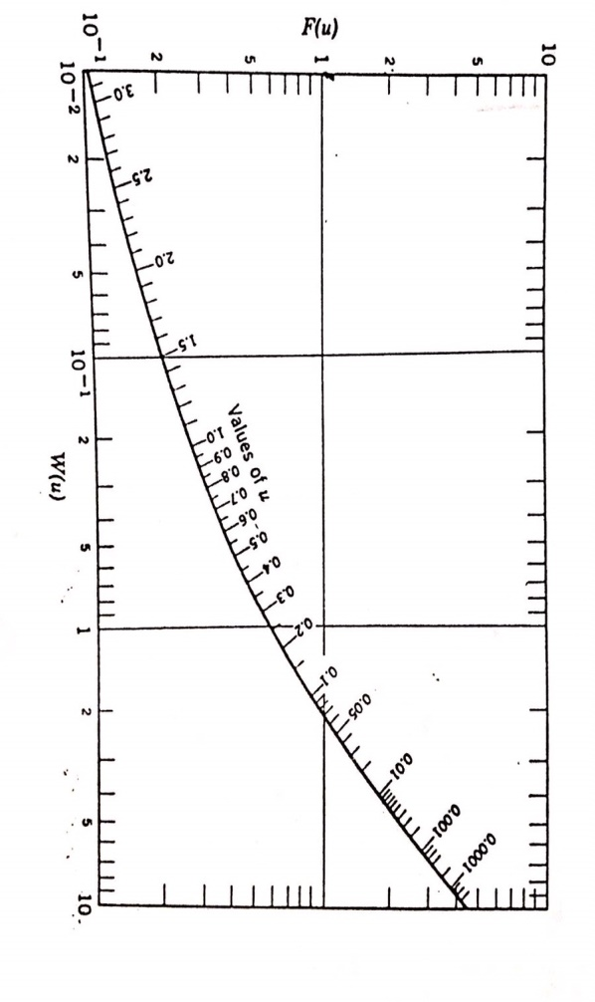

Salahaddin University Hydrogeology lab Class: 4th year
College of Science 2020-2021 Lab no. (10)
Dep. of Geology
(( Well Test ))
A well in an unconfined aquifer was pumped at a rate of 780 m³/day .The aquifer is 42m thick. Time- Drawdown data measured in the well are given in the table below. Find Transsmisivity, hydraulic conductivity by using Jacobs straight line method and Recovery method.

Residual draw down | Time since pumping stopped | Drawdown(m) | Time (min)
1.7 | 0.5 | 0.1 | 0.5
1.3 | 1 | 0.42 | 1
1 | 1.5 | 0.7 | 1.5
0.95 | 2 | 0.95 | 2
0.79 | 3 | 1.12 | 3
0.66 | 4 | 1.36 | 4
0.5 | 5 | 1.5 | 5
0.4 | 6 | 1.59 | 6
0.38 | 7 | 1.74 | 7
0.27 | 8 | 1.8 | 8
0.21 | 9 | 1.89 | 9
0.04 | 10 | 2 | 10
0 | 15 | 2.3 | 15
0 | 20 | 2.6 | 20
 |  | 2.82 | 30
 |  | 2.9 | 40
 |  | 3.2 | 50
 |  | 3.3 | 60
 |  | 43. | 70
 |  | 43. | 80

Salahaddin University Hydrogeology lab Class: 4th year
College of Science 2020-2021 Lab no. (11)
Dep. of Geology ((Slug Test))
A Slug test was made with a piezometer that had a casing radius of 0.083ft and a screen of radius 0.095ft. The well screen is 10ft length .the following data was obtained when a quantity of water was removed rapidly from the well. Determine the hydraulic conductivity of the aquifer by using Hvorssleve slug test method.

h/h_{o} | Change in water level h(ft) | Depth to water (ft) | Time (sec)
 |  | 13.99 | Static level
 | 0.88 (h_{o}) | 14.87 | 0
 |  | 14.59 | 1
 |  | 14.37 | 2
 |  | 14.20 | 3
 |  | 14.11 | 4
 |  | 14.05 | 5
 |  | 14.03 | 6
 |  | 14.01 | 7
 |  | 14.00 | 8
 |  | 13.99 | 9

Salahaddin University Hydrogeology lab Class: 4th year
Science College 2020-2021 Lab no. (12)
Geology Department
((Chemical analyses for Ground water samples))

Ex:The table below shows chemical analysis of ground water samples selected from some wells in kurdistan region .Plot the results on Piper diagram and Schoeller semilogarithmic diagram. Determine the accuracy of the samples and mention the source of the ground water.

Sample 6  Ppm | Sample 5  ppm | Sample 4  Ppm | Sample 3  Ppm | Sample 2  Ppm | Sample 1  ppm | valance | Atomic weight | Element
45 | 138 | 67.6 | 74 | 92 | 38 | 2 | 40 | Ca
22 | 36 | 21.72 | 43 | 39.6 | 18 | 2 | 24 | Mg
9.1 | 14.2 | 44.3 | 80 | 24.3 | 6.2 | 1 | 23 | Na
0.7 | 2.3 | 0.95 | 2.4 | 4.7 | 0.7 | 1 | 39 | K
184 | 189 | 360.5 | 205 | 452.4 | 147 | 1 | 61 | HCO₃
40 | 320 | 31.7 | 267 | 52.3 | 52 | 2 | 96 | SO₄
12.2 | 29 | 23.6 | 36 | 27.3 | 10.1 | 1 | 35.5 | Cl
0.2 | 0.1 | 0 | 0 | 0 | 0.2 | 1 | 62 | NO₃

$Equivalent weight =\frac{ Atomic weight}{Valance}$

$concentration in epm=\frac{concentration in ppm}{Equivalent weight }$

$U \%=\frac{∑cations- ∑anions}{∑cations+∑anions}*100$
A = 100 – U
Where U%: relative difference
A: accuracy

Accuracy classification according to Stoodly (1980)
Class or Type | A | U
Certain | A ≥ 95% | U ≤ 5%
Probably certain | 90% ≤ A < 95% | 10% ≥ U > 5%
Uncertain | A < 90 | U > 10%

