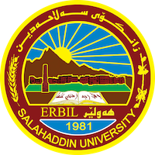
Academic Curriculum Vitae
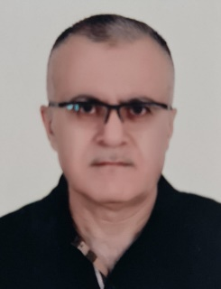
Personal Information:
Full Name: Ahmed Ismail Alauldin
Academic Title: Assistant Lecturer
Email: ahmed.alauldeen@su.edu.krd
Mobile:009647504527508

Education:
· 2009 – Msc. - University of Salahaddin –Erbil(SUE)
· 1998 – Bsc. - University of Salahaddin –Erbil(SUE)

Employment:
From 2004 till now in University of Salahaddin –Erbil(SUE)
Qualifications
Master of science –Architectural theory
Teaching experience:
· Architecture Design
· Architecture Theory

Professional memberships
Kurdistan Engineers union / Erbil ID No. 962

