Question Bank Medical Optics

Q1/ A beam of collimated light traveling in air makes an angle of 30º to normal to a glass plate. If the index of the glass is n_{g}=3/2, determine the direction of the transmitted beam within the plate.

Q2/ Prove that a ray incident at θi to a planer glass plate immersed in air will emerge from the plate at the same angle , b- Derive an expression for the displacement a of the ray if the thickness of glass is d.

Q4 /Derive an expression for the transit time of a ray of light that travels a distance x1through a medium of index n1 a distance x2 through a medium of index n2,……. and a distance xm through a medium of index nm Use a summation to express your result.E

Q5/A concave spherical mirror of 20 cm radius is to be used to project an image of a candle onto a wall 110 cm away . Where will the candle have to be placed and what will the image look like.

Q6/ Design a spherical mirror which will form an erect half-sized image of an object 100 cm from the vertex, where will the image be located?

Q7/ suppose that we have a glass rod (n= 1.50) surrounded by air with left end ground to a convex hemisphere of 2 cm radius. If a point source is located 6 cm to the left of the hemispheres vertex , where will its image appear?

Q8/ If the glass rod of above problem is immersed in water (n=1.33) determine the new location of the image of the point source.

Q9/ It is required that a real image twice the size of the object be formed by a thin plano-convex lens . If the lens has a radius of curvature of 50 cm and refractive index of 1.5, determine the location of the object and the image with respect to the lens.

Q10/ A biconvex (also called a double convex) thin spherical lens has radii of 100 cm and 20.0 cm. The lens is made of glass with an index of 1.54 and is immersed in air. (a) If an object is placed 70.0 cm in front of the 100-cm surface, locate the resulting image and describe it in detail. (b) Determine the transverse magnification of the image.

Q11/A convex thin lens with refractive index of 1.50 has a focal length of 30 cm in air. When immersed in a certain transparent liquid, it becomes a negative lens with a focal length of 188 cm. Determine the refractive index of the liquid.

Q12/ Light rays emanating in air from a point object on axis strike a plano-cylindrical lens with its convex surface facing the object. Describe the line image by length and location if the lens has a radius of curvature of 5 cm, a refractive index of 1.60, and an axial length of 7 cm. The point object is 15 cm from the lens.

Q13/ A small object faces the convex spherical glass window of a small water tank. The radius of curvature of the window is 5 cm. The inner back side of the tank is a plane mirror, 25 cm from the window. If the object is 30 cm outside the window, determine the nature of its final image, neglecting any refraction due to the thin glass window itself. n=4/3

Q14/ Two identical, thin, plano-convex lenses with radii of curvature of 15 cm are situated with their curved surfaces in contact at their centers. The intervening space is filled with oil of refractive index 1.65. The index of the glass is 1.50. Determine the focal length of the combination. (Hint: Think of the oil layer as an intermediate thin lens)

Q15/ A diverging lens and a concave mirror have focal lengths of equal magnitude. An object is placed (3/2)f from the diverging lens and the mirror is placed at a distance 3f on the other side of the lens. Using Gaussian optics, determine the final image of the system, after two refractions (and one reflection!) , a) by a three-ray diagram, and b) by calculation.

Q16/ A plano-cylindrical lens in air has a radius of curvature of 10 cm, a refractive index of 1.50, and an axial length of 5 cm. Light from a point object is incident on the concave, cylindrical surface from a distance of 25 cm to the left of the lens. Find the position and length of the line image formed by the lens.

Q23/ In a Young’s experiment, narrow double slits 0.2 mm apart diffract monochromatic light onto a screen 1.5 m away. The distance between the fifth minima on either side of the zeroth-order maximum is measured to be 34.73 mm. Determine the wavelength of the light.

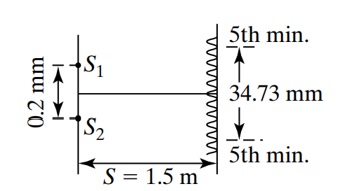

Q24/ Two slits are illuminated by light that consists of two wavelengths. One wavelength is known to be 436 nm. On a screen, the fourth minimum of the 436-nm light coincides with the third maximum of the other light. What is the wavelength of the other light?

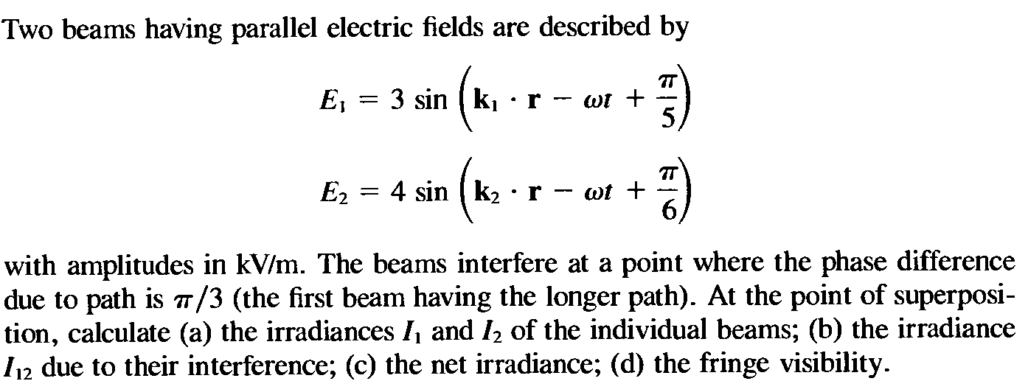
Q25/
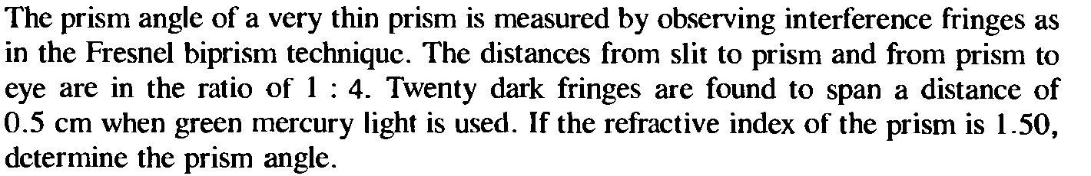
Q26/

Q31/ Eyeglasses for the nearsighted — A nearsighted person has a far point 100 cm and near point 15 cm. 1- what correction should on optometrist prescribe to move the myopic far point out to infinity ? 2- with this correction can the myopic person read a book held at normal near point 25 cm from the eye?

Q32/ Eyeglasses for the farsighted:A farsighted person to have a near point at 150cm, what corrective power is required for spectacles to enable this person to see object brought in to the normal near point 25 cm from the eye?
Q/ A near-sighted person has a far point that is 4.2 m from his eyes. What refractive power lenses (in diopters) must he use in his contacts to allow him to focus on distant objects.
The far point of a myopic person is 80cm in front of the eye . What is the nature and power Of the lens required to enable him to see very distant objects distinctly?

