Question Bank of physical optics

Q1/

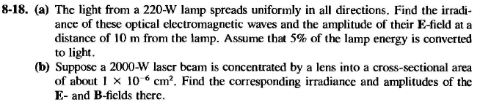

Q3/

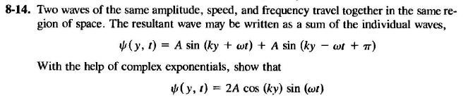

Q4/

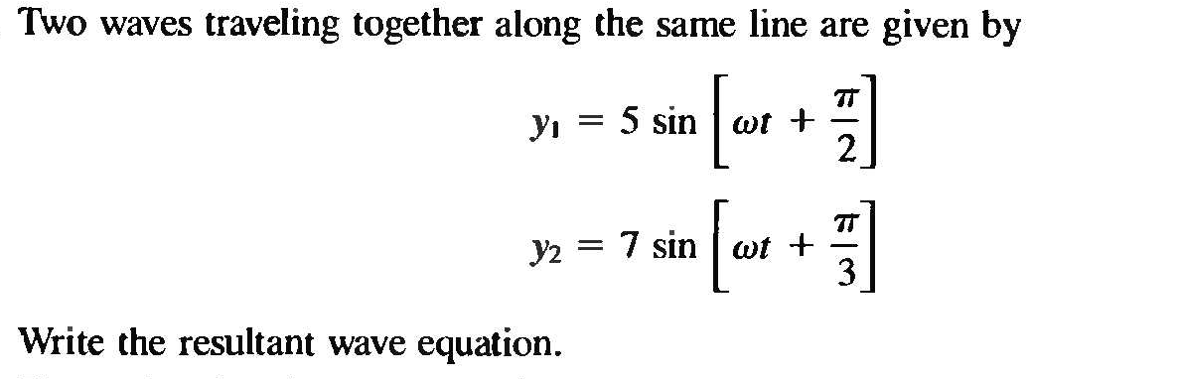

Q5/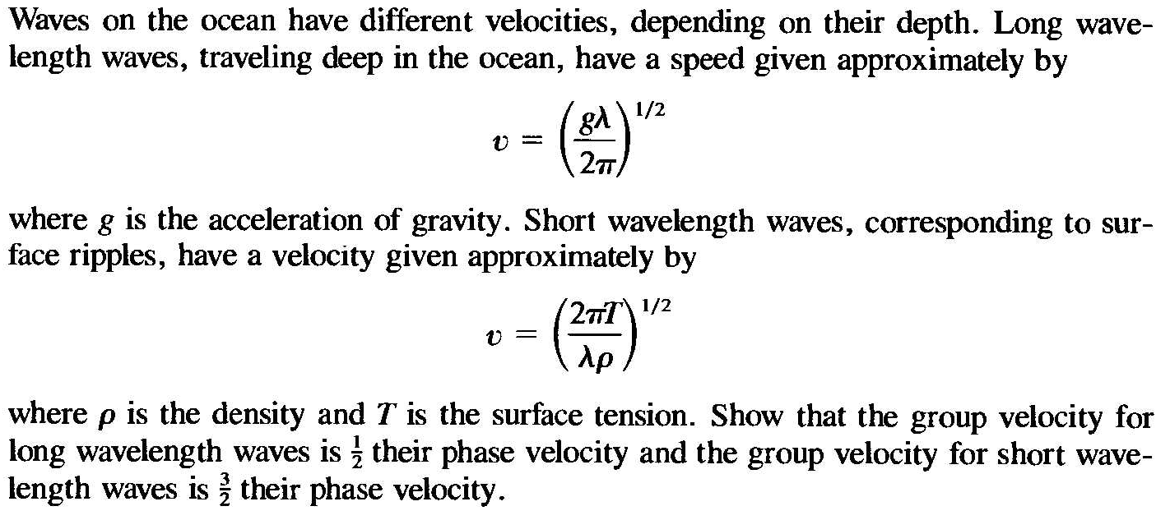

Q6/

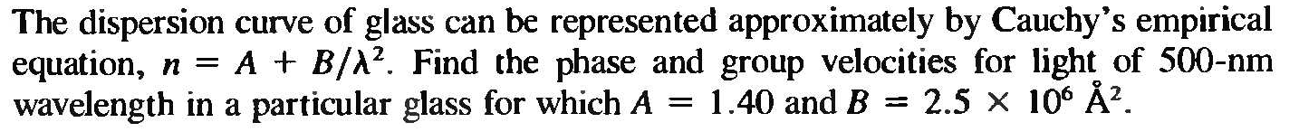

Q7/

Red light (*l*=664 nm) is used in Young’s double slit experiment according to the drawing beside. Find the distance *y* on the screen between the central bright and the third-order bright fringe.

Q8/

In a two slit interference experiment, the slits are 0.20 mm apart, and the screen at a distance of 1.0 m. The third bright fringe (not counting the central bright fringe) is displaced by 7.5 mm. Find the wavelength of light used.

Q9/S1 and S2 in Fig. are point sources of electromagnetic waves of wavelength 1.00 m. They are in phase and separated by d = 4.00 m, and they emit at the same power.

1. If a detector is moved to the right along the x-axis from source S1, at what distances from S1 are the first three interference maxima detected?
2. Where do the minima occur?

Q10/

A disabled tanker leaks kerosene (n = 1.20) into the Arab Gulf, creating a large slick on top of the water (n = 1.30).

1. If you are looking straight down from an airplane while the Sun is overhead at a region of the slick where its thickness is t=460 nm, for which wavelength(s) of visible light is the reflection brightest because of constructive interference?
2. (b) If you are scuba diving directly under this same region of the slick, for which wavelength(s) of visible light is the transmitted intensity strongest? (Hint: use figure (a) with appropriate indices of refraction.)

Q11/

**Light shines on a soap film nearly perpendicularly. The film is 375 nm thick and has n = 1.33. List the first four wavelengths of light for which constructive interference causes the film to look bright in reflected light.**

**Q12/**

**665 nm light shines on a soap film nearly perpendicularly. The soap film has n = 1.33. What is the minimum thickness of the film if this wavelength is strongly reflected?**

Q13/

Show that the radius of the mth dark Newton’s ring as viewed from directly above is given by:



Where R is the radius of curvature of the curved glass surface and l is the wavelength of the light used. Assume that the thickness of the air gap is much less than R at all points and that x<<R

Q13/

Two pieces of plane glass are placed together and a piece of paper between the two at One edge. Find the angle of the wedge-shaped air between the plates, if on viewing the wedge normally with light λ = 460 nm, there are 18 fringes per cm.

Q14/

Light interfering from 10 equally spaced slits initially illuminates a screen. Now we double the number of slits, keeping the spacing constant.

What happens to the net power on the screen?

a. stays the same b. doubles c. increases by 4

Q15/

If we *double* the number of slits, we expect the net power on the screen to double. How does it do this…

1. The location and number of the principle maxima (which have most of the power) does *not* change.
2. The principle maxima become 4x brighter.
3. But they also become only half as wide.
4. Therefore, the net power (integrating over all the peaks) increases two-fold, as we would expect.

Q16/

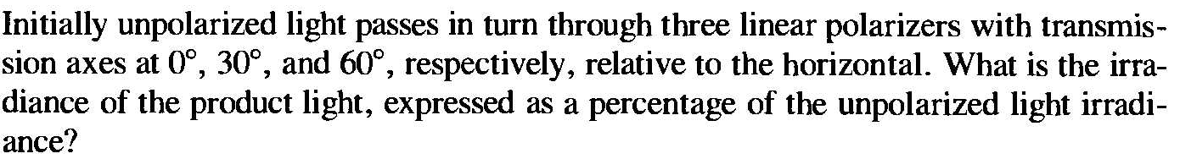

Q17/



Q18/

What is the angular separation in second order between light of wavelengths 400 nm and 600 nm when diffracted by a grating of 5000 grooves/cm?

Q19/

Describe the dispersion in the red wavelength region around 650 nm (both in °/nm and in nm/mm) for a transmission grating 6 cm wide, containing 3500 grooves/cm, when it is focused in the third-order spectrum on a screen by a lens of focal length 150 cm. b. Find the resolving power of the grating under these conditions.

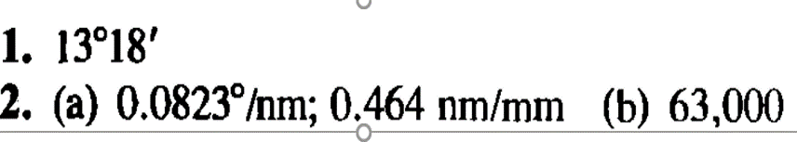

Q20/

How many lines must be ruled on a transmission grating so that it is just capable of resolving the sodium doublet (589.592 nm and 588.995 nm) in the first- and second-order spectra.