Problems Chapter Five
Example 1: A sample of gas at 25.0 °C has a volume of 11.0 L and exerts a pressure of 660.0 mmHg. How many moles of gas are in the sample?
Solution:
1) PV = nRT:
(660.0 mmHg / 760.0 mmHg/1.00 atm) (11.0 L) = (n) (0.08206 L atm / mol K) (298 K)
Note the conversion from mmHg to atm and from Celsius to Kelvin.
2) Solve:
 |  | (0.868421 atm) (11.0 L)
n = |  | –––––––––––––––––––––––––––
 |  | (0.08206 L atm / mol K) (298 K)
n = 0.391 mol
Example 2: Calculate the approximate volume of a 0.400 mol sample of gas at 11.0 °C and a pressure of 2.43 atm.
Solution:
1) PV = nRT:
(2.43 atm) (V) = (0.400 mol) (0.08206 L atm / mol K) (284 K)
2) Calculate:
 |  | (0.400 mol) (0.08206 L atm / mol K) (284 K)
V = |  | –––––––––––––––––––––––––––––––––––––
 |  | (2.43 atm)
V = 3.84 L
Example 3: Calculate the approximate temperature of a 0.30 mol sample of gas at 780 mmHg and a volume of 6.0 L.
Solution:
1) PV = nRT:
(780 mmHg) (6.0 L) = (0.30 mol) (62.3638 L mmHg / mol K) (T K)
Note the different value and unit for R, to be in agreement with using mmHg for the volume unit.
2) T = PV / nR
T = [(780) (6.0)] / [(0.30) (62.3638)]
T = 250 K
The problem does not specify the final unit, but Celsius is most often requested.
250 - 273 = -23 °C

Example 4: What is the pressure exerted by 2.3 mol of a gas with a temperature of 40. °C and a volume of 3.5 L?
Solution:
PV = nRT
(P) (3.5 L) = (2.3 mol) (0.08206 L atm / mol K) (313 K)
P = [(2.3) (0.08206) (313)] / 3.5
P = 16.9 atm
Example 5: A sample of dry gas weighing 2.1025 grams is found to occupy 2.850 L at 22.00 °C and 740.0 mmHg. How many moles of the gas are present?
Solution:
1) I will change the units for pressure to atm., so as to keep with my preferred value for R:
740.0 mm Hg ÷ 760.0 mm Hg/atm = 0.973684 atm
2) Now, plug into the equation and solve for n:
(0.973684 atm) (2.850 L) = (n) (0.08206 L atm / mol K) (295.0 K)
To four sig figs, the answer is 0.1146 mol
I will use 0.1146329 mol in the next example and round off at the end.

Example 6: At STP, a 5.00 L flask filled with air has a mass of 543.251 g. The air in the flask is replaced with another gas and the mass of the flask is 566.107 g. The density of air is 1.29 g/L. What is the gas that replaced the air?
Solution:
1) Calculate mass of air in flask:
1.29 g/L times 5.00 L = 6.45 g
2) Calculate mass of flask:
543.251 g minus 6.45 g = 536.801 g
3) Calculate mass of unknown gas:
566.107 g minus 536.801 g = 29.306 g
4) Calculate moles of unknown gas:
PV = nRT
(1.00 atm) (5.00 L) = (n) (0.08206) (273 K)
n = 0.22319 mol
5) Calculate molar mass of unknown gas:
29.306 g / 0.22319 mol = 131.3 g/mol
The unknown gas could be xenon.
Example 7: (a) A gas has a temperature of 300. K and a pressure of 104 kPa. Find the volume occupied by 1.05 mol of this gas, assuming it is ideal. (b) Assuming the gas molecules can be approximated as small spheres of diameter 3.0 x 10¯¹⁰ m , determine the fraction of the volume found in part (a) that is occupied by the molecules.
Solution:
1) PV = nRT:
(104 kPa / 101.325 kPa/atm) (V) = (1.05 mol) (0.08206 L atm / mol K) (300. K)
V = 25.184 L
To three sig figs, the answer is 25.2 L
2) PV = nRT with slightly different numbers:
PV = nRT where
P = 104000 Pa, n = 1.05 mol, R = 8.314 Pa m³/mol K, T = 300. K.
V = nRT/p = (315) (8.31447 m³) / 104000 = 0.025183 m³ <--- note the 315, which comes from 300. x 1.05
Note how only the final unit that survives in the answer is shown.
V = 0.0252 m³
3) The number of molecules in 1.05 moles:
(1.05 mol) (6.022 x 10²³ molecules mol¯¹) = 6.3231 x 10²³ molecules
4) The volume of an individual molecule is:
(4/3) (3.14159) (1.5 x 10¯¹⁰ m)³ = 1.4137 x 10¯²⁹ m³
5) The total volume of the molecules in m³:
(6.3231 x 10²³ molecules) (1.4137 x 10¯²⁹ m³ / molecule) = 0.00000894 m³
6) The fraction of the gas volume that is occupied by matter is:
0.00000894 m³ / 0.025183 m³ = 0.000355 or about 1/2817 of the total volume
Example 8: A 0.105 g sample of an unknown diatomic gas contained in a 125 mL vessel has a pressure of 560 torr at 23 &175;C. What is the molar mass of the gas? What is the identity of the gas?
Solution:
PV = nRT
(560 torr / 760 torr/atm) (0.125 L) = (n) (0.08206 L atm / mol K) (296 K)
n = 0.003792 mol
0.105 g / 0.003792 mol = 27.7 g/mol
Nitrogen has a molar mass of 28.0 g/mol
Example 9: 1 L volume of a gas is at a pressure of 20 atm. A valve allows the gas to flow into a 12-L container, connecting the two containers. What is the final pressure of this gas?
A good place to start this problem is to write out the formula for Boyle's law and identify which variables you know and which remain to be found.
The formula is:
P₁V₁ = P₂V₂
You know:
Initial pressure P₁ = 20 atm
Initial volume V₁ = 1 L
final volume V₂ = 1 L + 12 L = 13 L
final pressure P₂ = variable to find
P₁V₁ = P₂V₂
Dividing both sides of the equation by V₂ gives you:
P₁V₁ / V₂ = P₂
Filling in the numbers:
(20 atm)(1 L)/(13 L) = final pressure
final pressure = 1.54 atm (not the correct number of significant figures, just so you know)
Example 10: A scuba tank contains O₂ with a pressure of 0.450 atm and He at 855 mm Hg. What is the total pressure in mm Hg in the tank?

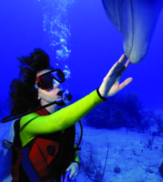

1. Convert the pressure in atm to mm Hg
0.450 atm x 760 mm Hg = 342 mm Hg = P_{O2} 1 atm

2. Calculate the sum of the partial pressures.
P_{total} = P_{O2} + P_{He}

P_{total} = 342 mm Hg + 855 mm Hg
= 1197 mm Hg
Example11: For a deep dive, a scuba diver uses a mixture of helium and oxygen with a pressure of 8.00 atm. If the oxygen has a partial pressure of 1280 mm Hg, what is the partial pressure of the helium?
1) 520 mm Hg
2) 2040 mm Hg
3) 4800 mm Hg

Example12: The air we breathe is a gas mixture contains mostly N₂ and O₂ and small amounts of other gases.
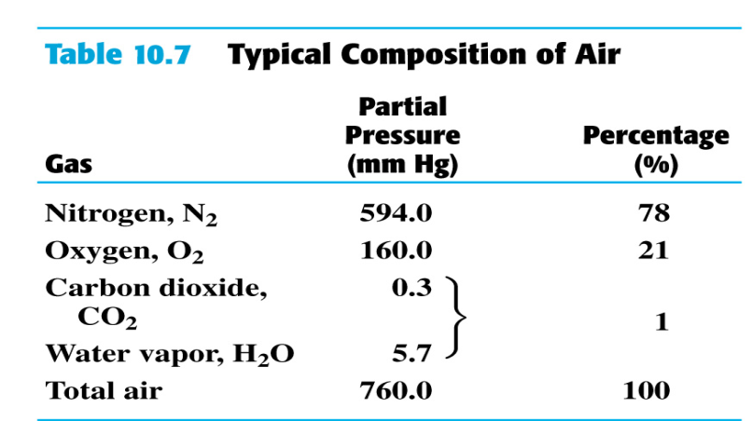
- A. If the atmospheric pressure today is 745 mm Hg, what is the partial pressure (mm Hg) of O₂ in the air?
1) 35.6 2) 156 3) 760
- B. At an atmospheric pressure of 714, what is the partial pressure (mm Hg) N₂ in the air?
1) 557 2) 9.14 3) 0.109

