Academic Curriculum Vitae
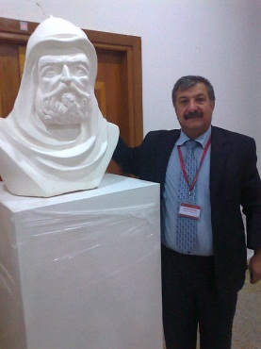
Personal Information:
Full Name:AHMED MUSTAFA MAHMOOD
Academic Title: ASSISTANT TEACHER
Email: (university email) ahmed.mahmood1@su.edu.krd
Mobile: 07504885660

Education:
- State all educations accomplished
MASTER IN SCUIPTURE
Employment:
- State employment starting from first employment
13-1-2002
Qualifications
- Teaching qualifications ;- 1- ARABIC CALLIGRAPHY QUALIFICATIONS
2- DRAWING QUALIFICATIONS
- IT qualifications
- Language qualifications such as TOEFL, IELTS or any equivalent
QUALIFICATIONS IN PERSIAN AND ARABIC
- Any professional qualification
- You could put any professional courses you have attended;- 1- ACOURSE IN ARABIC CALLIGRAPHY
2- ACOURS IN CERAMICS
Teaching experience:
- State all teaching courses you delivered, stating undergraduate or post graduate
- Courses, trainings, lab supervision, etc.,
TEACHING METHODS COURSE
Research and publications
- State all researches, publication you made.

Conferences and courses attended
- Give details of any conferences you have attended, and those at which you have presented delivered poster presentations.
Conference ( CYBER HARASSMENT AND SEXUAL EXPLOITATION)
I HELD APERSONAL EXHIBITION AT THIS CONFERENCE ON 20-10-2022 ,AND ITS MY TENTH PERSONAL EXHIBITION
Funding and academic awards
- List any bursaries, scholarships, travel grants or other sources of funding that you were awarded for research projects or to attend meetings or conferences.
ALETTER OF THANKS AND APPRECIATION
Professional memberships
- List any membership you hold of any professional body or learned society relevant to your research or other life activities.
1- MEMBER OF THE IRAQI CALLIGRAPHERS ASSOSCITION 8-5-1994
2- MEMBER OF PLASTIC ARTISTS UNION 6-11-1994
Professional Social Network Accounts:

- List your profile links of ReserchGate, LinkedIn, etc.
https//www.facebook.com/ahmed.zahawee

It is also recommended to create an academic cover letter for your CV, for further information about the cover letter, please visit below link:
https://career-advice.jobs.ac.uk/cv-and-cover-letter-advice/academic-cover-letter/

