Academic Curriculum Vitae
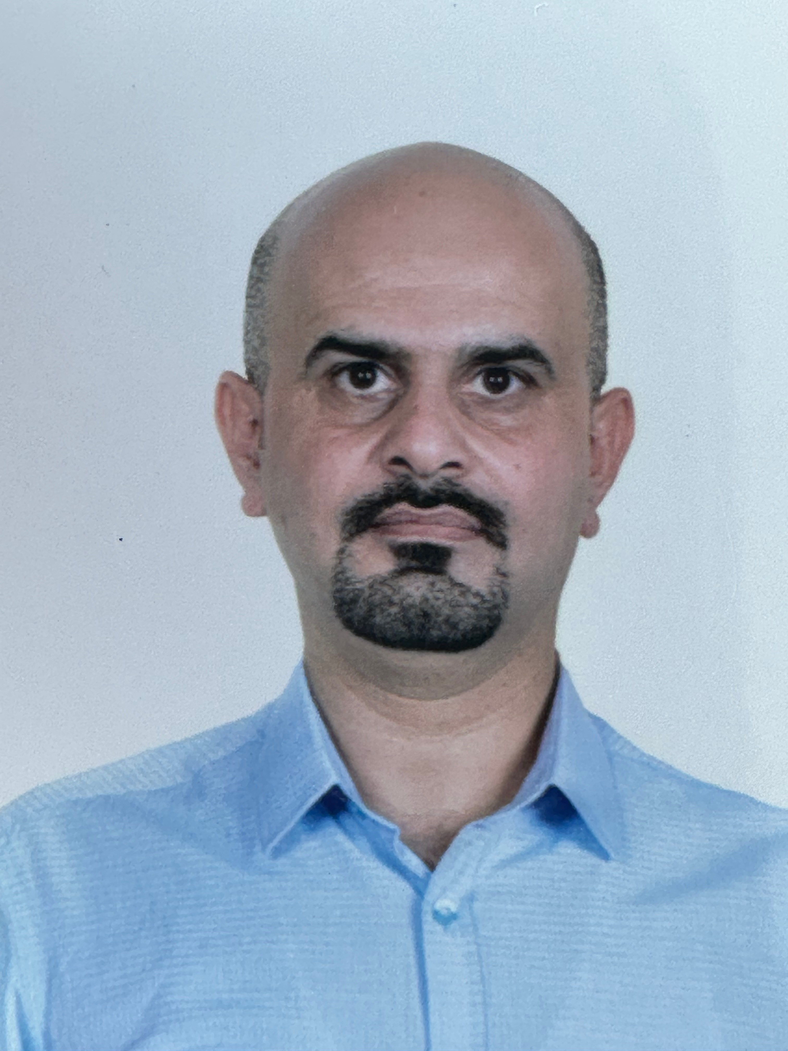
Personal Information
Full Name: Ahmed Mamoon Mahmood Alkadi
Academic Title: Lecturer
Email: (ahmed.mahmood@su.edu.krd)
Mobile: 07703963630

Education:
- Doctor (Ph.D) Gaziantep University/ Communication Electronics 2017
- Master (Msc) University of Al-Rasheed/ Laser Engineering 2004
- Bachelor University of Al-Rasheed/ Electric And Electronic Engineering 1997
- High School Baghdad Collage High School 1992

Employment:
- 1998-2001 Air Defense Radar Maintenance engineer
- 2001-2004 Academic sabbatical
- 2005-2006 University of Al-Mustansirye / Lecturer assistance
- 2006-tell Know University of Salahdien Electric Engineering Lecturer
Qualifications
- Teaching Methods course.
- Work comfortably with Microsoft Excel, Microsoft Word , Microsoft Power Point.
- CST Microwave Simulator.
- Language: English 480 TOEFL ,Turkish Academic Diploma.
- Any professional qualification

Teaching experience:
- Teaching courses that been delivered:
- Math I, II, III, IV, Engineering Analysis, Microcontrollers, Microprocessors, Communication, Analogue Electronics, Digital Electronics stating For undergraduate and CST Microwave Simulator Program, Advance Microcontrollers for post graduate.
- Lab supervision: Electronics Lab., Microcontrollers Lab. Communication Lab.

Research and publications
- Design and Fabrication of a Novel Wideband DNG Metamaterial with the Absorber Application in Microwave X-Band
- Wideband Negative Permittivity and Double Negative Fishnet-Mushroom-Like Metamaterial in X-Band Waveguide
- A Low Mutual Coupling Design for Array Microstrip Antennas Integrated with Mushroom-Like Fishnet (EBG) Structures
- Enhancement of information propagation on the highway in VANET based on Multiple Vehicle Class
- Performance Evaluation of Hybrid Optical OFDM-Based VLC Schemes in LOS and NLOS Indoor Optical Wireless Channels

Conferences and courses attended
- Give details of any conferences you have attended, and those at which you have presented delivered poster presentations.

Funding and academic awards
- Turkey Ph.D scholarships

Professional memberships
- Iraqi Engineers Union Consultant
- Kurdistan Engineers Union Consultant

Professional Social Network Accounts:

- Google Schuler https://scholar.google.com/citations?user=J6B9nekAAAAJ&hl=en&authuser=1
- Linkdin
https://www.linkedin.com/in/ahmed-mamoon-alqadi-686ab059/
- RESEARCH GATE
https://www.researchgate.net/profile/Ahmed_Mahmood18

