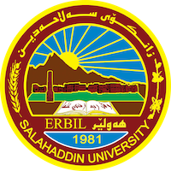
Academic Curriculum Vitae
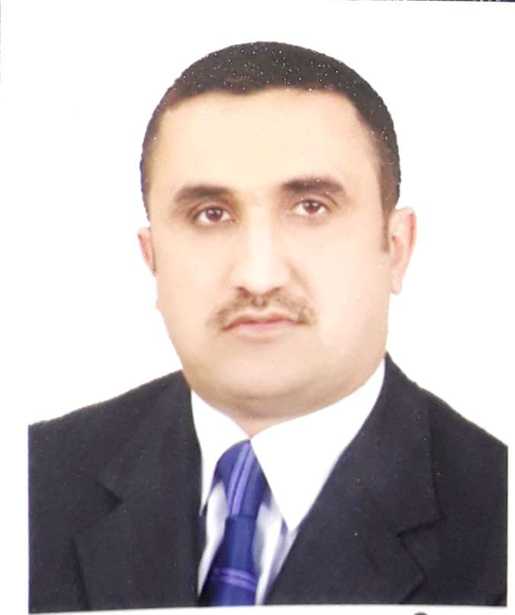
Personal Information:
Full Name: AHMED AZAN SHAREEF
Academic Title: assistant professor
Email: (Ahmed.azan@su.edu.krd )
Mobile:07504169379

Education:
- 1995-1996, B. Sc., Salahaddin University, College of Administration and Economics, Administration Department. (Erbil - IRAQ)
- 2011, M. Sc., Salahaddin University, College of Administration and Economics, Administration Department. (Erbil - IRAQ)

Employment:
I am a graduate of the Department of Business Administration and obtained a bachelor's degree in 1995-1996 And I was second in my batch of (140) students And the sixth at the level of the college, and at that time the college was composed of four departments, and they were as follows (business administration, accounting, statistics, economics), but now and at the present time the college has opened two departments (financial and banking sciences, management of tourism organizations) Six months after my graduation, I was appointed to my college and started as a teaching assistant in the Business Administration Department on 11/1/1997. Since then, until I accepted my master’s degree in 2009, I stayed for a period of (14) years working in the department.

Teaching experience:
1- Principles of Business Administration First Business Administration
2- Materials Management Third Business Administration
3- Human Resources Department, Business Administration
4- Management Information Systems Fourth Business Administration
5- Administrative Information Systems Fourth Business Administration Evening
6- Scientific Research Methods II Business Administration
7 Productions and Operations Management Fourth Business Administration
Research and publications

Conferences and courses attended
- The International Monetary Fund conference held in 2010, the conference venue is the Khanzad Hotel in Erbil.
- Icabe 2021 certificate of attendance on 29-30-2021 tishk International University.
- I participated in a course to strengthen the English language in the Faculty of Arts in 1997 for an oil-for-food contract.
- I participated in a course to learn computers in the main center at Salah al-Din University / Erbil.
- I participated in a course to strengthen the English language of the University Language Center for the purpose of taking the Tofel exam.
- I participated in the course of teaching methods at the university as part of obtaining the scientific title.
- I took an English language course at the English Language Center of Salahaddin University - Erbil for a period of six (6) months.
- I participated in an online training course in Germany on diversity in terms of cultures, religion, and acceptance of others.
- I was a trainer for a training course in the Iraqi High Electoral Commission on management and manager problems.

Professional memberships
- Teachers union
- Association of accountants and auditors
- Economists Syndicate

- List your profile links of ReserchGate, LinkedIn, etc.
- Research gate: https://www.researchgate.net/profile/Ahmed-Shareef
- LinkedIn: https://www.linkedin.com/in/ahmed-shareef-5a0478122/
- Google scholar: https://scholar.google.com/citations?hl=en&user=vWRoGy8AAAAJ

