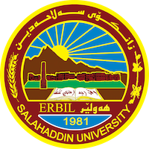

Academic Curriculum Vitae

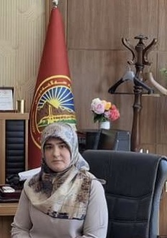
Personal Information:
Full Name: Aisha Khalid Omer
Academic Title: Assistant Lecturer
Email: (aisha.omer@su.edu.krd)
Mobile:9647506387878

Education:
- State all educations accomplished
- Master of Arts/ English Literature/ Salahaddin University/College of Languages/16/7/2014
- BA/ English Language and Literature/ Salahaddin University/College of Languages/1/7/2008

Employment:
- 2009-2011 Assistant Researcher at Salahaddin University/College of Languages/ In Charge of Secrecy and Dean’s office.
- 2012-2014 MA student in at Salahaddin University/College of Languages
- 2014-2023 A member teaching staff in Salahaddin University/College of Education

Qualifications
- Master of Arts/ English Literature/ Salahaddin University/College of Languages/16/7/2014
- BA/ English Language and Literature/ Salahaddin University/College of Languages/1/7/2008
- Computer and information technology 2021-2022

Teaching experience:
Linguistic and Literary Terms/ Second Grade/Kurdish Languag/ Salahaddin University College of Education/Shaqlawa
General English for University Students/ First Grade/ Arabic department/ Salahaddin University College of Education/Shaqlawa
General English for University Students/ First Grade/ Biology department/ Salahaddin University College of Education/Shaqlawa
Comprehension Communication/ First Grade/English department/ Salahaddin University College of Education/Shaqlawa
Comprehension composition/ First Grade/English department/ Salahaddin University College of Education/Shaqlawa
Introduction to Literature/ Second Grade/English department/ Salahaddin University College of Education/Shaqlawa
Literature Ages/ Second Grade/English department/ Salahaddin University College of Education/Shaqlawa
Academic Skills/ First Grade/English department/ Salahaddin University College of Education/Shaqlawa

Research and publications
Disorder and Estrangement in V.S. Naipaul’s A House for Mr. Biswas
( PP.343-354) Aisha Khalid Omar
Salahaddin University – Erbil

Conferences and courses attended
-Language Inquiry in Media and Business Advertisement in Ministry of Culture 26/2/2023 Hotel Dedaman.
-Fifth Conference Best Researches and Academic Poster in 30/4/ 2023
-Conference of Granting Rewards to the Student of Salahaddin University in 20/2/2023.

Funding and academic awards
-Academic Acknowledgment for supervising the best Academic in Fifth Conference Best Researches and Academic Poster in 30/4/ 2023
- Academic Acknowledgment for achieving best
-

- Professional memberships
- List any membership you hold of any professional body or learned society relevant to your research or other life activities.

Professional Social Network Accounts:

- List your profile links of ReserchGate, LinkedIn, etc.

It is also recommended to create an academic cover letter for your CV, for further information about the cover letter, please visit below link:
https://career-advice.jobs.ac.uk/cv-and-cover-letter-advice/academic-cover-letter/

