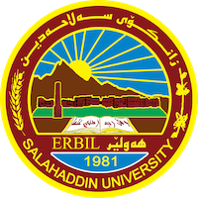

**Academic Curriculum Vitae**

**Personal Information:** 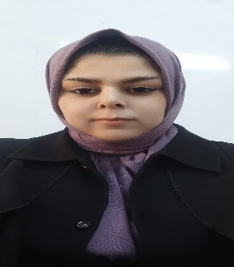

Full Name :Ala jalal ahmad

Academic Title: assistant lecture

Email: (university email) ala.ahmad@su.edu.krd

Mobile:07504971644

**Education:**

* Graduated biology in 2007
* Studied master degree in (2011 -2013)in medical bacteriology.

**Employment:**

* Biology department college of science university of salahaddin 2008.

**Qualifications**

* Academic staff in biology department
* Teaching first stage and fourth stage

**Teaching experience:**

* Stating undergraduate

**Research and publications**

**I have 2 published research**

1. **Accelerating Burn Wound Healing by Egg Yolk Oil Extracts Against Pseudomonas Aeruginosa**

**Biofilm infection.**

2. Effect of Methanol Extract and Crud Alkaloids of Cloves Syzygium Aromaticum on *Staphylococcus aureus* and *E coli* Isolated from vaginitis

**Conferences and courses attended**

* شةشةمين كونفرانسي سالانةى بيشبركيي زانستي (باشترين بوستةرى ئةكاديمي وبروزةى دةرجوون)

**Funding and academic awards**

* List any bursaries, scholarships, travel grants or other sources of funding that you were awarded for research projects or to attend meetings or conferences.

**Professional memberships**

* Kurdistan Biologists syndicate since 2008
* Kurdistan teachers union since 2010

**Professional Social Network Accounts:**

* https://www.researchgate.net/profile/Ala-Ahmad-3