Lab-3- Prepared by MSc.Ala J.Ahmad
acid–base titration
is a method of quantitative analysis for determining the concentration of an acid or base by exactly neutralizing it with a standard solution of base or acid having known concentration. A pH indicator is used to monitor the progress of the acid–base reaction. If the acid dissociation constant (pK_{a}) of the acid or base dissociation constant (pK_{b}) of base in the analyte solution is known, its solution concentration (molarity) can be determined. Alternately, the pK_{a} can be determined if the analyte solution has a known solution concentration by constructing a titration curve.

Alkalimetry and acidimetry
Alkalimetry and acidimetry are a kind of volumetric analysis in which the fundamental reaction is a neutralization reaction. Acidimetry is the specialized analytic use of acid-base titration to determine the concentration of a basic (synonymous to alkaline) substances using standard acid. Alkalimetry, is the same concept of specialized analytic acid-base titration, but for an acidic substance using standard base.

Indicator choice
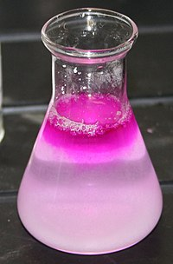
An acid–base titration using phenolphthalein as the indicator. The conical flask contained solution that just reached the endpoint.
A suitable pH indicator must be chosen in order to detect the end point of the titration. The colour change or other effect should occur close to the equivalence point of the reaction so that the experimenter can accurately determine when that point is reached. The pH of the equivalence point can be estimated using the following rules:
- A strong acid will react with a strong base to form a neutral (pH = 7) solution.
- A strong acid will react with a weak base to form an acidic (pH < 7) solution.
- A weak acid will react with a strong base to form a basic (pH > 7) solution.
When a weak acid reacts with a weak base, the equivalence point solution will be basic if the base is stronger and acidic if the acid is stronger. If both are of equal strength, then the equivalence pH will be neutral. However, weak acids are not often titrated against weak bases because the colour change shown with the indicator is often quick, and therefore very difficult for the observer to see the change of colour.
The point at which the indicator changes colour is called the end point. A suitable indicator should be chosen, preferably one that will experience a change in colour (an end point) close to the equivalence point of the reaction.

Mathematical analysis: titration of weak acid
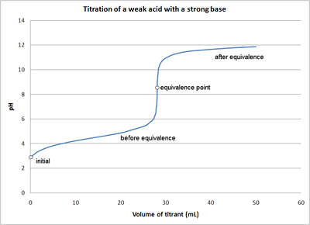
The pH of a weak acid solution being titrated with a strong base solution can be found at different points along the way. These points fall into one of four categories.
- initial pH
- pH before the equivalence point
- pH at the equivalence point
- pH after the equivalence point

