Lab 4: Biochemical and Molecular Bacterial Identification
- Biochemical Bacterial Identification using API kit
- API (Analytical Profile Index) is a test kit for the identification of Gram-positive and Gram-negative bacteria and yeast. The kit includes strips that contain up to 20 miniature biochemical tests which are all quick, safe and easy to perform for manual microorganism identification to the species level.
- There are different types of API tests, such as API 20E.
- Objective: To identify and differentiate members of the family Enterobacteriaceae.
- Principle: Detection of enzymatic activity, mostly related to the fermentation of carbohydrates or catabolism of proteins or amino acids by the inoculated organisms.
Test Requirements
- API 20E Test strip and related reagents like Kovac’s reagent, ferric chloride and 40 % KOH and α-Naphthol
- Growth of test organism (pure form i.e. pure isolated colonies)
- Oxidase reagent
- Distilled water, Pasteur pipette and Sterile oil and Marker
- API logbook
Procedures:
- Confirm the culture is Enterobacteriaceae. To test this, a quick oxidase test for cytochrome c oxidase may be performed.
- Pick a single isolated colony (from a pure culture) and make a suspension of it in sterile distilled water.
- Using a Pasteur pipette, fill up the biochemical Test Strip (up to the brim) with the bacterial suspension.
- Add sterile oil into the ADH, LDC, ODC, H2S and URE compartments.
- Put some drops of water in the tray, put the API Test strip, and close the tray.
- Mark the tray with the identification number (Patient ID or Organism ID), date, and initials.
- Incubate the tray at 37oC for 18 to 24 hours.
Result Interpretation
For some of the compartments, the colour change can be read straightway after 24 hrs but for others, reagents must be added to them before interpretation. (TDA: Put one drop of Ferric Chloride, IND: Put one drop of Kovacs reagent and VP: Put one drop of 40 % KOH (VP reagent 1) & One drop of VP Reagent 2 (α-Naphthol).
Get the API Reading Scale (color chart) by marking each test as positive or negative on the lid of the tray. The wells are marked off into triplets by black triangles, for which scores are allocated.
- Molecular Bacterial Identification:
Is the most appropriate technique for the identification of infectious agents that are difficult to detect, identify or test for susceptibility in a standard time with conventional methods. Every organism contains some unique, species-specific DNA sequence. Molecular diagnostics makes the species-specific DNA visible through single-gene sequencing (e.g., by sequencing ribosomal RNA encoding 16S, 23S, 18S, and ITS gene), multiple-gene sequencing (housekeeping and pathogenic genes), and whole-genome sequencing
- Molecular Biology Techniques
Two principal molecular techniques are used in the detection of microorganisms:
1- Nucleic acid probe-based methods.
2- Polymerase chain reaction (PCR).
- Conventional PCR
- Nested PCR
- Multiplex PCR
- Reverse- transcriptase PCR
- Real-time PCR
- Leading uses for nucleic–acid-based tests :
- Fastidious, slow-growing microorganisms: Mycobacterium tuberculosis
- Non-culturable agents (VBNC): Chlamydia trachomatis, and Rickettsia sp.
- Highly infectious agents that are dangerous to culture: Brucella species.
- In situ detection of infectious agent: Helicobacter pylori.
- Non-viable organisms: not alive or organisms tied up in immune complexes.
- Culture confirmation.
- Polymerase chain reaction (PCR)
PCR is a simple technique for in vitro amplification of specific DNA sequences via the temperature-mediated DNA polymerase enzyme by simultaneous primer extension of complementary strands of DNA.
The basis for PCR diagnostic applications in microbiology is the detection of infectious agents and the discrimination of non-pathogenic from pathogenic strains (e.g. E. coli) by virtue of specific genes.
Requirements of the PCR reaction:
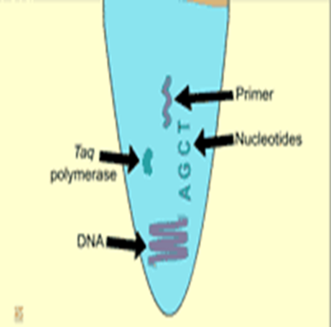
- Template DNA: previously extracted and purified.
- Two primers: to flank the target sequence.
- Four normal deoxynucleotides (dNTPs): provide energy and nucleosides for the synthesis of DNA.
- Buffer system containing magnesium.
- DNA polymerase (thermostable or heat-stable Taq polymerase isolated and purified from Thermus aquaticus, a bacterium that lives in hot springs).
- Thermal Cycling Profile for Standard PCR
Each cycle includes three successive steps:
- Denaturation: One to several minutes at 94-96 C°, during which the DNA is denatured into single strands.

- Annealing: One to several minutes at 50-65 C °, during which the primers hybridize or "anneal" (by way of hydrogen bonds) to their complementary sequences on either side of the target sequence; and

- Extension: One to several minutes at 72 C °, during which the polymerase binds and extends a complementary DNA strand from each primer.

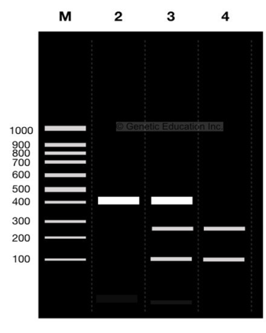
PCR Products
Following amplification, the PCR products are usually loaded into wells of an agarose gel and electrophoresed.

What are the advantages of using a molecular test?
- High sensitivity: Can detect the presence of a single organism.
- High specificity: Can detect specific genotypes, determine drug resistance and predict virulence traits.
- Speed: Quicker than traditional culturing.
- Simplicity: Some assays are now automated.

HW:
- Mention other types of API kit tests.
- What are the disadvantages of using a molecular test for bacterial identification?

