**Lab-5 Bacteriological Examination of Urine**

**Collection of urine specimens:**

* The first voided morning urine (the most common)
* Random urine (for emergency)
* Clean-catch, midstream urine (for urine culture)

**Attention:**

* Need to be examined within 1-2 hours.
* Bacteriological Examination of Urine **called General Urine Examination, consist of 3 parts:**
* Physical examination
* Chemical examination
* Microscopic examination

**Physical** **examination**

* Appearance
* Urine volume
* Specific gravity (SG)

**Appearance:** Including color and clarity

* Color: normally, pale to dark yellow (urochrome).

Abnormal color: some drugs cause color changes

1. red urine: causes: hematuria, hemoglobinuria and myoglobinuria

2. yellow-brown or green-brown urine: bilirubin, cause: obstructive jaundice or bacterial infection.

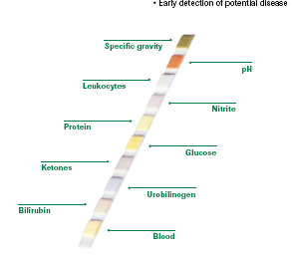

**Chemical examination**

**Urine dipsticks:**

* The entire strip is dipped in the urine sample and color changes in each square are noted. The color change takes place after several seconds to a few minutes from dipping the strip. If read too early or too long after the strip is dipped, the results may not be accurate.

[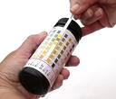](http://images.google.com.sa/imgres?imgurl=http://www.pulsetoday.co.uk/Pictures/web/b/k/p/urine_dipstick_testing_analysis__PPL.jpg&imgrefurl=http://www.pulsetoday.co.uk/story_attachment.asp?storycode=4122514&seq=1&type=P&c=1&usg=__rxYzcsVNkApdBuhZFuUvdj791JY=&h=399&w=466&sz=97&hl=ar&start=1&tbnid=9KwGKHQ0dIPzMM:&tbnh=110&tbnw=128&prev=/images?q=urine+analysis+dip+stick&gbv=2&hl=ar&safe=active&sa=G)

**Microscopic examination:**

* Microscopic urinalysis is done simply by pouring the urine sample into a test tube and centrifuging it for a few minutes. The top liquid part (the supernatant) is discarded. The solid part left in the bottom of the test tube (the urine sediment) is mixed with the remaining drop of urine in the test tube and one drop is analyzed under a microscope.

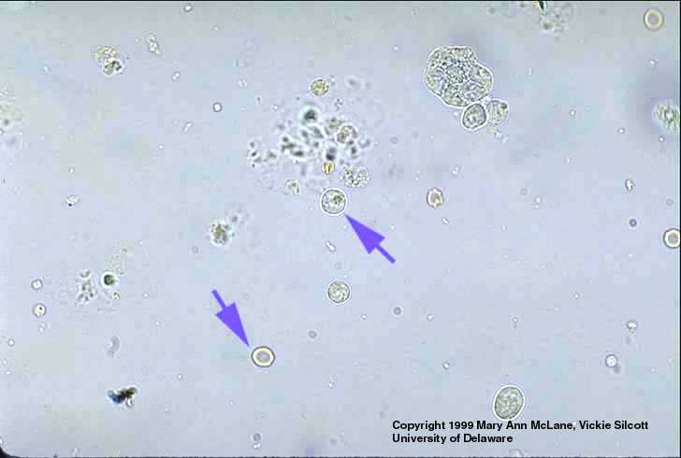**Contents of normal urine:**

* Contains few epithelial cells,
* Occasional RBCs, few crystals.

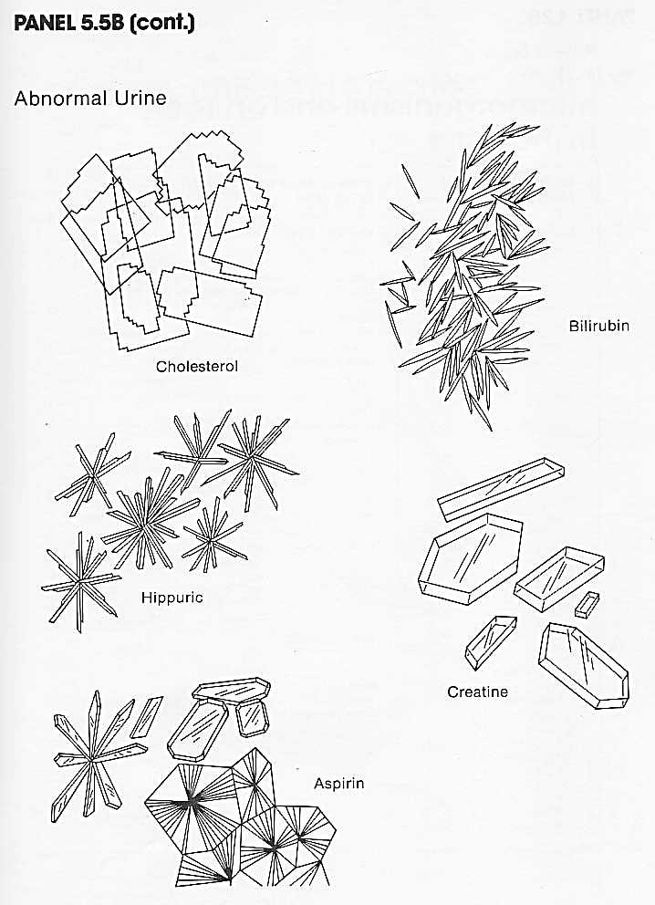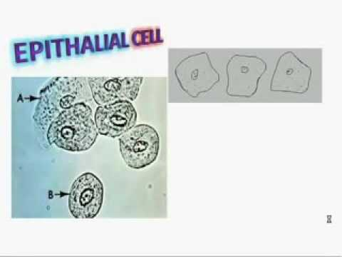

**Crystals in urine:**

Crystals in acidic urine

* Uric acid
* Calcium oxalate
* Cystine
* Leucine

Crystals in alkaline urine

* Ammonium magnesium phosphates

(triple phosphate crystals)

* Calcium carbonate

**Casts:**

Urinary casts are cylindrical aggregations of particles that form in the distal nephron, dislodge, and pass into the urine. In urinalysis, they indicate kidney disease.

**Types of casts:**

* Acellular casts

Hyaline casts

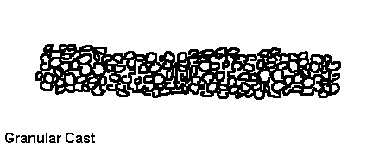

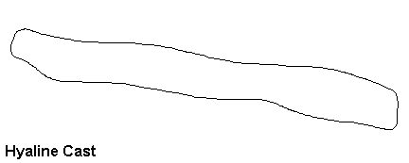

Granular casts

Waxy casts

Fatty casts

Pigment casts

Crystal casts

* Cellular casts

Red cell casts

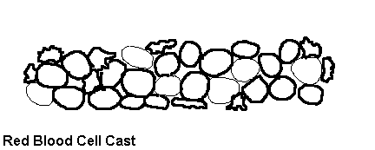

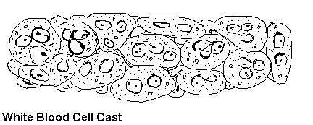

White cell casts

Epithelial cell cast

**Microbiological examination of urine:**

**Expected pathogens:**

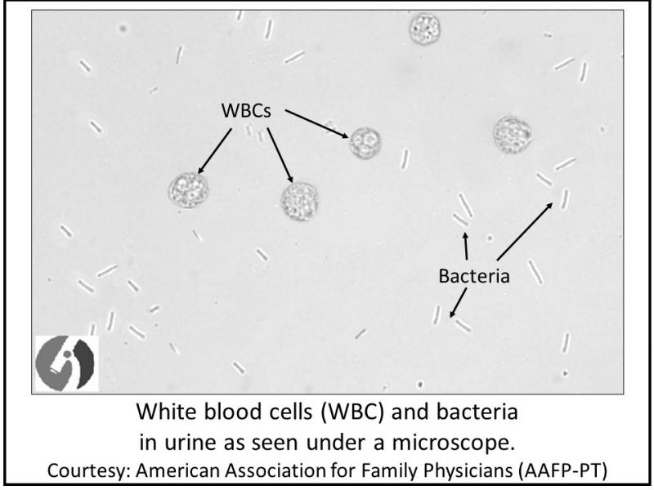*Candida albicans*

Enterococci

*Escherichia coli*

*Mycobacterium tuberculosis*

Other Enterobacteriaceae

Other staphylococci

*Pseudomonas* and other non-fermenters

*Staphylococcus saprophyticus*

**Media and diagnostic reagents:**

Isolation:

* Blood agar and MacConkey agar

**Identification media and diagnostic reagents:**

For **Gram-negative rods**:

* Kligler iron agar (KIA)
* Kovacs reagent for indole
* motility–indole–urease (MIU) medium
* oxidase reagent
* Simmons citrate agar

For **staphylococci and enterococci**

* catalase test (H2O2)
* coagulase plasma
* novobiocin (5mg) disc for differentiating negative-coagulase staphylococci

