Lab -1 - General chemistry( first stage ) Recrystallization MS.c. Ala Jalal
In chemistry, recrystallization is a technique used to purify chemicals. By dissolving both impurities and a compound in an appropriate solvent, either the desired compound or impurities can be removed from the solution, leaving the other behind. It is named for the crystalsoften formed when the compound precipitates out. Alternatively, recrystallization can refer to the natural growth of larger ice crystals at the expense of smaller ones.

Single-solvent recrystallization
Typically, the mixture of "compound A" and "impurity B" is dissolved in the smallest amount of hot solvent to fully dissolve the mixture, thus making a saturated solution. The solution is then allowed to cool. As the solution cools the solubility of compounds in solution drops. This results in the desired compound dropping (recrystallizing) from solution. The slower the rate of cooling, the bigger the crystals form.
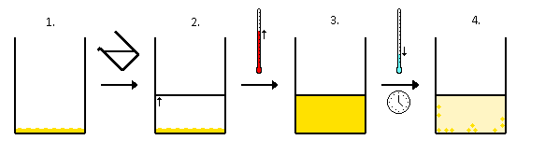
→ Solvent added (clear) to compound (orange) → Solvent heated to give saturated compound solution (orange) → Saturated compound solution (orange) allowed to cool over time to give crystals (orange) and a saturated solution (pale-orange).
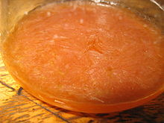
Crystallization of Ibuprofen in HCl(aq)
In an ideal situation the solubility product of the impurity, B, is not exceeded at any temperature. In that case the solid crystals will consist of pure A and all the impurity will remain in solution. The solid crystals are collected by filtration and the filtrate is discarded. If the solubility product of the impurity is exceeded, some of the impurity will co-precipitate. However, because of the relatively low concentration of the impurity, its concentration in the precipitated crystals will be less than its concentration in the original solid. Repeated recrystallization will result in an even purer crystalline precipitate. The purity is checked after each recrystallization by measuring the melting point, since impurities lower the melting point. NMR spectroscopy can also be used to check the level of impurity. Repeated recrystallization results in some loss of material because of the non-zero solubility of compound A.
The crystallization process requires an initiation step, such as the addition of a "seed" crystal. In the laboratory a minuscule fragment of glass, produced by scratching the side of the glass recrystallization vessel, may provide the nucleus on which crystals may grow. Successful recrystallization depends on finding the right solvent. This is usually a combination of prediction/experience and trial/error. The compounds must be more soluble at the higher temperature than at the lower temperatures. Any insoluble impurity is removed by the technique of hot filtration.

Multi-solvent recrystallization
This method is the same as the above but where two (or more) solvents are used. This relies on both "compound A" and "impurity B" being soluble in a first solvent. A second solvent is slowly added. Either "compound A" or "impurity B" will be insoluble in this solvent and precipitate, whilst the other of "compound A"/"impurity B" will remain in solution. Thus the proportion of first and second solvents is critical. Typically the second solvent is added slowly until one of the compounds begins to crystallize from solution and then the solution is cooled.

Hot filtration-recrystallization
Hot filtration] can be used to separate "compound A" from both "impurity B" and some "insoluble matter C". This technique normally uses a single-solvent system as described above. When both "compound A" and "impurity B" are dissolved in the minimum amount of hot solvent, the solution is filtered to remove "insoluble matter C". This matter may be anything from a third impurity compound to fragments of broken glass. For a successful procedure, one must ensure that the filtration apparatus is hot in order to stop the dissolved compounds crystallizing from solution during filtration, thus forming crystals on the filter paper or funnel.
One way to achieve this is to heat a conical flask containing a small amount of clean solvent on a hot plate. A filter funnel is rested on the mouth, and hot solvent vapors keep the stem warm. Jacketed filter funnels may also be used. The filter paper is preferably fluted, rather than folded into a quarter; this allows quicker filtration, thus less opportunity for the desired compound to cool and crystallize from the solution.
Often it is simpler to do the filtration and recrystallization as two independent and separate steps. That is dissolve "compound A" and "impurity B" in a suitable solvent at room temperature, filter (to remove insoluble compound/glass), remove the solvent and then recrystallize using any of the methods listed above.
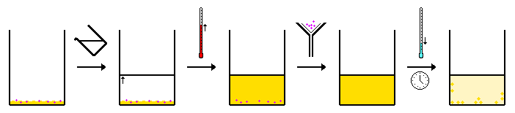
→ Solvent added (clear) to a mixture of compound (orange) + insoluble substance (purple) → Solvent heated to give saturated compound solution (orange) + insoluble substance (purple) → Saturated compound solution (orange) filtered to remove insoluble substance (purple) → Saturated compound solution (orange) allowed to cool over time to give crystals (orange) and a saturated solution (pale-orange).

References[
  - ^ Jump up to:ª ^{b} Laurence M. Harwood, Christopher J. Moody (1989). Experimental organic chemistry: Principles and Practice. Oxford: Blackwell Scientific Publications. pp. 127–132. ISBN 0-632-02017-2.
  - ^ Laurence M. Harwood, Christopher J. Moody (1989). Experimental organic chemistry: Principles and Practice. Oxford: Blackwell Scientific Publications. p. 74. ISBN

