Salahaddin University – Erbil Sub: Ornamental Birds College of Agricultural Engineering Sciences Stage: 4
Animal Resources Department Time:2 hour

Final Examination / 2nd Semester (2022- 2023)

Q1/ Fill in the blanks with correct words, numbers or sentences. (24Marks)
1- Ornithology is -----------------------------------------------------------------------------.
2- Ornamental birds account for -------- of the poultry population in the country were selected due to 1---------------------, 2--------------------- and 3--------------------.
3- ----------------- are well known for their ability to find their way back home from long distances and at high speed.
4- Hummingbird often brightly colored birds of the order--------and family---------.
5- Most toucan species lay about --------- eggs that are incubated for around -----days.
6- The adult gray partridge stands between -------cm tall and weighs between --grams.
Q2/ Answer the followings below. (25 Marks)
1- What are general characteristics of birds. (5 only).
2- What are the differences between Silkie and other chickens?
3- What are the Pheasants?
4- What are the uses or purpose of breeding: 1- Pigeons. 2- Pheasants.
5- Pigeons are unique in the avian kingdom. Why?
Q3/ Answer the following questions? (30 Marks)
1- Enumerate the Common species of Toucan bird with the scientific name for each species
2-Mention types of Parrots based on the size of they grow?
3-Mention Genus &all Species of Peafowl birds?
4-write only (5) characteristics about Humming birds?
5-Write the scientific classification of Gray Partridge?
6-Write only (5) general features of Parrots description?

Q4/ Write briefly the common and scientific name for each birds in the following pictures? (16 Marks)
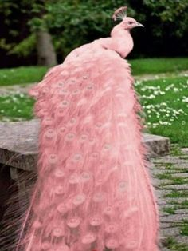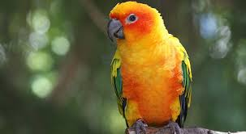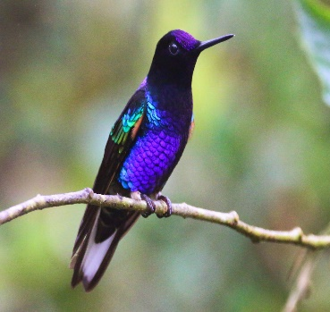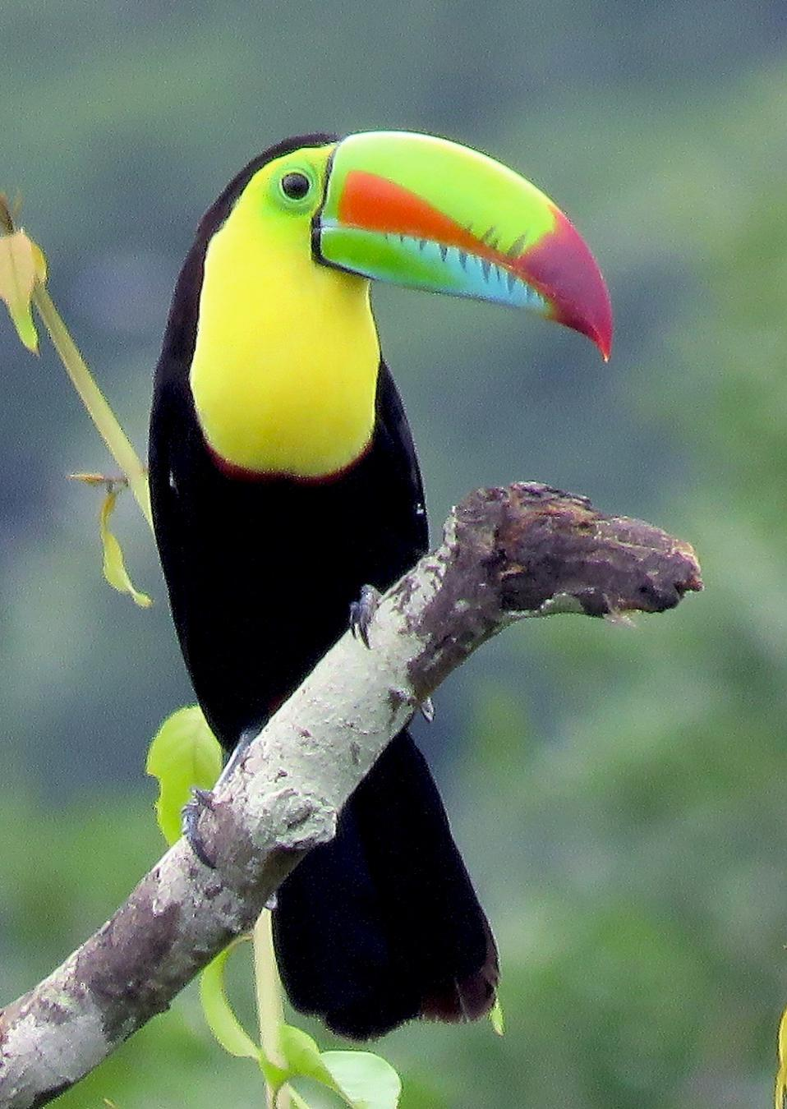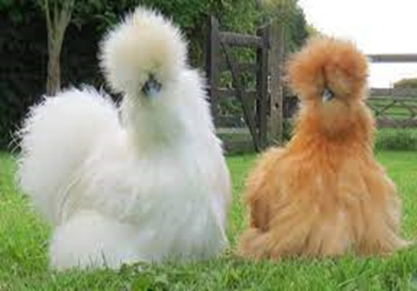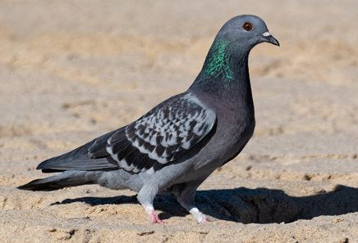

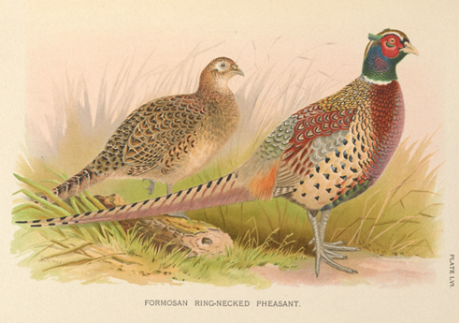

Lecturer Lecturer
Dr. Alaa ABDUL.Mustafa Dr. Bnar F. Sulaiman

