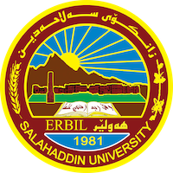
Academic Curriculum Vitae

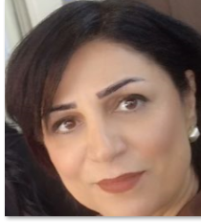p

Personal information:
Full Name: Alan Anwar Hasan
Academic Title: lecturer
Email: alan.hasan@su.edu.krd
Mobile: 07514142131

Education:
- diploma, Teacher training Institute , English Language Dept.,1993
- BA. University of Salahaddin, College of Education, English Language Dept., 2005
- MA. University of Salahaddin, College of Languages, Language and linguistics Dept., 2009

Employment:
- 1994 Teacher in primary school.
- 2006 Assistant Researcher, College of Education.
- 2010 Assistant Lecturer, College of Education.
- 2020 Lecturer, College of Education.

Qualifications

1-Primary school teacher / 1994-2001

2-Secondary school teacher / 2005-2006

3-Researcher at Salahaddin university, college of Education/ English language Dept./2006-0007
University teacher/2009 up to now
Languages
- Kurdish language
- Arabic language
- English language efficiency qualifications

Teaching experience:
- Under graduate students;
- Grammar - second year.
- Essay witting - second year
- English grammar - first year.
- scientific debates - first year.
- Communication - first year.
- Translation - second year . Arabic department
- Management- psychology department
- General English . first year mathematics departmental.
- phonetics - first year .
- Phonology - second year.
- English for university students- special education department
- English for university students- psychology and educational counseling.
- English for specific purposes . psychology and educational counseling.
- History of English language ,fourth year. department of English

- Research and publications
- Neutralization in English phonology: Journal of Tikrit University for Humanities. (2021) 28 (7) 72-60
- The Polysemy of “Head” in English and Kurdish: s for Babylon of University the of J. Vol. 29/ No. 4/ 2021
- An Analysis of Errors Made by Kurdish University Students in the English Consonant Clusters System. TISHK INTERNATIONAL UNIVERSITY.ERBIL, KURDISTAN REGION, IRAQ: ISBN 978-9922-9036-4-4
- Teaching Strategies Used in Vocabulary In “Communication” Course for.First year Students at Salahaddin University-Erbil:

Professional Social Network Accounts:
https://orcid.org/my-orcid?orcid=0009-0008-0138-4380
https://www.researchgate.net/signup.SignUp.
https://scholar.google.com/citations?hl=en&user=YypvuVkAAAAJ&view_op=list_works&sortby=pubdate&gmla=
https://www.goodreads.com/?ref=nav_home
http://119.13.111.19/profile-admin/index.php?p=dashboard

