Q? / Answer the following questions?
1. What do you mean by artificial, natural and phylogenetic system of plant classification? Give the outline of Bentham and Hooker plant classification. Mention its merit and demerits.
2. What is chemotaxonomy? Illustrate the role of different secondary metabolites in solving the systematic disputes of different taxa in angiosperms.
3. What do you mean by palynology?
4. What is phytochemistry? Discuss some important sources of taxonomic evidence derived from phytochemistry.

Q??? / 1- Difference between the natural system of plant classification and artificial system of classification is
(a) Considers only one vegetative character
(b) Considers all the similarities between plants
(c) Considers only one floral character
(d) All of the above
2- This system of classification was used by Linnaeus
(a) Phylogenetic system
(b) Natural system
(c) Artificial system
(d) Asexual system
3. Phenetic classification is based on
(a) Observable characteristics of existing entities
(b) The ancestral lineage of existing organisms
(c) Dendrograms based on DNA characteristics
(d) Sexual characteristics
4. The primary advantage of Bentham and Hookers classification is
(a) It is a system whose basis is on evolutionary concepts
(b) It is a natural system of classification of all plant groups
(c) Deemed to be the phylogenetic aspect as well
(d) The taxa description is based on the actual examination of the specimens
5. The reason why the system of plant classification proposed by Carolus Linnaeus was artificial is
(a) Because it considered the physiological facts along with the morphological traits.
(b) Because it was based on the similarities and differences in floral and other morphological characters only.
(c) Because it was on the basis of evolutionary relationships of plants
(d) None of these
6. Choose the right answer for the common characteristic in Plant taxonomy.
(a) Morphology
(b) Palynology
(c) All of the Above
(b) Anatomy

Q? / What is the different between?
- Phenetic and phylogenetic. (b) Decussate with Superposed.

Q? / Point to the following graphics with the types of leaves listed.
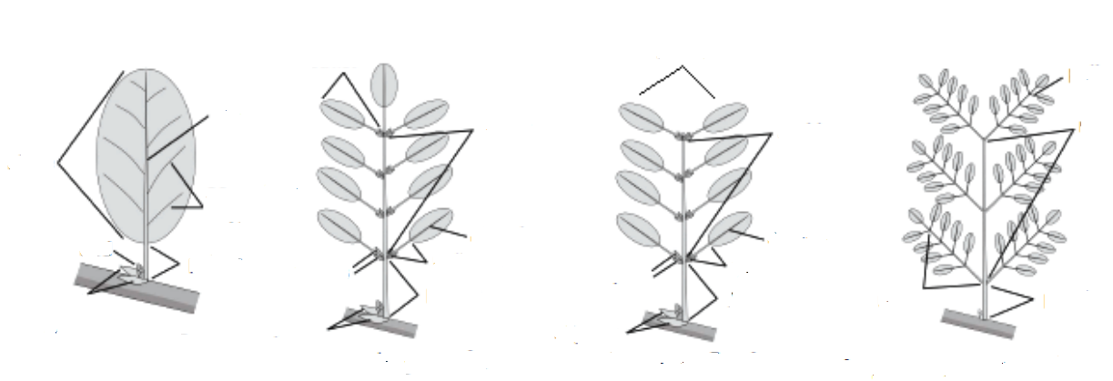

Q? / What are the various steps in the process of identification of plants?

