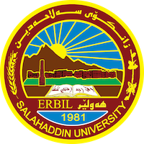
Academic Curriculum Vitae
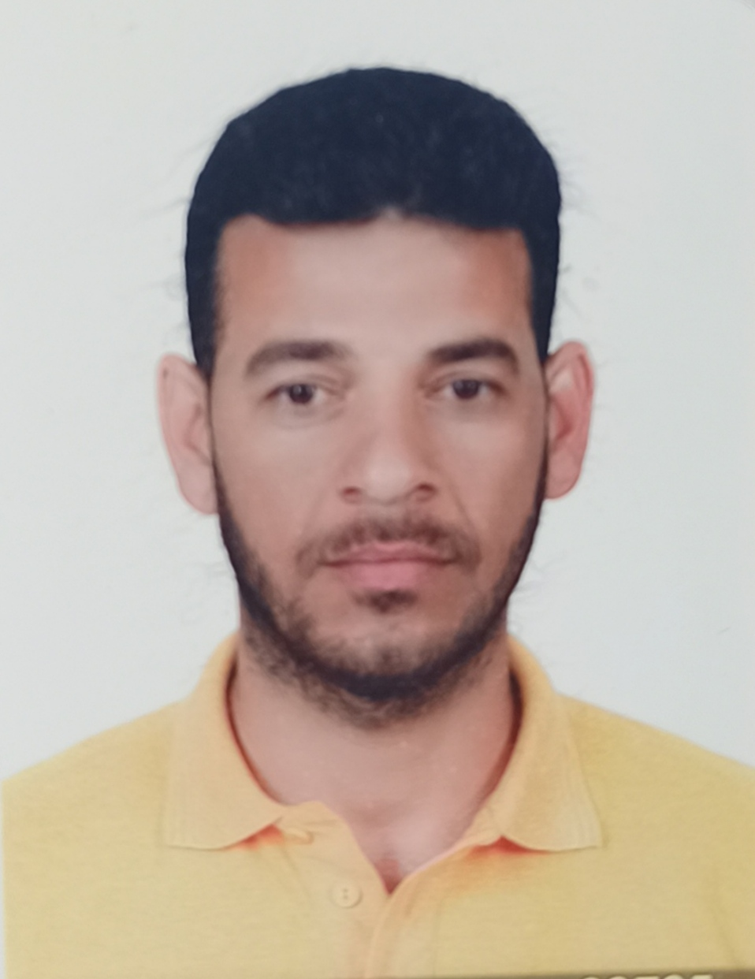
Personal Information:
Full Name: Ali Abdulwahed Mahmod
Academic Title: Assistant lecturer
Email: ali.mahmod@su.edu.krd
Mobile: 0750 484 2912

Education:
- 2001-2005 BSc. in Civil Engineering at Basrah University, Basrah, Iraq.
- 2014-2017 MSc. in Geomatics Engineering at Aksaray University, Aksaray, Turkey.
Employment:
- 2009-2014 as a civil engineer at civil engineering department-college of engineering-Salahaddin University (soil lab.).
- 2016-2020 as a civil engineer (with MSc. degree) at civil engineering department-college of engineering-Salahaddin University (surveying lab.).
- 2020 till now as an assistant lecturer at civil engineering department-college of engineering-Salahaddin University.
Qualifications
Teaching qualifications
2016-2017
1. Surveying engineering (theory and practical), 3rd stage, architecture engineering students.
2. Surveying engineering (practical), 2nd stage, civil engineering students.
2017-2018, 2018-2019, 2019, 2020
Surveying engineering (practical), 2nd stage, civil engineering students.
2020-2021
1. Surveying engineering (practical), 2nd stage, civil engineering students.
2. Geology engineering, 1st stage, civil engineering students.
2021-2022
1. Surveying engineering (practical), 2nd stage, civil engineering students.
2. Geology engineering, 1st stage, civil engineering students.
2022-2023
Surveying engineering (practical), 2nd stage, civil engineering students.
IT qualifications
- Microsoft office.
- Auto CAD, civil 3d.
- GIS, remote sensing, photogrammetry software.
- Many application and programs on mobile and computer.

Language qualifications
Arabic, Kurdish, English (IELTS)

Teaching experience:
- State all teaching courses you delivered, stating undergraduate or post graduate
- Courses, trainings, lab supervision, etc.,

