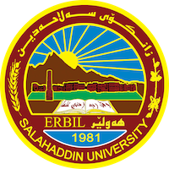
Academic Curriculum Vitae

Personal Information: 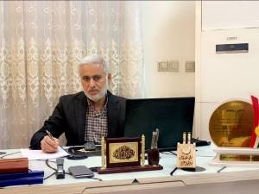
Full Name: Ali Ramadhan Yousif
Academic Title: Professor
Email: (university email): ali.yousif@su.edu.krd
Mobile: 07504661557

Education:
- State all educations accomplished
- PhD in structural engineering, University of Salahaddin, 2006
- MSc in structural engineering, University of Mosul, 1986
- BSc in civil engineering, University of Mosul, 1983

Employment:
- State employment starting from first employment:
- University of Tikrit, 15-3-1988-1994
- University of Salahaddin, 1994 till now.

Qualifications
- Teaching qualifications: from my start employment in 1988 till now.
- IT qualifications: Softwares like
- Language qualifications such as TOEFL, IELTS or any equivalent
- Any professional qualification
- You could put any professional courses you have attended

Teaching experience:
- State all teaching courses you delivered, stating undergraduate or post graduate
- Courses, trainings, lab supervision, etc.,:
- Teaching the following subjects: Structural analysis, Mechanics of materials, reinforced concrete (3rd year and 4th year), engineering analysis, civil drawings, engineering drawing, advanced structural analysis(MSc student), design with frp materials (PhD students), advanced mathematics and numerical analysis (PhD student).

Research and publications
- State all researches, publication you made.
- 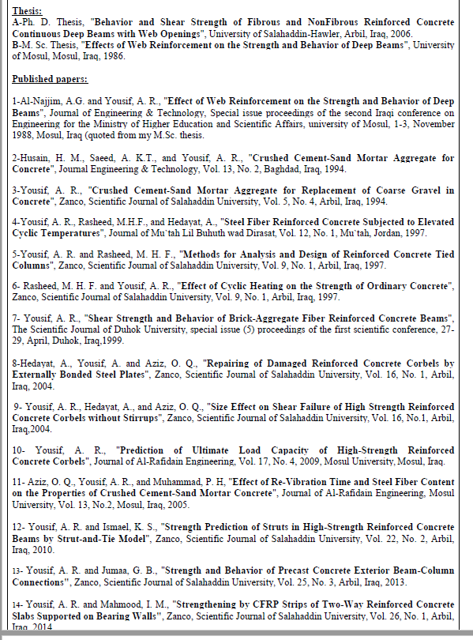

24-Mohammed M. Saleh, Dilshad K. Ahmed, Ali R. Yousef, “The comparative study of biaxial bending analysis of steel sections using AISC and Eurocode approaches”, CUESJ, 4 (2), 2020, pp. 25-32.
25- Mariwan - Mirhaj Mohamed Salih and Ali Ramadhan Yousif, “Torsional Behavior of Trapezoidal and Rectangular Concrete Box-Girders Reinforced with BFRP Bars and Steel Stirrups –An Experimental Study”, Journal of Hunan University Natural Sciences,Vol. 48 No. 10 October 2021, pp 89-101.
26- Mariwan Mirhaj Mohamed-Salih and Ali Ramadhan Yousif, “Effect of Reinforcement Type, Diaphragms, and Hollow Core on the Torsional Capacity of HSC Box-Girders under Torsion, Shear, and Bending”, Journal of Hunan University Natural Sciences,Vol. 48 No. 10 October 2021, pp 356-368.
27- Mariwan Mirhaj Mohamedsalih and Ali Ramadhan Yousif, “Experimental study on torsional behavior of thin- and thick-walled RC box-girders using BFRP bars and steel stirrups under combined torsion-shear-moment”, Elsevier-Structures, (36), 2022, pp 549-564.
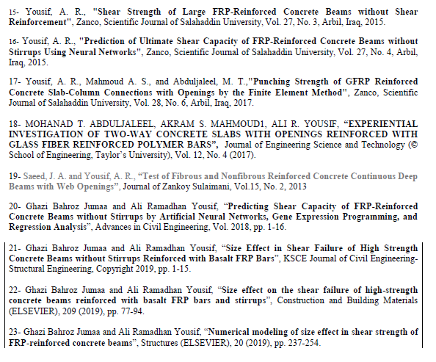
24-Mohammed M. Saleh, Dilshad K. Ahmed, Ali R. Yousef, “The comparative study of biaxial bending analysis of steel sections using AISC and Eurocode approaches”, CUESJ, 4 (2), 2020, pp. 25-32.
25- Mariwan - Mirhaj Mohamed Salih and Ali Ramadhan Yousif, “Torsional Behavior of Trapezoidal and Rectangular Concrete Box-Girders Reinforced with BFRP Bars and Steel Stirrups –An Experimental Study”, Journal of Hunan University Natural Sciences,Vol. 48 No. 10 October 2021, pp 89-101.
26- Mariwan Mirhaj Mohamed-Salih and Ali Ramadhan Yousif, “Effect of Reinforcement Type, Diaphragms, and Hollow Core on the Torsional Capacity of HSC Box-Girders under Torsion, Shear, and Bending”, Journal of Hunan University Natural Sciences,Vol. 48 No. 10 October 2021, pp 356-368.
27- Mariwan Mirhaj Mohamedsalih and Ali Ramadhan Yousif, “Experimental study on torsional behavior of thin- and thick-walled RC box-girders using BFRP bars and steel stirrups under combined torsion-shear-moment”, Elsevier-Structures, (36), 2022, pp 549-564.

Conferences and courses attended
- Give details of any conferences you have attended, and those at which you have presented delivered poster presentations.

Funding and academic awards
- List any bursaries, scholarships, travel grants or other sources of funding that you were awarded for research projects or to attend meetings or conferences.

Professional memberships
- List any membership you hold of any professional body or learned society relevant to your research or other life activities.
- Kurdistan Engineers Union
- Kurdistan teachers Union

Professional Social Network Accounts:

- List your profile links of ReserchGate, LinkedIn, etc.

It is also recommended to create an academic cover letter for your CV, for further information about the cover letter, please visit below link:
https://career-advice.jobs.ac.uk/cv-and-cover-letter-advice/academic-cover-letter/

