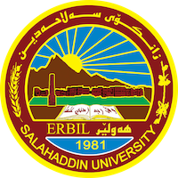
Academic Curriculum Vitae

Personal Information:
Full Name: Amanj Ali Qadir
Academic Title: Assist Lecturer
Email: amanj.qadir@su.edu.krd
Mobile:

Education:
- BA in Law, Salahaddin University-Erbil 2008
- LLM Master in International Law, Nottingham University, UK 2013

Employment:
- Assist Researcher, College of Law, Salahaddin University-Erbil 2009
- Assist Lecturer, College of Law, Salahaddin University-Erbil 2014

Qualifications
- Teaching qualifications
- IT & MS
- Language: Kurdish, Arabic, English and Persian

Teaching experience:
- Teaching courses:
Academic English, Administrative Law, Legal Terminology and General English and Teaching Methods

Professional Social Network Accounts:

- Research Gate: https://www.researchgate.net/profile/Amanj_Ali_Qadir
- LinkedIn: https://www.linkedin.com/in/amanj-a-qadir-2ab03239/
- Google Scholar: https://scholar.google.com/citations?user=qPTupKIAAAAJ&hl=en

