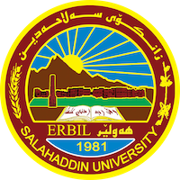
Academic Curriculum Vitae

Personal Information:
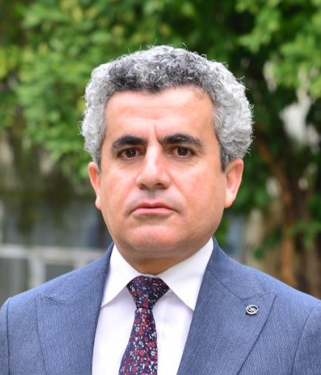
Full Name: Ameer S. Muhammed
Academic Title: Assistant Professor
Email: ameer. muhammed@su.edu.krd
Mobile: 009647504492413

Education:
1996 – 2000 B.Sc degree in Economics, Salahaddin University.
2003 – 2007 M.Sc degree in Economics, Salahaddin University.
2015 – 2019 PhD in Economics (Fiscal Policy), Salahaddin University.

Employment:
2004 – 2009 Economic page supervisor, Khabat daily Newspaper.
2008 – 2009 Postpaid Department Executive, Korektel Company for Communication.
2007 – 2019 Assistant Lecturer, College of Administration & Economics, Salahaddin University.
2012 – 2013 Director of Administration and Finance, KO-ART Company
2013 – 2014 Director of Administration and Finance, EMC Company
2019 – 2020 Lecturer, College of Administration & Economics, Salahaddin University.
2020 – Now Head of Finance and Banking Department, College of Administration & Economics, Salahaddin University.

Qualifications:
Since 2008 I taught different theoretical lectures to undergraduate students in each Economics as well as Banking and Finance Departments in Administration and Economics College.
IT qualifications such as Word Microsoft, Excel, Access, PowerPoint, SPSS, and EViews.
Language qualifications such as IELTS, language center- Salahuddin University certificate.

Teaching experience:
I taught different theoretical lectures such as money and banking, econometrics, mathematic economics, international finance, public finance, and microfinance.

Research and publications:
- ڕۆلی تۆڕی کۆمەڵایەتییەکان لە برەودان بە بەرهەمە خۆماڵییەکان تۆێژینەوەیەکی مەیدانییە بە وەرگرتنی بژاردەیەک لە بەکارهێنەرانی تۆڕی کۆمەڵایەتییەکان لە شاری هەولێر بۆ ساڵی 2022، گۆڤاری زانکۆ بۆ زانستە مرۆاڤایەتییەکان )پەسەندی بڵاوکردنەوە).
- دور إتقان اللغات في إيجاد فرص العمل في مدينة أربيل في عام 2022: قطاع الفنادق أنموذجاً، المجلة العراقية للعلوم الاقتصادية (قبول نشر).

Conferences and courses attended:
I attended Salahaddin University Language Center course.

Funding and academic awards:
- List any bursaries, scholarships, travel grants, or other sources of funding that you were awarded for research projects or to attend meetings or conferences.

Professional memberships:
Kurdistan Teachers Union
Kurdistan Economist Syndicate2011

Professional Social Network Accounts:
ResearchGate
LinkedIn
Google Scholar
ORCID
Facebook

https://account.jobs.ac.uk/your-account/account-settings

