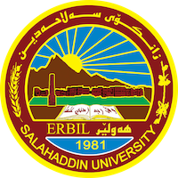
Academic Curriculum Vitae
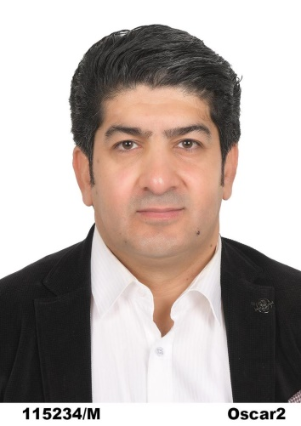
Personal Information: Name:Amer Msto Muhamad
Academic Title: lecture
Email: amer.muhammed@su.edu.krd
Mobile: 07504560456
Education:
Bachelor’s degree in Salahaddin University, College of Arts (kurdish Department) in 2001ــ2002
Master degree in University of salahaddin, College of Arts (Kurdish langauge)20-12-2009(pronoun in northern Kurmanji Dialect According to Government and Binding Theory)
PHD degree in Urmia University, Faculty of literature and humanities (دانشکدە ادبیات وعلوم انسانی) ــ ( گروە زبان وادبیات فارسی)
عنوان رسالة دكتراه: (بررسى مقايسه اى قيد در زبان هاى فارسى وكردى)
Employment:
In 2004/5/24 I was hired in Salahaddin University, College of Arts as a teaching assistant
Now I am teaching in College of Arts (Archaeology Department)

Qualifications
- Teaching qualifications
- IT qualifications: I am skilled at using computers
- Language qualifications : Persian language-Turkish language
- Any professional qualification:

Teaching experience:
)Kurdology ((کوردناسی گشتی
Research and publications:
-گۆڕان لە زماندا (بڵاوکراوە لە گۆڤاری ئەکادیمیا)
لێڵی و کاریگەری لەسەر تێگەیشتن (بڵاوکراوە لە گۆڤاری ئەکادیمیا)-
- بةراوردي ريَزماني جيَناو لة نيَوان زماني كوردي و زماني سؤمةريدا
کاربست های قیود اخلاقی در ادبیات کردی و فارسی(انجمن معارف اسلامى ايران)

Conferences and courses attended
- کۆنفرانسی پرسی ئینتیما و گرفتەکانی نیشتمانسازی لە هەرێمی کوردستان
- کۆنفرانسی شوينەوار و کەلەپوری هەولێر
- کۆنفرانسی هەولێر لە سەرچاوە ميژوویەکاندا
کۆنفرانسی جینۆسایدی گەلی کورد(جینۆسایدی فەیلیەکان)-
Funding and academic awards
- List any bursaries, scholarships, travel grants or other sources of funding that you were awarded for research projects or to attend meetings or conferences.

Professional memberships
- Member of the teachers union.
Professional Social Network Accounts:
- Research gate: https://www.researchgate.net/profile/Amer-Muhammed
- Gool Scholar:https://scholar.google.com/
- Twitter: https://twitter.com/amermuhammed7
- Linkedin:https://www.linkedin.com/in/amer-msto-muhammed-b5562a278/
- Email:amer.muhammed@su.edu.krd
- Facebook: https://www.facebook.com/ameer.mustefa
- Instagram: https://www.instagram.com/ameer_mustefa/

It is also recommended to create an academic cover letter for your CV, for further information about the cover letter, please visit below link:
https://career-advice.jobs.ac.uk/cv-and-cover-letter-advice/academic-cover-letter/

