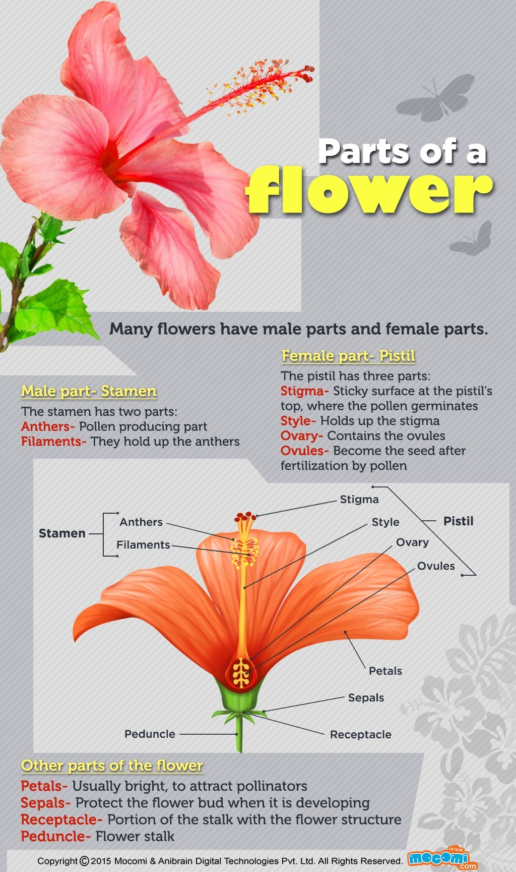
Many flowers have male parts and female parts.
Male part – Stamen
The stamen has two parts
- Anthers – Pollen producing part
- Filaments – They hold up the anthers
Female part – Pistil
The pistil has three parts
- Stigma – Sticky surface at the pistil’s top, where the pollen germinates
- Style – Holds up the stigma
- Ovary – Contains the ovules
- Ovules – Become the seed after fertilization by pollen
Other Parts of the Flower
- Petals – Usually bright, to attract pollinators
- Sepals – Protect the flower bud when it is developing
- Receptacle – Portion of the stalk with the flower structure
- Peduncle – Flower stalk
Learn more about the different Parts of a Flower and their Functions.
- What are the parts of the flower and their functions?
- What are the accessory parts of a flower?
- What are the external parts of a flower?
- What are the main parts of a plant's circulatory system?
- What are the reproductive and accessory parts of a flower?
Ask New Question

The 4 main part of flower are; pistil(It is the male part of the flower that produces pollen), petal(Used to attract insects to the flower. They usually give off an odor.), stem(Gives the flower support and supplies it with water and nutrients from the soil.) and stamen(The female part of the flower that helps the plant with reproduction.)
Parts of a Typical Flower : A flower consists of an axis known as thalamus, on which four different sets or whorls of floral members are inserted viz.
(a) Outermost, i.e., first accessory whorl of sepals = Calyx square..
(b) Above the calyx, the second accessory whorl of petals = Corolla square
(c) Above the corolla, first essential whorl of stamens = Androecium.
(d) Next above, second essential whorl of carpels = Gynoecium or Pistil.
THALAMUS-The thalamus or axis or torus is the direct prolongation of the pedicel and bears four whorls of floral members. Thalamus is also known as receptacle which is often short and suppressed, usually convex or concave. Sometimes it is long, showing distinct internodes or it may be dilated into flat or concave structure. Sometimes thalamus presents certain modifications of forms as various outgrowths which are seen between floral whorls ; such modification of the thalamus is known as disc. In case of Artabotrys somewhat elongated and conical thalamus noted bearing spirally arranged floral leaves.
CALYX-It forms the outermost envelope of the floral whorl and is the first accessory members, its respective leaves are called sepals which may remain free or united--the former is known as polysepalous calyx, the latter as gamosepalous calyx. Sepals are mostly green and are always sessile. The number of sepals in a calyx whorl may vary from one to many.
COROLLA-It is the second accessory member of the floral whorl. Its constituent leaves are known as petals, which are delicate and coloured or white, rarely greenish. Petal may be free or united forming polypetalous or gamopetalous corolla respectively. The petal may be sometimes stalked, the stalk of petal is called claw ; the expanded portion of the petal is called limb. The number of petals in a corolla varies from one to many. Above mentioned two whorls (calyx and corolla) are termed accessory whorls.
ANDROECIUM-The third member and the first essential whorl is the androecium ; its individual members are known as stamens. In an androecium, the number of stamens may be one to many. The stamens may remain free or variously united or attached to other whorls. A stamen has a slender stalk called filament, which bears at its tip anther lobes (microsporangia) containing pollen grains i.e. microspores. The filament may be short, slender or flat, or in some cases absent-then the stamen is called sessile.
GYNOECIUM OR PISTIL-It is the topmost or centrally placed floral member and forms the second essential whorl ; its individual members are known as camels. In a gynoecium the number of carpel varies from one to many. The gynoecium consists of a swollen basal structure-the ovary, the long filiform structure called style and the knobed tip of the style called stigma. The carpels may remain free or united, the former is known as apocarpous gynoecium, the latter as syncarpous gynoecium.
Read also-Parts of a Flower and their Functions -digieduco
1.1k Views
Ananda Sagan, works at University of Kansas
Answered Aug 5, 2015 · Author has 486 answers and 662.8k answer views
If I had to pick the 4 main features of flowers, I'd say pistil (female part), stamen (male part), petals (colorful part) and sepals (modified leaves that protect the developing flower bud). The pistil is made up of stigma, style and ovary. The stamen consists of filament and anther. Petals may be numerous, few or even absent. Sepals are usually green but in some species are colored similarly to the petals.
Image from
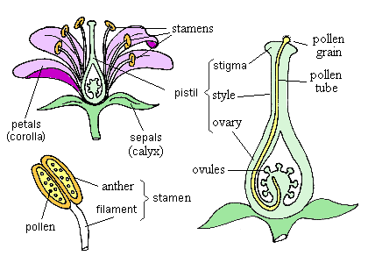

Related Questions
- What are the different parts of a brassica flower?
- What are the main parts of a root?
- What is the most attractive part of a flower?
- How can you describe the essential parts of a flower?
- What are the 3 main parts of a plant cell?
- Can you think of any four uses of flowers?
- What part of the flower is the style?
- Which part of the flower change into fruit?
- Which part of a plant is involved in the formation of fruit and seed?
- What are the four main parts of a plant?
- Is it necessary that the aestivation of the corolla and the calyx of the same flower have to be same?
- Which part of the flower forms the fruit?
- What are the parts and purposes of each parts of a flower?
- What flowers can survive indoors through winter in the Netherlands? Most Dutch people have cacti/succulents, but I'd love to keep the home war...
- What kind of flower smells the best?

What are the accessory parts of a flower?

As the reproductive part of the plant the flower contains the male pollen and/or the female ovule plus accessory parts such as petals, sepals, and nectar glands. The pistil is the female part of the plant.

It is generally shaped like a bowling pin and located in the center of the flower.

Flowers
A flower is the reproductive part of a plant. It is the most attractive part of the plant. Different parts of a flower include sepals, petals, stamens and pistil. Parts of a flower can be grouped into two categories namely, accessory whorls and essential whorls.
- Accessory whorls are also called as vegetative whorls which include sepals and petals.
- Essential whorls are also called as reproductive whorls which include stamens and pistil.
Complete and incomplete flowers
A flower can be complete or incomplete based on the number of whorls present in it.
- Complete flowers are the flowers which possess all the four whorls on it.
- Incomplete whorls are the whorls which do not possess any one or more of the four whorls.
Uni sexual and bisexual flowers
Flowers can be uni sexual or bisexual based on the reproductive structures present in it.
- Uni sexual flowers are the flowers which have either one of the reproductive structure i.e. either the stamen, male reproductive structure or the pistil, female reproductive structure. Flower is termed to be a male flower if it has only stamens. It is termed to be female flower if it has only pistil.
- Bisexual flowers are the flowers which have both male and female reproductive structures, stamens and pistil in them. Bisexual flowers are also called as hermaphrodite flowers.
Sepals
These are hard, leaf-like structures around the base of a flower.
- They protect the bud before it blooms into a flower.
- These are green in colour in most of the plants.
- The sepals are collectively called as calyx.
- The number of sepals varies from plant to plant.
Petals
These are brightly coloured portions of a flower.
- They petals are collectively called as corolla.
- They are brightly coloured so as to attract insects and birds for pollination.
- The number of petals is almost equal to the number of sepals in a flower.
- In some flowers, the petals and sepals combine to form a round structure called as tepal.
Stamens
The stamens are the male reproductive parts of a flower. Stamen is made up of a filament and anther.
- Anther is a bilobed structure at the tip of the filament.
- Anther contains male reproductive cells, the pollen grains.
- Pollen grains are the male reproductive cells which are very light, that they can be carried away by wind.
- Pollen grain has a thick covering made up of two layers, outer exine and inner intine.
Pistil
The pistil is the female reproductive part of a flower. It is made up of the stigma, the style and the ovary.
- Stigma is a bulged sticky structure at the tip of the pistil. As it is sticky it receives pollen grains from the male reproductive structure.
- Style is a long tube like structure which allows pollen grain to travel from stigma to ovule, the egg cell.
- Ovary is a large lobed structure at the base of the carpel. It contains the female reproductive cells, the ovules. The number and arrangement of ovules differ in different flowering plants.

