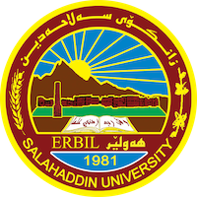
Academic Curriculum Vitae
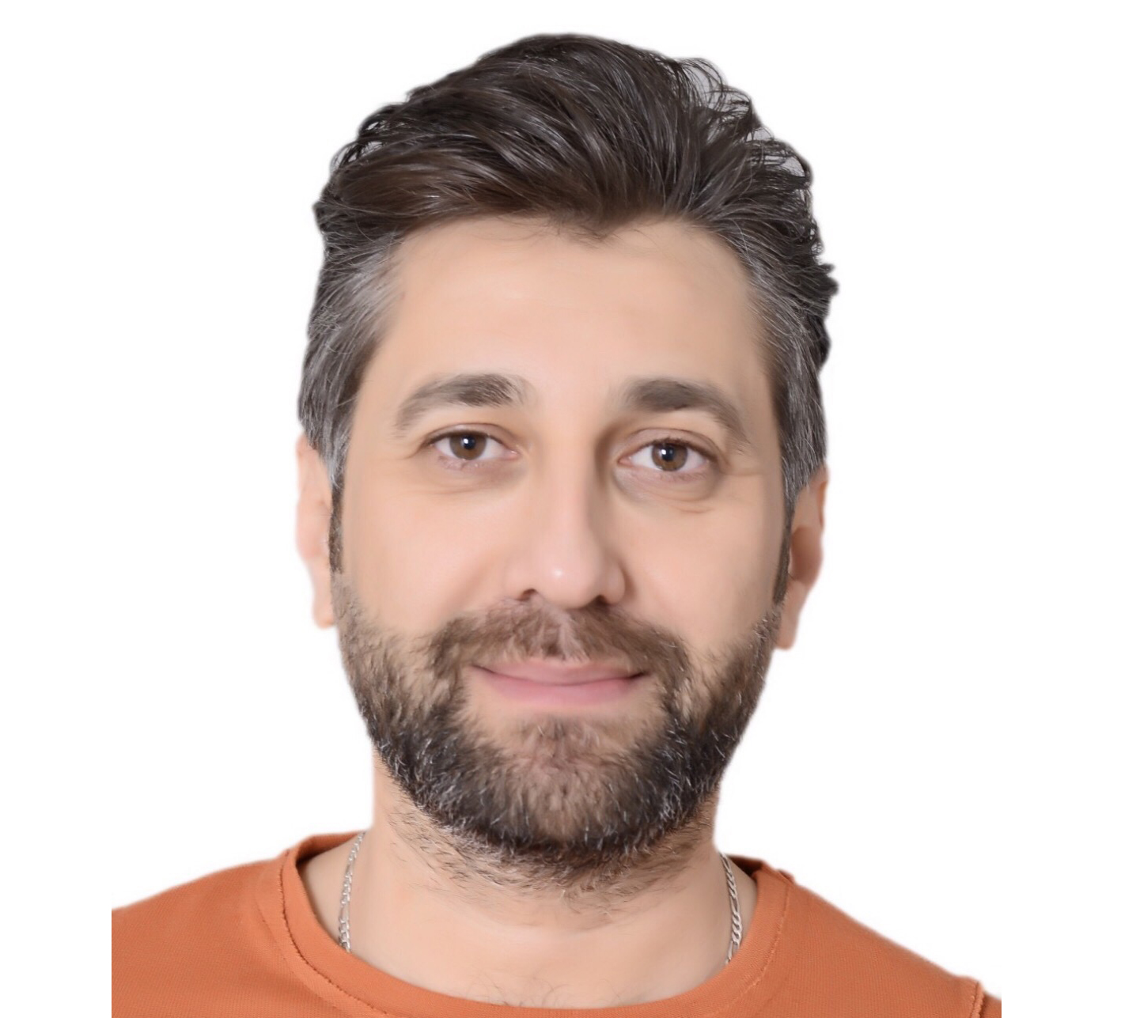
Personal Information:
Full Name: Aram Naser Abdullah
Academic Title: Assistant Lecturer
Email: (aram.abdullah@su.edu.krd)
Mobile: 009647504488684

Education:
Sept 2001 - October 2006 Fine Art Institute/Erbil (Fine Art, Diploma in sculpture)
Sept 2006 - October 2010 Salahaddin University- College of Fine Art/Erbil (Fine Art, Bachelor of sculpture)
Sept 2013 - October 2014 Université de Strasbourg,UFR, Arts, (Arts visuels).
Sept 2014 - Sept 2016 École pratique des hautes études(EPHE) (MA, History of art, Archéologie )

Employment:
- Salahaddin University – College of Fine Arts, Plastic Arts Department

Qualifications
- 2011-2012 Université de Grenoble, faculté de lettres, enseignement de FLE.
- 2017 Teaching Methods Course, Salahaddin University

Teaching experience:
• Salahaddin University\ College of Fine Arts, Erbil (Academic Staff) Courses; Drawing ,Sculpture Project,Composition, history of art, Monument.
Professional Social Network Accounts:

- ReserchGate

