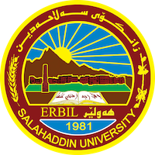
Academic Curriculum Vitae
Personal Information:
Full Name: Aram Abubaker Hamadameen
Academic Title: Assistant lecturer
Email: (aram.hamadameen@su.edu.krd)
Mobile:07504962342
Education:
- Bachelor degree at historical department { salahadin university college of arts} in 2010
- Master of history in modern and contemporary history { salahadin university college of arts} in 2016
Employment:
- Sallahadin university college of arts
Qualifications
- Word , excel ,access, power point.
- Ihave 4 in IELTS xaminaton, and language English certificate, Computer certificate .
Teaching experience:
- I teached in first stage, second stage and third stage of college of arts in salahaddin uneversity.

Research and publications

Conferences and courses attended
- I attended of conference about Erbil in Historcal Sources – Read and evaluate 2019/4/ 10 – 11 . 3rd Student Research Projects & Idea Grant Conference, 2nd February 2023

Professional memberships
- I membership in komallay mezhunusan. IFAD group.

Professional Social Network Accounts:

https://scholar.google.com/citations?hl=en&user=9tjhlxIAAAAJ

