Academic Curriculum Vitae

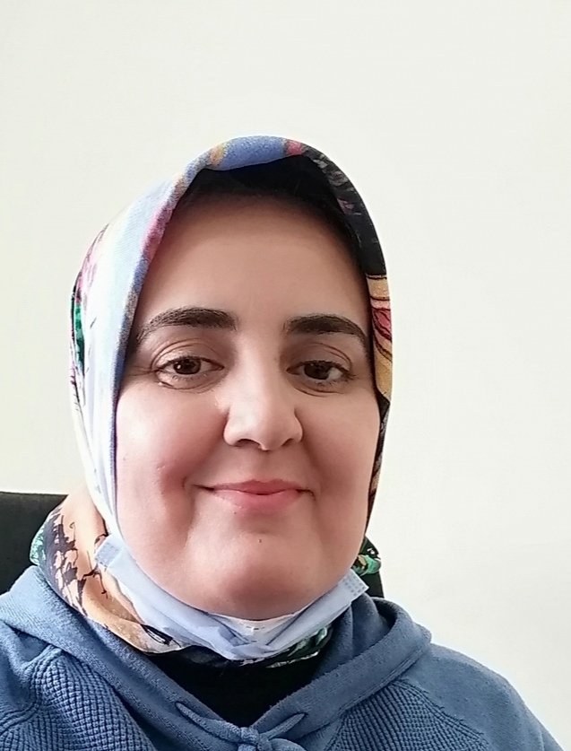
Personal Information:
Full Name: Dr. Aras Muhammed Khudhur
Academic Title: Assistant Professor
Email: (university email): aras.khudhur@su.edu.krd
Mobile: 07504631754

Education:
Degrees | Department | University | Country | Date of Completion
BSc | Biology | Salahaddin | Iraq | 1997
Diploma
MSc | Biology | Salahaddin | Kurdistan Region/ Iraq | 2006
PhD | Soil and Water | Salahaddin | Kurdistan Region/ Iraq | 2011

Employment:
Year | Department | Collage | University
1998 | Plant Production | Agriculture Engineering Sciences | Salahaddin University
2004 | Plant Protection | Agriculture Engineering Sciences | Assistant Lecture Salahaddin University
2010 | Plant Protection | Agriculture Engineering Sciences | Lecturer  Salahaddin University
2019 | Plant Protection | Agricultural Engineering Sciences | Assistant Professor

Teaching experience:
Stage | Department | Course Teaching | No.
2nd Stage | Soil and Water | General Microbiology
2nd Stage | Soil and Water | Soil Microbiology
Msc. Student | Postgraduate | Biofertilizer

Research and publications
No | Research Title
 | Effects Of The Transconjugant Pseudomonas Fluorescens Carrying 1-Aminocyclopropane-1-Carboxylate Deaminase Gene On Drought Tolerance Of Wheat
 | Chromosomal nif Genes Transfer by Conjugation in Nitrogen Fixing Azotobacter chroococcum to Lactobacillus plantarium
 | Transferring of Exopolysaccharide (EPS) Gene Cluster from Rhizobium leguminosarum to Pseudomonas fluorescens by Horizontal Gene Transfer Techniques
 | Prospects of Potassium and Phosphate Solubilizing Bacteria for Nodulation Enhancement, growth and yield of Chickpea plant (Cicer arientinum L.)
 | PASSAGE OF WHEAT FIRE IMPACT ON SOIL PROPERTIES AND ENVIRONMENT IN KURDISTAN REGION
 | EFFECT OF SOME PESTICIDES ON 1-AMINOCYCLOPROPANE-1- CARBOXYLATE (ACC) DEAMINASE BIOSYNTHESIS GENE OF DROUGHT RESISTANCE PSEUDOMONAS PUTIDA AND TRANSCONJUGANT PSEUDOMONAS FLUORESCENS
 | The combined Application of Iron and Phosphate Solubilizing Bacteria to enhance Wheat (Triticum aestivum L.) growth and yield
 | Isolation of Pseudomonas putida from Harir district/Erbil, Kurdistan region-Iraq soil and screening for the presence of phosphate solubilizing genes
 | ISOLATION AND CHARACTERIZATION OF PLANT GROWTH PROMOTING RHIZOBACTERIA (FLUORESCENT PSEUDOMONADS) FROM ERBIL SOIL, KURDISTAN REGION-IRAQ AND USE TO IMPROVE GROWTH AND YIELD OF ZEA MAYS
Conferences and courses attended
Second International conference of sunn pest Eurygaster integricips Puton in Aleppo
Syria.
Plant protection conference in Damascus -Syria
Plant Protection conference in Beirut- Lebanon.
International conference of Salahaddin-University -Erbil
The 2nd Scientific Agricultural Conference Salahaddin- University-Erbil
5th International conference of Honey bee in Abha-Saudi.
International conference of honey bee in Karage -Tehran.
- .

Funding and academic awards
- List any bursaries, scholarships, travel grants or other sources of funding that you were awarded for research projects or to attend meetings or conferences.

Professional Social Network Accounts:
- List your profile links of ReserchGate, LinkedIn, etc.

Profile link | Social Account | No.
https://scholar.google.com/citations?view_op=list_works&hl=en&user=neL_WD0AAAAJ | Google Scholar
https://www.researchgate.net/profile/Aras-Khudhur | ReserchGate
https://www.linkedin.com/in/aras-muhamad-67440654 | LinkedIn
https://orcid.org/0009-0003-6937-0237 | Orcid

