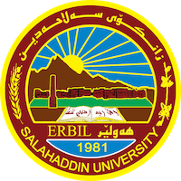
Academic Curriculum Vitae
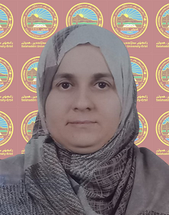
Personal Information:
Full Name: ئاره زو محمود حمدامي ن
Academic Title:مامۆستاى ياريده‌ده‌ر
Email: (university email): arazu.hamadamin@su.edu.krd
Mobile:07507473219

Education:
- State all educations accomplished
بكالوريوس له‌ زانكۆى سه‌لاحه‌دين/ كۆليژى زانسته‌ ئيسلامييه‌كان/ به‌شى خوێندنى ئيسلامى ساڵى 2004-2005
ماسته‌ر له‌ له‌ زانكۆى سه‌لاحه‌دين/ كۆليژى زانسته‌ ئيسلامييه‌كان / به‌شى خوێندنى ئيسلامى له‌ ساڵى 2017-2018
Employment:
- State employment starting from first employment

يه‌كه‌م دامه‌زراندن له‌ كۆلێژى زانسته‌ ئيسلاميه‌كان له‌ ساڵى 2007
Qualifications
- Teaching qualifications
- به‌شداریم كردووه‌ له‌ خولی ڕیگاكانی وانه‌ ووتنه‌وه‌ له‌ زانكۆی سه‌لاحه‌ددین له‌ ساڵى 2018
- IT qualifications
- Language qualifications such as TOEFL, IELTS or any equivalent
- بروانامه‌ى فێربوونی زمانی ئینگلیزی الكفاءة‌ الانجليزية له‌ ساڵی 2021 .
- Any professional qualification
- You could put any professional courses you have attended

Teaching experience:
- State all teaching courses you delivered, stating undergraduate or post graduate
- Courses, trainings, lab supervision, etc.,
وانه‌ ووتنه‌وه‌ له‌ كۆلێژ، ئه‌م وانانه‌ی خواره‌وه‌:
وانه‌ی (أصول الفقه – أدلة الاحكام ). قۆناغى دووه‌م بكالوريوس

Research and publications
- State all researches, publication you made.

Conferences and courses attended
- Give details of any conferences you have attended, and those at which you have presented delivered poster presentations.
  - سپمیوزیومى دۆزينه‌وه‌ى هه‌لى كار 2024-2025
  - سپمیوزیومى گرنگى په‌ره‌پێدانى ته‌ندروستى له‌ شوێ،ى كاردا 2024-2025.
  - سپمیوزیومى په‌يام وكه‌سايه‌تى قوتابى زانكۆ 2024-2025.
Funding and academic awards
- List any bursaries, scholarships, travel grants or other sources of funding that you were awarded for research projects or to attend meetings or conferences.

Professional memberships
- List any membership you hold of any professional body or learned society relevant to your research or other life activities.
Professional Social Network Accounts:
- List your profile links of ReserchGate, LinkedIn, etc.

It is also recommended to create an academic cover letter for your CV, for further information about the cover letter, please visit below link:
https://career-advice.jobs.ac.uk/cv-and-cover-letter-advice/academic-cover-letter/

