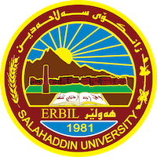

**Academic Curriculum Vitae**

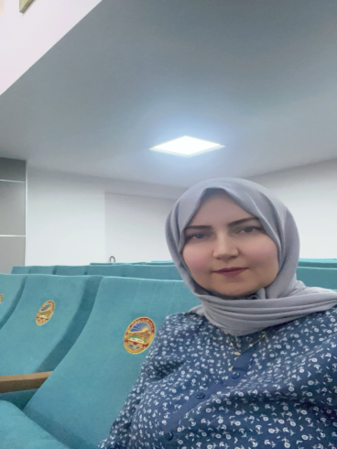**Personal Information:**

Full Name: Arazu Saeed Omer

Academic Title: Assistant Lecturer

Email: arazu.omer@su.edu.krd

Mobile: 07504965295

**Education:**

2013 Master of Technology in Computer Science at salahaddin University, erbil Iraq.

2000-2003 Bachelors in Computer Science at Salahaddin University, Erbil.

**Employment:**

2004- till Present Employee at Salahaddin University, College of Science Education

Computer Science Dept as Teacher Assistant.

**Qualifications**

2004 Computer course - Salahaddin University

2010 Cisco CCNA Routing & Switching.

2013 Teaching Method certifications.

**Teaching experience:**

* Introduction To Programming Using C++
* Computer Skills
* Database & SQL
* Computer Network
* Wireless Network

2011 Instructor in Zankoline Trainer in computer department for 1 month.

2019 Lecturer Evening shift of science college .

**Professional Social Network Accounts**

* <https://orcid.org/0009-0006-7039-4473>
* <https://www.linkedin.com/in/arazu-omer-15a5b1147/>
* <https://www.researchgate.net/profile/Arazu-Omer>
* <https://scholar.google.com/citations?hl>