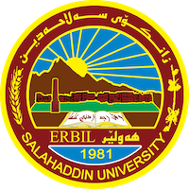

**Academic Curriculum Vitae**

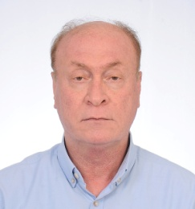**Personal Information:**

Full Name: Dr. Ardalan Ahmad Sulayman

Academic Title: Assistant professor

Email: ardalan.sulayman@su.edu.krd

Mobile: 07504779547

**Education:**

B.Sc. Biology -Salahaddin university -1986

M.Sc. Botany - Almustansyria university - 1999

Ph.D. Botany - Almustansyria university - 2002

**Employment:**

**7/4/2003 in Salahaddin university as a Lecturer**

**Qualifications**

* Teaching qualifications
* IT qualifications
* Language qualifications such as TOEFL, IELTS or any equivalent
* Any professional qualification
* You could put any professional courses you have attended

**Teaching experience:**

General Botany ( Theory )

Plant Anatomy (Theory)

Plant physiology (Theory)

**Research and publications**

|  |  |  |
| --- | --- | --- |
| No. | Title of research | Date |
| 1. | *In vitro* shoot tips culture of *Vitis vinifera* L. | 2009 |
| 2. | Effect of cigarette smoke condensate or tar on the growth of some bacterial pathogens. | 2010 |
| 3. | Propagation of three species of Bougainvillea via tissue culture technique (1. Establishment and rooting) | 2012 |
| 4. | Anatomical study of Scorzonera phaeopappa Boiss. and Serratula cerinthifolia Boiss. in Kurdistan region –Iraq | 2016 |
|  |  |  |
|  |  |  |
|  |  |  |
|  |  |  |
|  |  |  |
|  |  |  |
|  |  |  |

**Conferences and courses attended**

**Funding and academic awards**

**Professional memberships**

1. member of Kurdistan teachers union

2. member of Kurdistan biology syndicate

**Professional Social Network Accounts:**