زانکۆی سەلا‌حەدین - هەولێر
Salahaddin University - Erbil

Undergraduate Research Project Title:
The Impact of English Proficiency on The Use of Communication Strategies: An Interaction-Based Study in The EFL Context
Research Project
Submitted to the Department of English in partial fulfilment of the requirements for the degree of B.A or BSc. In 2023.

by:
Zana Khider Ahmed
Sara Abdulwahid Abdullah

Supervised by:
Arev Mirza Astifo
2022-2023

Acknowledgement
First of all, I would like to express my whole-hearted gratitude to Allah, The almighty, for allowing me to finish my research successfully. Then, I would like to thank my family for supporting me to keep going no matter how hard things would get. Moreover, I would like to thank my dear supervisor, Dr Arev Mirza Astifo, for helping me by giving advice, checking my research, and making useful notes which enhanced the research and for her patience in instructing and updating us on how to conduct the parts of this study. Her great ideas contributed a lot to the betterment of this paper.

Abstract
This research investigates classroom interaction in English as Foreign Language (EFL) classrooms. It is aimed to understand the process of classroom interaction and to know the pattern of classroom interaction in an English as Foreign Language (EFL) classroom The method used in this research is qualitative by using observation and a questionnaire to collect the data from the research subject. The research of this result shows the process of classroom interaction is still teacher-centred. While the most dominant pattern used in classroom interaction is the content cross.
Keywords: Communication strategies, language proficiency, interaction-based methodology, English as a foreign language.

Table of Contents
Acknowledgment I
Abstract II
Chapter One: Introduction 1
1.1. Introduction 1
1.2. Background of the Study 1
1.3. Amis of the Study 2
1.4. Significance of the Research 2
1.5. Scope of the Study 2
1.6. Problems of the study 3
Chapter Two: 4
2.0. Literature Review 4
2.1. Communication strategies: 4
2.2. Scaffolding Strategy 6
2.3. Sociocultural Theory 8
2.4. Spoken Interaction 9
Chapter Three: 11
3.0 Methodology 11
3.1 Setting and Participants: 11
3.2 Procedure: 13
3.3 Data collection procedure: 13
3.4 Limitations 13
3.5 Data analysis procedure: 14
3.6 Results 19
3.7 Discussion: 19
Chapter Four 21
4.0 Conclusion 21
4.1 Recommendations 21
Appendixes 22
Reference 24

Section One: Introduction

1.1 Introduction
Classroom interaction has been a central issue in teaching and learning English in the era of communicative language teaching and other modern strategies. Teaching based on the context can make students reflect on the idea behind the context to expand their knowledge and also to be familiar with Vocabulary and Grammar patterns in the context. Also, in the modern era of teaching, contexts can be considered one of the effective ways of language learning. Several articles and books related to comprehensible input, output, and interaction in foreign language teaching have been made that gave great contributions to language teaching and learning. However, classroom interaction in a foreign language context has been a major problem in ours, where students have very limited opportunities for exposure to real-world input, and oral communication with native speakers, often students face difficulties as they interact or communicate with their colleagues and teachers.

1.2 Background of the Study
Communicative Approaches in language learning are approaches that are used in learning a second language or foreign language that emphasizes the improvement of the ability to communicate interactions within English classes, that is” the ability to apply the language principle to produce grammatical sentences and understand 'when, where, and to whom the sentences used” (Richard, 1997). Those communicative strategies focus on language as a medium of communication. It recognizes that communication has a social purpose – the learner has something to say or find out." Communication embraces a whole spectrum of functions and notions" (Richards, Jack C. & Rogers, Theodore S., 2001).
In EFL contexts like in Arab countries, deliberate interaction in the classrooms becomes essential for developing their communicative language competence. Needless to say, the unquestionable value of that kind of interaction between the teacher and the students and among students themselves for the development of foreign/second language proficiency has long been emphasized by many linguists. Even nowadays in our public schools in Kurdistan as a part of the Iraq government, there is plenty of a lack of class interactions in the classes that led students to face many challenges as they interact in English in their daily lives.

1.3 Amis of the Study
The current study aims at discussing some basic ways first we want to be able to answer questions that we raised in the study, also for teachers at school, the research will be able to knowledge them and give them some modern contextual teaching alternatives and show the impact of these strategies upon students, also in our quest we strive to deliver the strategies of what makes a good teacher in foreign language classrooms.

1.4 Significance of the Research
This Research is considered a highly important study for the following reasons: -
- introduces teachers to the most crucial and effective strategies of teaching.
- Familiarize teachers with how they should teach based on the contexts and how to use the contexts as an effective tool of learning and communication that can enable students to gain more vocabulary and know how sentences are structured.
- Enables students to interact freely and confidently within the classroom in which the methods have been used.

1.5 Scope of the Study
The scope of the study is defining or introducing crucial terms related to the study, such as English as a foreign language, then what is the meaning of class interaction, and what contexts mean and can include. after then we will jump into these strategies in which we are going to explain the meaning of these strategies and how they would be used furthermore we will explain the circumstances in which these strategies can occur. In this study, our main focus would be on university students at Salahaddin University in Erbil Kurdistan, which we are currently studying in 2022-2023, where students could not speak through class interaction in a foreign language context.

1.6 Problems of the Study
These are the problems that the study is trying to solve: -
- How teachers use strategies to promote contextual interactions in a class.
- How teachers have received interactions and how they think their students may benefit from the use of these strategies that they undertake during the class that overlaps with introductions and classroom management.
- What are these flexible strategies and techniques that can be used and what contexts can be taught in the language classroom at any time?

Section Two

2. Literature Review

2.1 Communication Strategies:
Communication is key in the classroom: successful teaching is generally considered to require only 50% knowledge to 50% communication skills. As a result, a teacher should be proficient in all four modes of communication – listening, speaking, reading, and writing – and should know how to utilize this proficiency effectively in a school environment. Being able to do this has been proven to impact the success students achieve in their academic lives, as well as the teacher’s career success. The better your communication Strategies, the more effectively you can perform these tasks. In turn, your students will make more academic progress. (Sword 2020). Studies have found that the success of students is directly related to interactive, engaging teaching environments formed by able teachers (see Mashburn et al., 2008). Additionally, the way that you communicate with your students can positively affect their perceptions of school, their role in the classroom, their abilities, and their motivation to succeed (see Dobbs & Arnold, 2009). The term “strategy” is also used several times in the Swedish curriculum for English (Bialystok 2011), even so in the knowledge requirements. There are several communicative interaction strategies which work in various situations and for different learners. Bialystok (1990) goes on to say that all speakers of a language use some form of CS but that it is not as apparent for native speakers, as it is for non-native speakers. It is crucial to have a repertoire of various CS to tackle these obstacles head-on, but many CS is introduced only when the speaker has difficulties producing or understanding a language.
In 2011, Rodríguez and Rodriguez (2012) researched the use of communicative strategies in an EFL classroom. Their results showed that the teachers were not aware that they used strategies themselves and therefore could not provide their students with them. However, of the total communication strategies used by the teachers in their study, 25% were language switches, 17% were clarification requests, 12% were comprehension checks, 12% asking for confirmation, 10% were translation, 9% were repetition, 5% paraphrase, 4% code-based confirmation check, 3% other reformulation, 2% meaning replacement, and 1% mime. Furthermore, they argue that communication strategies, unconsciously used in the first language, do not automatically transfer to a second or foreign language, which can explain the high percentage of language switches during lessons.
However, Lundahl (2014) claims that often when students do not know a word or a phrase in English, they tend to communicate by using their hands, sounds, inventing new words or describing what they mean. These are typical examples of communicative strategies even though the students may be unaware of that fact. It is therefore important that teachers use these strategies as well as explicitly provide their students with them.
Researchers Lightbown and Spada (2013) claim that when a learner is exposed to authentic situations where they feel the need to communicate their thoughts and opinions, there is a greater chance that they will use a CS to negotiate to mean and come to a mutual understanding. They also write, “According to the interaction hypothesis, negotiation leads learners to acquire the language forms - the words and grammatical structures - that carry the meaning they are attending to” (Lightbown and Spada, 2013, p.165).
One of the most common strategies is circumlocution and approximation. These strategies are used when a learner is trying to communicate a word that he/she has not yet learned and tries to explain the meaning of the word in a simplified way or using a synonym (Dörnyei, 1995 Lundahl, 2014). For example, a learner might not have the word “cucumber” and tries to explain it by saying “a long, green vegetable”.
Additionally, Mirsane and Khabiri (2016) conducted a study on a group of sixty EFL learners in Iran homogenized in terms of their language proficiency through PET. The group was divided into control and experimental groups, with 30 students in each group. The CSs were taught over an academic semester to the experimental group. A willingness to communicate questionnaire was distributed to the groups before and after the treatment as a pretest and posttest. The results of the WTC pretest and posttest scores of the two groups indicated that CSs instruction had significantly increased the experimental group‟s willingness to communicate.

2.2 Scaffolding Strategy
Scaffolding is a process in which students are given support until they can apply new skills and strategies independently (Rosenshine & Meister, 1992). Scaffolding is one of the principles of effective instruction that enables teachers to accommodate individual student needs (Kame'enui, Carnine, Dixon, Simmons, & Coyne, 2002). The term “scaffolding” comes from the works of Wood, Bruner, and Ross (1976). The term “scaffolding was developed as a metaphor to describe the type of assistance offered by a teacher or peer to support learning. In the process of scaffolding, the teacher helps the student master a task or concept that the student is initially unable to grasp independently. The teacher offers assistance with only those skills that are beyond the student’s capability. Of great importance is allowing the student to complete as much of the task as possible, unassisted. The teacher only attempts to help the student with tasks that are just beyond his current capability. Student errors are expected, but, with teacher feedback and prompting, the student can achieve the task or goal. When the student takes responsibility for or masters the task, the teacher begins the process of “fading”, or the gradual removal of the scaffolding, which allows the student to work independently. “Scaffolding is a bridge used to build upon what students already know to arrive at something they do not know. If scaffolding is properly administered, it will act as an enabler, not as a disabler” (Benson, 1997). Feedback comes in many forms and is a big part of the learning process. However, you have to be aware that there is a fine line between too little and too much feedback. Too much feedback can limit the students’ development and at the same time, make them question their ability to progress (Lundahl, 2009). Gibbons (2002) write about different situations in the classroom where direct corrective feedback is fairly common. She explains the pattern as a three-part exchange between teacher and student which gives the students very limited chances to communicate and develop. The concept of scaffolding between the teacher and students has been welcomed in Thailand. Khamwan (2007) studied the effect of interactional strategy training on teacher-student interaction, aiming to increase the effectiveness of the interaction between the teacher and students. Scaffolding is one of the interactional strategies she emphasized. Charttrakul (2009) commented that “scaffolding is very important for EFL young learners, particularly in Thai classroom situations where students rarely use L2 or English in their real life” (p.14). In his article, Nomnian (2002) called for more attention to promoting teacher-student scaffolding interaction in the language classroom. Numerous scaffolding activities can take place in EFL classes, but not to scaffold ideas of cultural texts which needs different kinds of activities that must be done within Vygotsky's zone of proximal development. (Large, A., & Nessest, V., 2000). In scaffolding, the learner does not simplify the task, but the role of the learner is simplified “through the gradual interference of the teacher as a supervisor” (Greenfield, 1984, p. 119). When the adult provides the learner with photos, the learner provides a scaffold to help the other learner move from assisted to unassisted success at the task (Greenfield, 1984, 117). The need to implement a scaffold will occur when you realize a student is not progressing on some aspect of a task or is unable to understand a particular concept. Although scaffolding is often carried out between the instructor and one student, scaffolds can successfully be used for an entire class. Finally, the learner can complete the task or master the concepts independently (Chang, Sung, & Chen, 2002, p. 7). Therefore, the goal of the educator when using the scaffolding teaching strategy is for the student to become an independent and self-regulating learner and problem solver (Hartman, 2002). As the learner’s knowledge and learning competency increase, the educator gradually reduces the support provided (Ellis, Larkin, Worthington, n.d.). “Scaffolding is actually a bridge used to build upon what students already know to arrive at something they do not know. If scaffolding is properly administered, it will act as an enabler, not as a disabler” (Benson, 1997).

2.3 Sociocultural Theory
Vygotsky’s sociocultural theory of learning explains that learning occurs during social interactions between individuals. It is one of the dominant theories of education today. It believes learning happens first through social interaction and second through individual internalization of social behaviours. In the sociocultural theory, students and teachers form relationships in the classroom to help the student learn. The relationships help facilitate social interaction and active participation in the learning tasks. Students learn through observation, listening and talking through their tasks (Chris Drew 2019). Sociocultural theorists believe that learning happens as a result of social interactions and takes place within a specific cultural environment (Bates, 2019; Leonard, 2002; Nagel, 2012). Vygotsky created three zones of development: the zone of actual development, which represents the current abilities of the pupil, the zone of proximal development where the pupil is in the process of formation and the zone of potential development, which would be the level that the child can reach with the help of a person (Francesc 2022). The sociocultural theory proposed by Vygotsky (1978) explains human cognitive development based on social and cultural development. According to the theory, cognitive development is connected with culture and society. Learners construct new knowledge through social interaction and collaboration with others. They construct their new knowledge with the help of other learners, the learning context and the environment. Thus, learners’ cognitive development depends on the tools provided by society. According to Vygotsky, cognitive development is a process through which learners develop more systematic, logical and rational concepts from their social interactions with the help of a teacher or a peer who is more skilled in the subject. Through the interactions, the learners acquire new knowledge of the world and culture, and strategies for learning (Aliyu and Yakubu 2019). According to researchers Lightbown and Spada (2013), it is through social interaction with others that we learn how to communicate successfully. In addition to this, Wenger (2010) states that learning is something that occurs constantly and more often together with others. To be able to learn, we need a way to communicate, preferably an oral way to communicate - speaking. When communicating with others through speaking we get a direct response and feedback that helps us to develop our thoughts further. We may also create meaningfulness and authenticity through our social engagements which are harder to achieve without interaction with others. Tornberg (2009) argues that the need for communicative competence is one of the things that have had the largest impact on modern language teaching in Sweden. She also underlines the importance of using the target language when interacting in various learning situations, to be able to achieve the best learning outcome.

2.4 Spoken Interaction
Interaction as the “heart of communication” is defined as the “collaborative exchange of thoughts, feelings or ideas between two or more people, resulting in a reciprocal effect on each other” (Brown, 2000, p.165). People involved in a communication act influence each other through what they say or do towards each other. Michael Long proposed the interaction hypothesis, suggesting that “learners learn new form in a language through the negotiation around meaning that occurs when they engage in communicative learning activities. In line with this, Rivers (1987, cited in Brown, 2000, p. 165) clarifies that in interaction students can use what they learned in “real-life exchanges”
According to Read (2007), there are two parts to spoken interaction. The first one is called spoken interaction and refers to the ability to handle interactions with others, such as asking and answering questions. The second part is about spoken production. This refers to the ability to produce the language needed to, for instance, retell a story or to describe something. Even though children may be good at imitating sounds and words, we should not forget that it is difficult for children to interact in, and produce a foreign language. This is something we must consider when planning appropriate activities for the classroom (Read 2007).
Research by Tati, Paul and Golingi (2016), revealed that the factor that was accountable for students’ low ability in spoken interaction was anxiety to speak in English. This also included their deficiency of English language skills, competitive characteristics, limited awareness of the second language, restriction of opportunities to speak in the language, uncomfortable communicating with anyone from the opposite gender, and stress from families. Additionally, the findings of the study revealed that learners’ apprehension of being mocked or an inclination of feeling insecure when speaking to more knowledgeable speakers, examination achievement anxiety, and the concern of being recognizable had also contributed to their spoken interaction anxiety in the English language.

Section Three

3. Methodology
This research methodology aims to investigate the impact of English proficiency on the use of communication strategies among university students in an EFL context, with a specific focus on spoken interaction and its effect among learners in an EFL context. The study will explore how scaffolding strategies and sociocultural theory can support effective communication in the EFL classroom. Scaffolding strategies will be used to provide support to students at various stages of language development, while sociocultural theory will be used to explore how cultural and social contexts impact students' language use. The study will employ a quantitative research design with an interaction-based approach, using questionnaires to collect data. The participants will be English students at the university level, specifically those currently enrolled in an English language course. A sample of 46 students will be selected from the university in the region.
The study's data collection and analysis will provide insights into the impact of English proficiency on the use of communication strategies in an EFL context. The study will be significant in providing valuable information for English language teachers to promote contextual interactions in the classroom and enhance students' communicative competence.

3.1 Setting and Participants:
This study will investigate the impact of English proficiency on the use of communication strategies among multilingual undergraduate English language students in an EFL context. The study will take place in the English Department of the College of Education at Salahaddin University in Kurdistan, Iraq. A purposive sampling technique will be used to select 46 participants (23 females and 23 males) who are currently enrolled in the English department, have completed at least one year of English language study, and are aged between 19 to 23 years old. In addition, the data collection process involved the use of a Google Form questionnaire, which was designed based on the research questions and hypotheses.

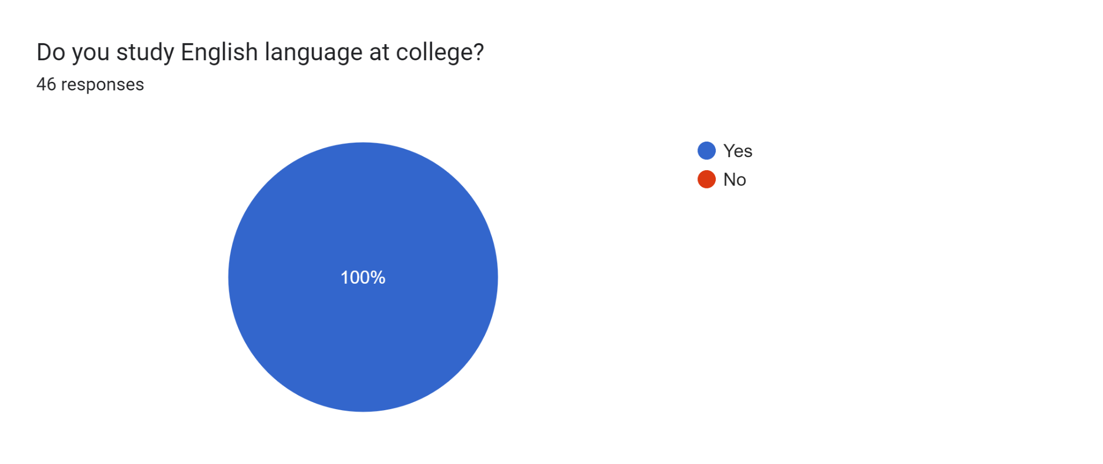

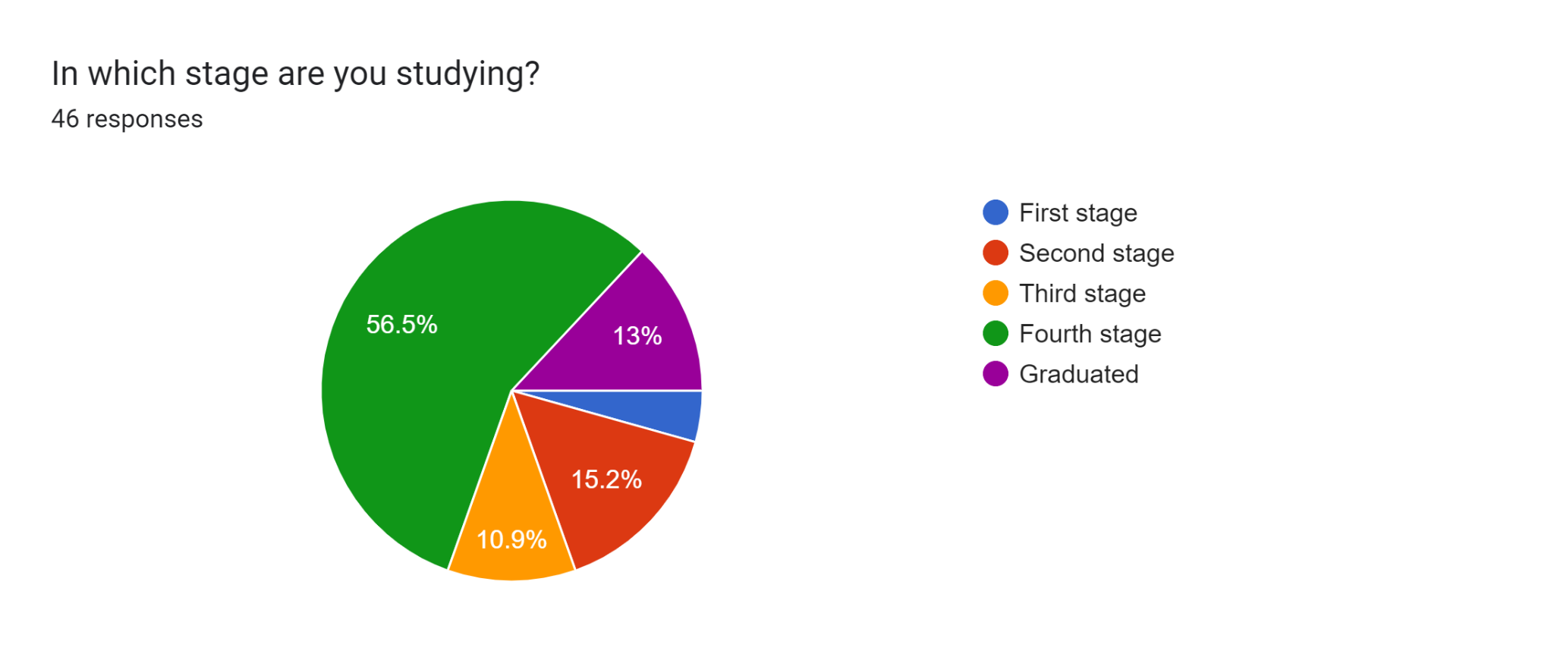

Figure:
The above chart displays the distribution of percentages of applicants across different stages of the research process. Specifically, the data indicate that 4.4% of the subjects are in the first stage, 15.2% are in the second stage, 10.9% are in the third stage, and the majority, 56.5%, are in the fourth stage. Additionally, 13% of the subjects have completed the process and graduated.

3.2 Procedure:
This research methodology aims to investigate the impact of different strategies and techniques on the effect of communication strategies and English proficiency among university students in an English as a Foreign Language (EFL) context. The study will explore how various techniques such as communication strategy, scaffolding strategy, sociocultural theory and spoken interaction can support and facilitate teaching and learning improvement in the EFL classroom. The research will employ a mixed-methods approach, using both qualitative and quantitative methods to collect data. The participants will be English language students at the university level, specifically those currently enrolled in an EFL course.

3.3 Data collection procedure:
This study is considered a qualitative-open answer and quantitative-close answer collection of data. This study was conducted for three months with an anonymous online questionnaire with 15 statements and questions that are designed to get the perceptions of the participants, with the opportunity to give the participants long, short, and multiple choice questions, the answers were ranging from via Google form. This online questionnaire was completed from the 22nd of March 2022 till the 30th of February 2023 due to reasons.

3.4 Limitations
Each research faces problems throughout its implementation and this paper has faced obstacles as many others. Some problems have been referred to in the research. First, there was a small number of students to get the answers from, the questionnaire was online and we faced some interruptions because of the midterm exam of college, and some of the questions were not relevant to the study. and finally, the students were like they were not interested to answer as long as we sent the form twice or three times in addition to getting the result in almost three months.

3.5 Data analysis procedure:
3.5.1. Do you think implementing communicative interaction affects students’ proficiency or ability in the classroom?
Chart (1) show all participant's views about how implementing communicative interaction affects student’s proficiency or ability in the classroom as the statistic shows, 47.8% of applicants think that Yes, implementing communicative interaction in the classroom positively affects students' proficiency or ability, while %50 of applicants they think that It depends on the student's learning styles and preferences, while %2.2 agree with No, implementing communicative interaction in the classroom does not affect students' proficiency or ability.
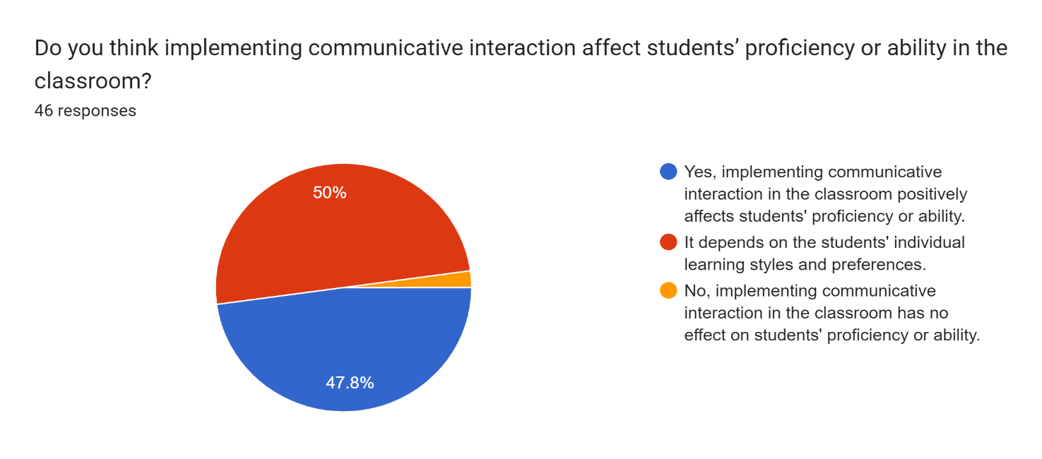

3.5.2. Chart (2) show all participants’ view about, how teachers' communication like listening, speaking, reading, and writing be effective in the school environment, as the statistic shows, that %50 agree with It depends on the student's learning styles and preferences, also %47.8 is agreed with Yes, implementing communicative interaction in the classroom positively affects students' proficiency or ability, the other %2.2 agrees with No, implementing communicative interaction in the classroom does not affect students' proficiency or ability.
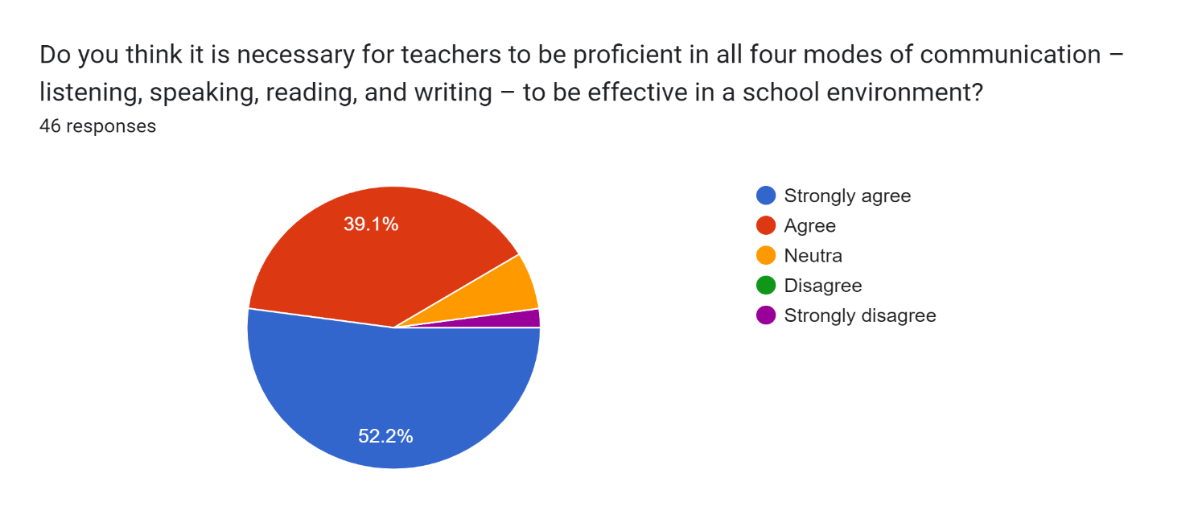

3.5.3. Chart (3) show all participants' view on the student’s experience with unprofessional teachers in communication skills. As the statistic shows, that %67.4 are experiencing it, and %32.6 didn’t experience it.
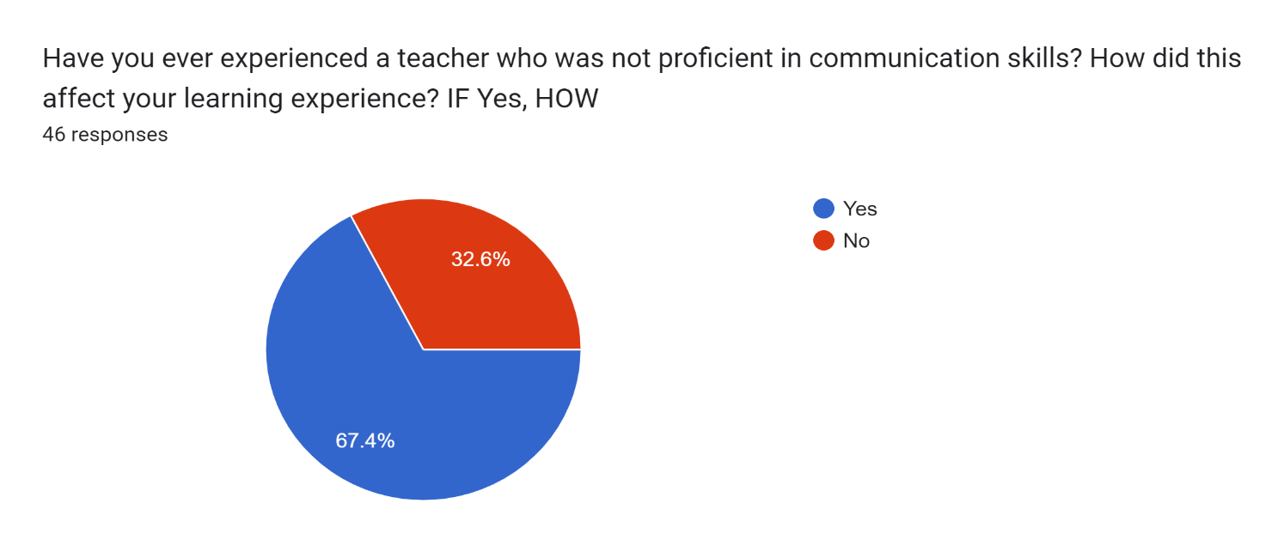
3.5.4. Chart (4) show all participants' view about the students being in an interactive engaging learning environment. As the statistic shows shat %54.3 of students were experienced in an active engaging learning environment, and % 45.7 of students aren’t in an engaging environment.
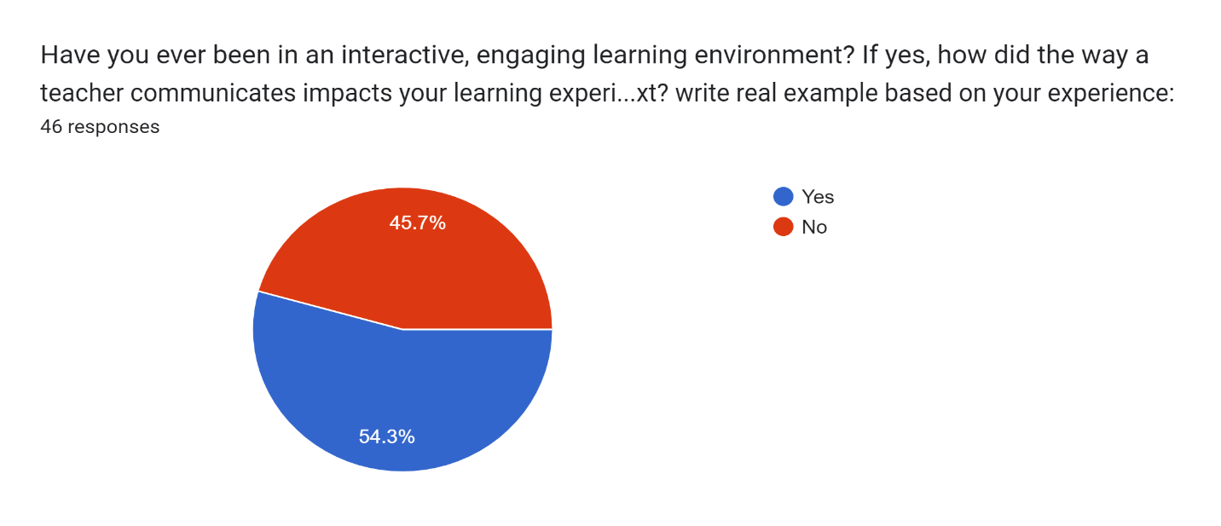

3.5.5. Chart (5) shows all participants' views about the effect of spoken interaction in language learning inside the classroom. As the statistic shows, %71.7 strongly agree, and %21.7 agree, %2 Neutral, and %5 disagree with the importance of spoken interaction inside the classroom..
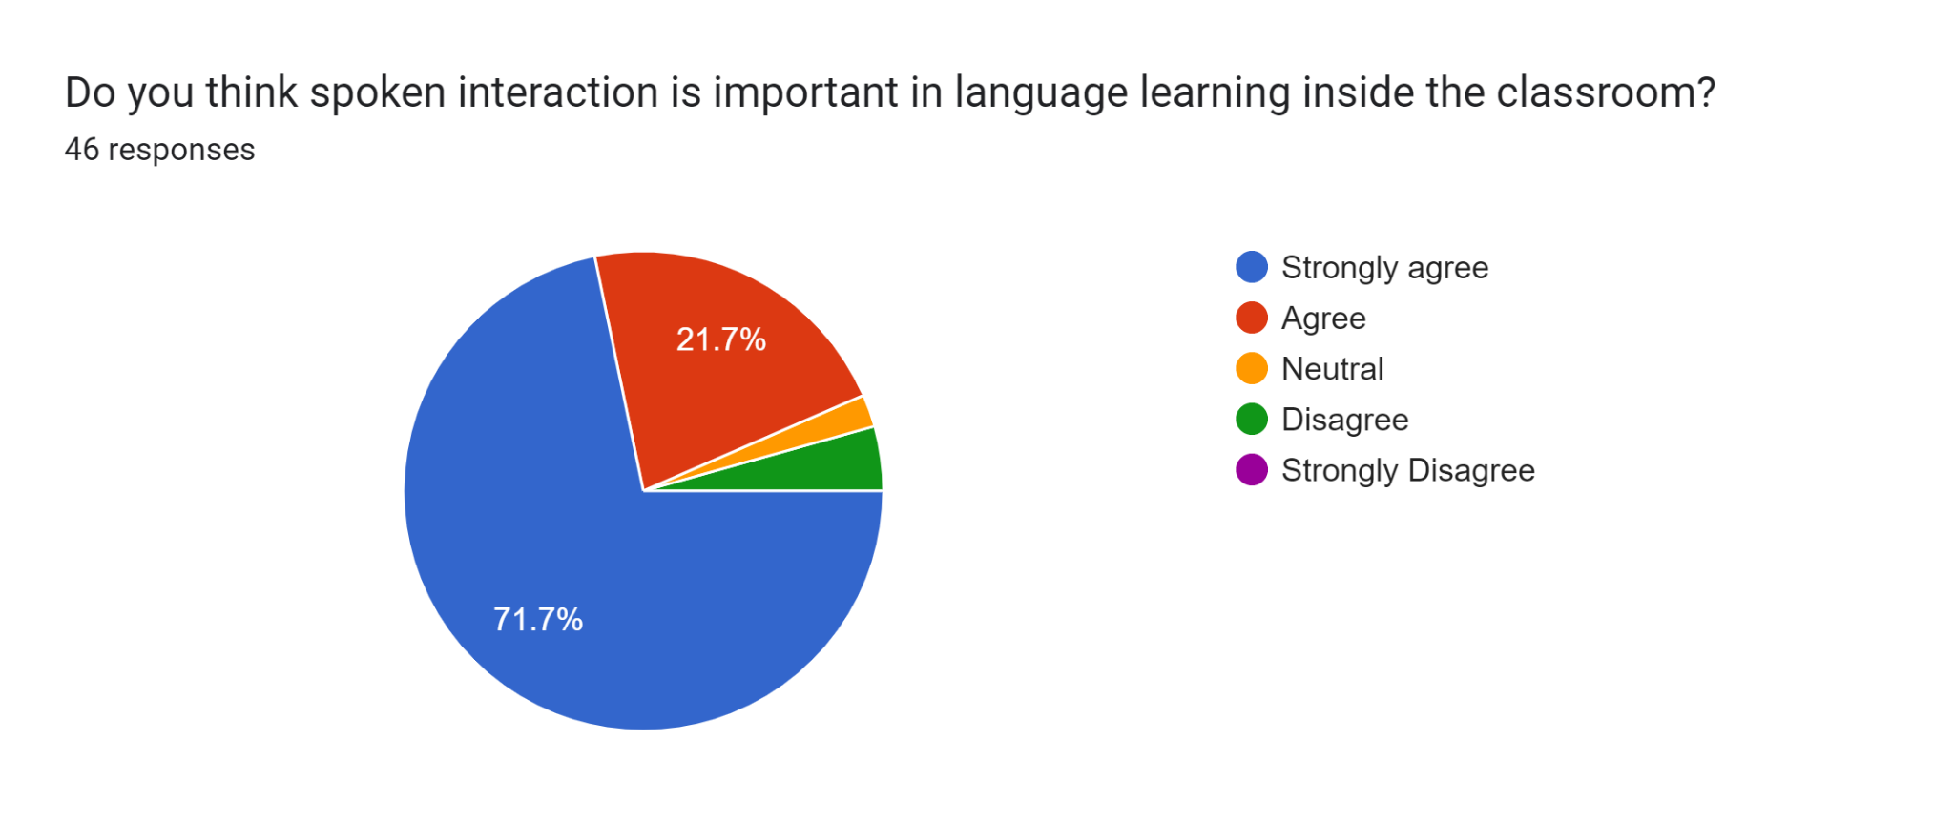

3.5.6. Chart (6) shows all participants’ views about the uncomfortableness of students when they speak in a foreign language in the classroom. %63 think that a Lack of communication skills can cause language anxiety among university students, and %23.9 are agreed with supportive language environments and targeted language classes can help alleviate anxiety, and %10.9 think that Cultural of the classroom and expectations and social pressure can contribute to language anxiety.
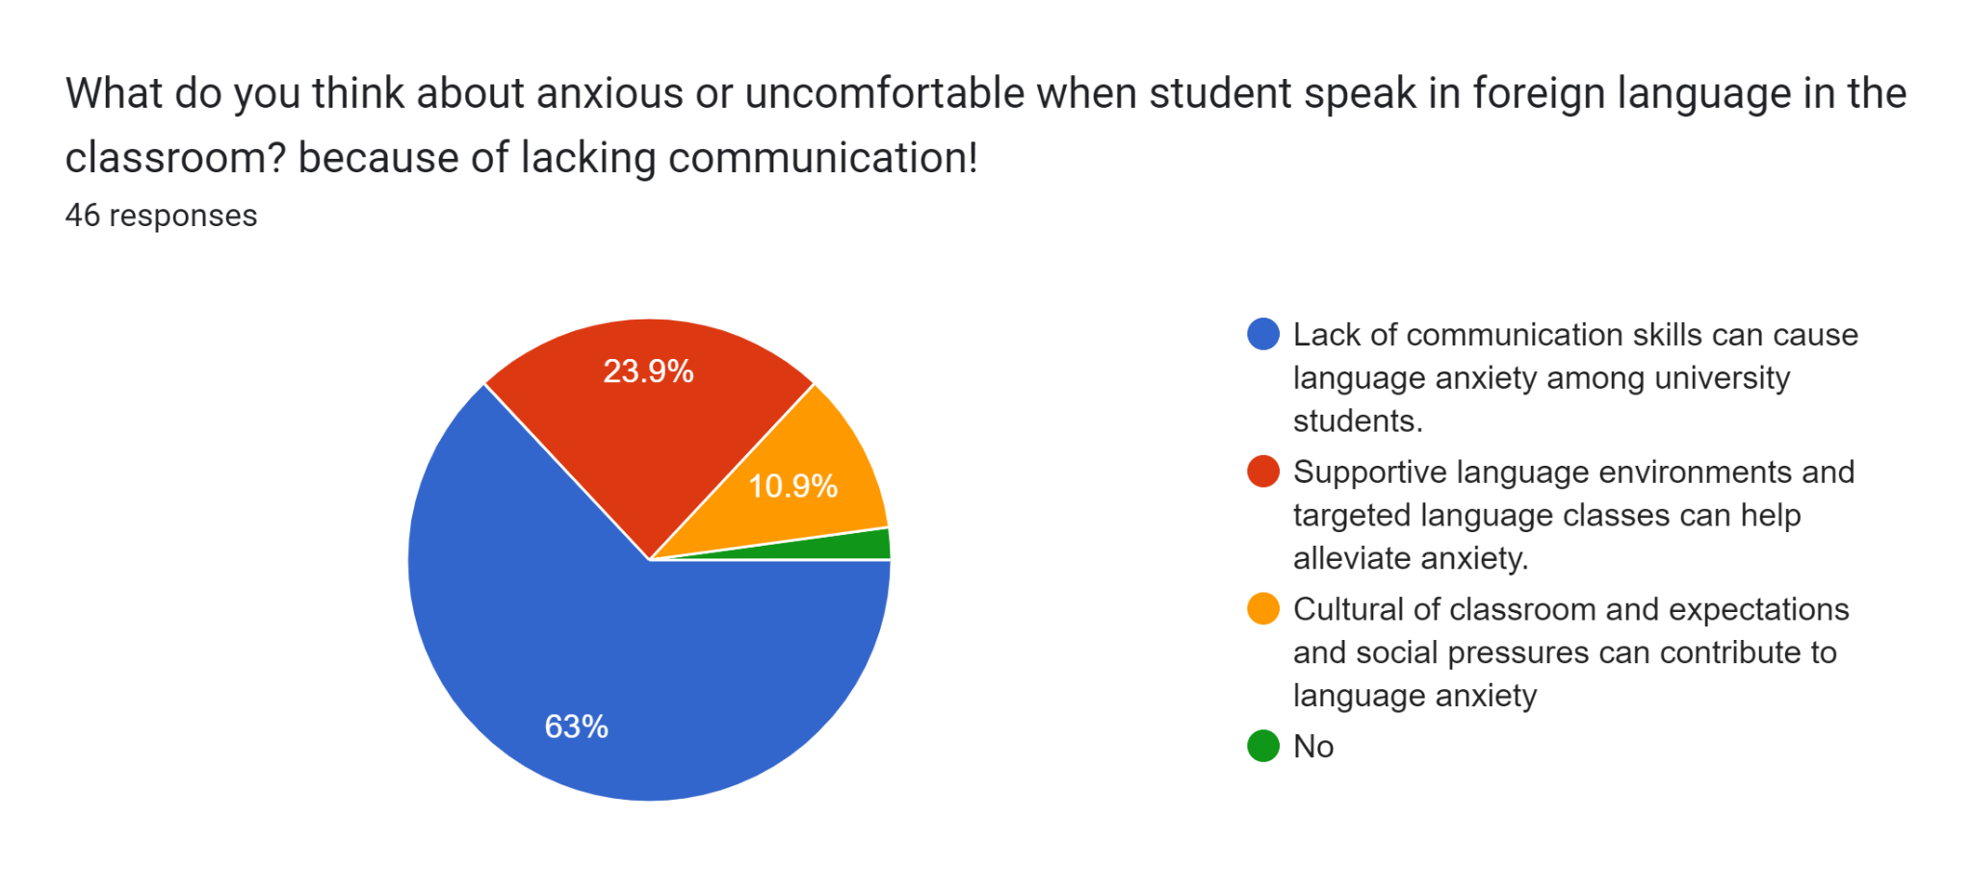

3.5.7. Chart (7) shows all participant's views about feeling stress as the major obstacle in students' ability to interact with a foreign language, %87 agree, and %15.2 don’t think that feeling stress is one of the obstacles,
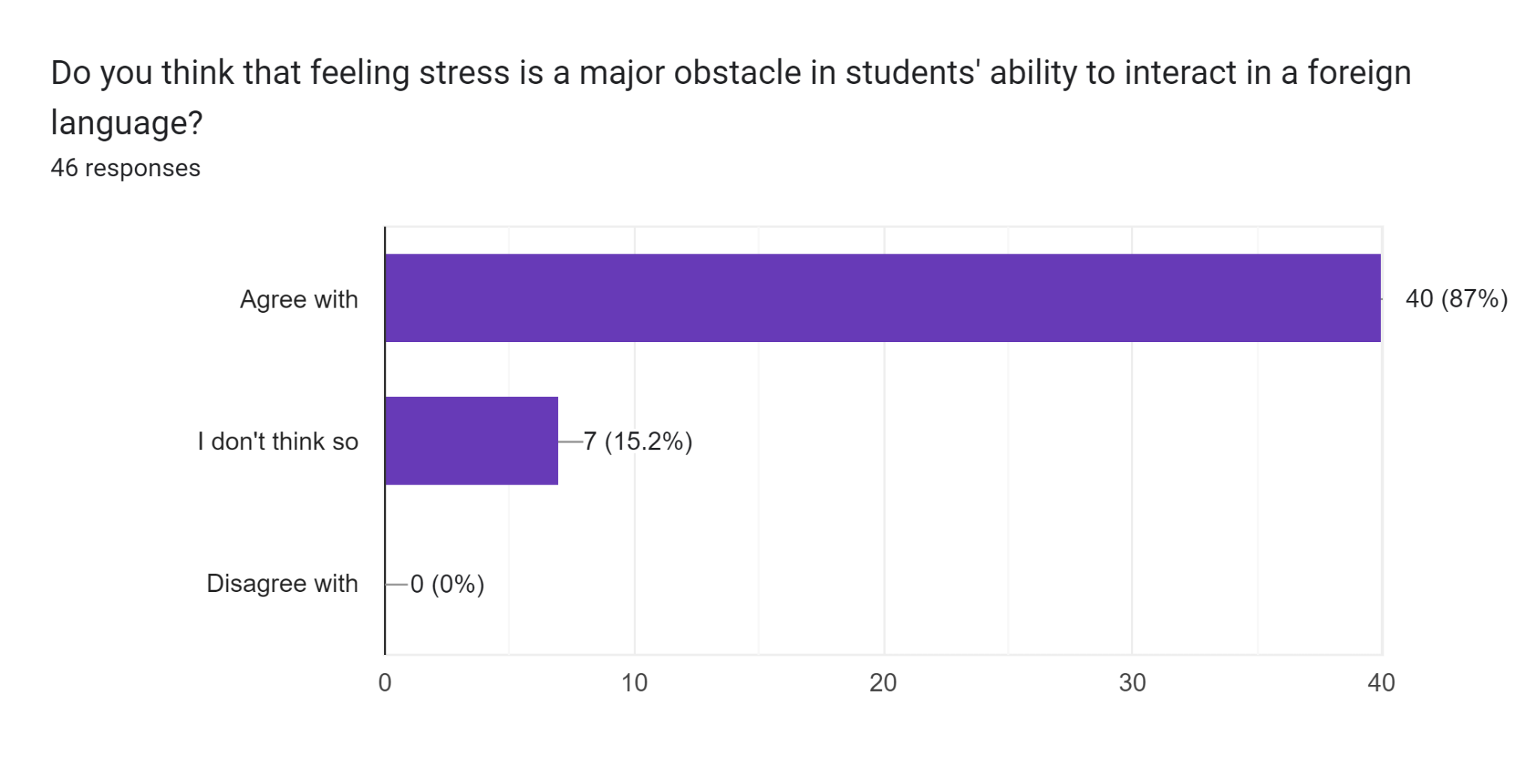
3.5.8. Chart (8) shows all participants’ view about how teachers can create a safe and supportive classroom environment that encourages students to interact with a foreign language, As the statistic shows that %28.3 are believed that students roll center of the classroom, and %34.8 believe classroom interaction, and %19.6 believe that teachers should give healthy feedback, and %17.4 believe group homework and %0 believe individual homework.
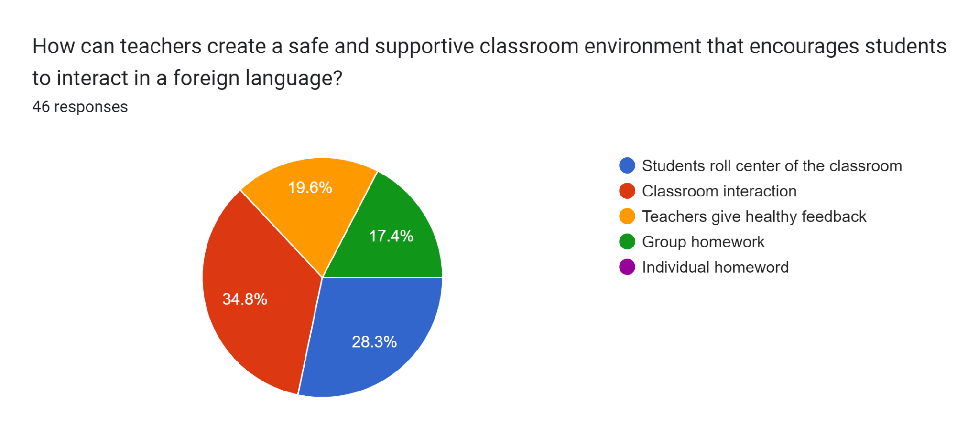

3.5.9. Chart (9) shows all participants’ view about how teachers' behavior affect students' language learning based on social interaction. %69.6 believed positive teachers' behavior positively affects students learning based on social interaction. And %26.1 is believed both positive and negative teachers' behavior can affect students learning based on social interaction, and %4.9 is believed in negative teachers' behavior negatively affects students learning based on social interaction.
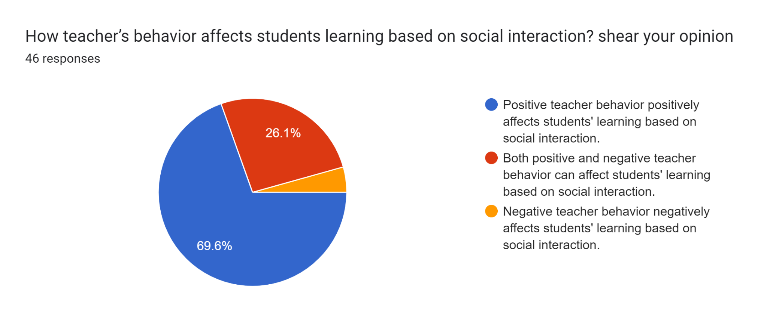
3.5.10. Chart (10) shows all participant's views about learning language interaction with peers being more effective than learning through individual study. and %47.8 strongly agree, %30.4 agree, %15.2 Neutered, %6.6 Disagree.
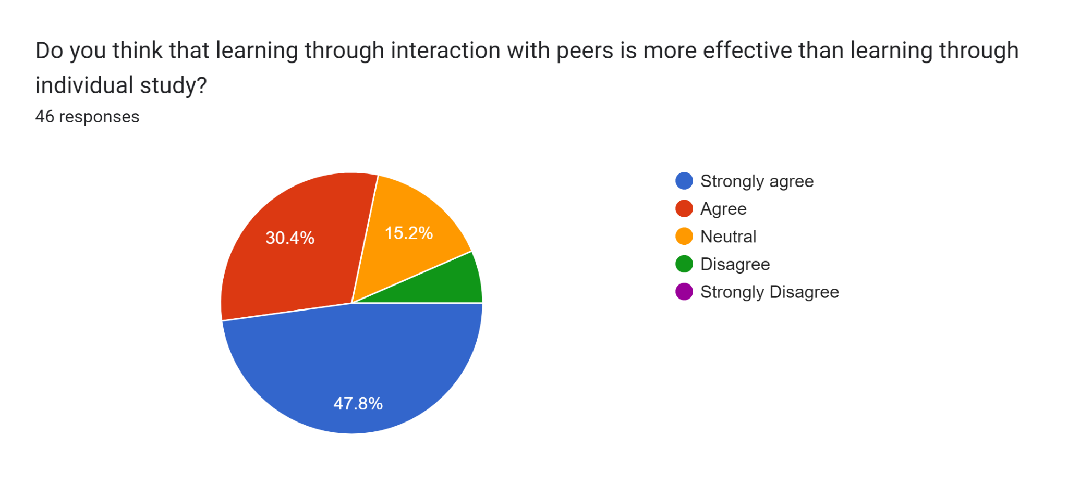

3.6 Results
The study explores the impact of English proficiency on communication strategies in English foreign language contexts. The findings suggest that teachers who solely rely on speaking may hinder and unabated the learning process of students who have a writing and speaking learning style. The lack of proficiency and communication skills from teachers can limit students' ability to develop their English language, also leading to a fear of speech and reduced participation and not giving healthy feedback to the students. Conversely, teachers who prioritize communication and encourage student participation can foster curiosity and improve overall English proficiency. These results highlight the importance of English proficiency and varied teaching methods in facilitating effective language learning.

3.7 Discussion:
This study aims to address the following problems: first, to explore how teachers use strategies to promote contextual interactions in a class; second, to investigate how teachers receive interactions and how they believe their students may benefit from the use of these strategies that overlap with introductions and classroom management; and third, to identify flexible strategies and techniques that can be used in different contexts in the language classroom at any time.
The literature review discusses two different teaching strategies in the classroom: communication strategies and scaffolding. Communication is considered a crucial aspect of teaching as it impacts various aspects of student performance, such as academic success, motivation, and perception of school. The article further discusses various communicative interaction strategies, including circumlocution and approximation. However, the use of communicative strategies in the classroom can be unconscious and not transferred automatically to second or foreign-language learners. The review also highlights the importance of scaffolding in teaching, which is a process of providing support to students until they can apply new skills and strategies independently.
The study's findings suggest that teachers who rely solely on speaking may hinder the learning process of students who have a writing and speaking learning style. Furthermore, the lack of proficiency and communication skills from teachers can limit students' ability to develop their English language, leading to a fear of speech and reduced participation. In contrast, teachers who prioritize communication and encourage student participation can foster curiosity and improve overall English proficiency. Therefore, the study highlights the importance of English proficiency and varied teaching methods in facilitating effective language learning.
In summary, this study aims to address various issues in language teaching, including the promotion of contextual interactions in the classroom, the use of effective teaching strategies and techniques, and the impact of teacher proficiency on language learning. The findings suggest that teachers should use a combination of effective communication strategies and scaffolding techniques to support learners with different learning styles and abilities. Therefore, the study provides important insights into improving language teaching and learning in diverse contexts.

Section Four

4. Conclusion
In conclusion, this research paper sheds light on the impact of English proficiency on the use of communication strategies in an EFL context. The study highlights the significance of teachers using contextual interaction strategies in the classroom, encouraging student participation, and developing effective communication skills. The results indicate that teachers who prioritize communication and encourage student participation can foster curiosity and improve overall English proficiency. On the other hand, a lack of proficiency and communication skills from teachers can limit students' ability to develop their English language skills, leading to reduced participation and fear of speech. This study provides valuable insights into the flexible strategies and techniques that can be used in different contexts in the language classroom at any time. The literature review further emphasizes the importance of scaffolding and effective communication strategies to support learners with different learning styles and abilities. It is hoped that this study will be of great significance to teachers, students, and researchers in the field of English language teaching and learning, particularly in EFL contexts, and will contribute to the improvement of the quality of English language education.

4.1 Recommendations
Here are some recommendations for teachers and ministries of education:
- Provide training and support for teachers: Provide professional development opportunities for teachers to enhance their knowledge and skills in teaching communication strategies. This could include workshops, online training, or mentoring programs.
- Promote the use of interaction-based approaches: Encourage the use of interaction-based approaches in the classroom to support the development of communication strategies. These could include pair work, group work, role-plays, and other interactive activities.
- Foster a supportive learning environment: Create a supportive learning environment that encourages learners to take risks and engage in communication. This could involve creating a safe and welcoming classroom environment, providing regular feedback, and offering opportunities for learners to practice their language skills outside of the classroom.

Reference
Abbas, N. J. (2017). Iraqi Academic Scientific Journals - IASJ. Iraqi Academic Scientific Journals. https://www.iasj.net/iasj/article/123470
BATENBURG, E. S. L. V. B., OOSTDAM, R. J. O., & GELDEREN, A. J. S. V. G. (2019, February 6). Oral Interaction in the EFL Classroom. Wiley Online Library. https://onlinelibrary.wiley.com/doi/full/10.1111/modl.12545
https://www.teachingenglish.org.uk/. (2020). Communicative approach. British Counsel. https://www.teachingenglish.org.uk/professional-development/teachers/knowing-subject/teaching-knowledge database/communicative#:~:text=The %20communicative %20approach%20is%20based,learn%20to%20use%20the%20language.
Khalid, A. T. K. (2018). The Impact of Communication Strategies Instruction on Kurdish EFL Students’ Willingness to Communicate in Kurdistan. Journal of Raparin University, No.15(Vol.5), e-ISSN (2522-7130). https://doi.org/10.26750/25227130
Malmberg, E. M., & Nilsson, H. N. (2018). Strategies to promote interaction (diva2:1489213). Malmö University. https://www.diva-portal.org/smash/get/diva 2:1489213 /FULLTEXT01.pdf
Rastegar, M. R., Sadat, S. S., & Gohari, M. G. (2016, June). Communication Strategies, Attitude, and Oral Output of EFL Learners: A Study of Relations. Scientific Research Publishing. https://www.scirp.org/pdf/OJML_2016102514552956.pdf
Samana, W. (2013, September 28). Teacher’s and Students’ Scaffolding in an EFL Classroom | Academic Journal of Interdisciplinary Studies. Academic Journal of Interdisciplinary Studies. https://www.richtmann.org/journal/index.php/ajis/article/view/743
Survey Questions  Appendixes | Yes | No | Your Opinion
Do you think implementing communicative interaction affects students’ proficiency in the classroom?
Do you think teachers must be proficient in all four modes of communication – listening, speaking, reading, and writing – to be effective in a school environment? HOW
Have you ever experienced a teacher who was not proficient in communication skills? How did this affect your learning experience? If Yes, HOW
Have you ever been in an interactive, engaging learning environment? If yes, how did the way a teacher communicates impacts your learning experience in the EFL context?
Do you think spoken interaction is important in language learning inside the classroom? Leave an opinion
Have you ever felt anxious or uncomfortable when speaking in a foreign language? If so, can you describe the situation and how you felt?
Do you think that anxiety is a major factor in students' ability to interact in a foreign language? Why or why not?
How can teachers create a safe and supportive classroom environment that encourages students to interact in a foreign language? Leave your opinion
How teacher’s behaviour affects students learning based on social interaction?
Do you think that learning through interaction with peers is more effective than learning through individual study? Why or why not?
To what extent teacher’s feedback helps the learner to construct or scaffold learning language independently?

