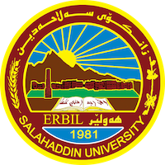
Academic Curriculum Vitae
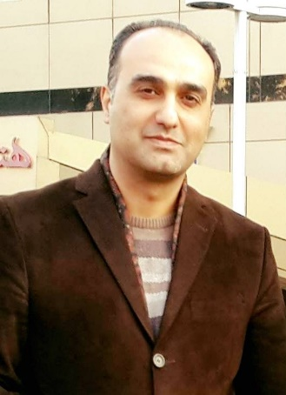
Personal Information:
Full Name: Arsalan Salim Mahmood
Academic Title: Assistant Lecturer
Email: arsalan.mahmood@su.edu.krd
Mobile:+9647504481077

Education:
- Urmia University
2007-2009
Urmia University, Iran, MA
- Salahaddin Unibversity
1999-2003
Salahaddin University, Iraq, BA
Employment:
- 2015-to the date , Head of Persian Department, College of Languages/ University of Salahaddin, Erbil, IRAQ.
- 2010-2011 , Manager of Registration Unit in College of Languages/ University of Salahaddin, Erbil, IRAQ.
- 2013-2017 Lecturer of Persian Language and Literature, Persian Department , College of Languages/ University of Salahaddin, Erbil, IRAQ.
- 2010 to date, Assist .Lecturer of of Persian Language and Literature, Persian Department , College of Languages/ University of Salahaddin, Erbil, IRAQ.
- 2003-2007 Teaching assist. at Persian Department , College of Languages/ University of Salahaddin, Erbil, IRAQ.
Qualifications
- Expertise in Fantasy literature & Persian Folk Tails.
- Expertise in Persian Language Teaching.
- Expertise in Translation(Persian to Kurdish & Kurdish to Persian).
- Experienced with MS Office: Creating/modifying Documents/spreadsheets Using Word, Excel, and PowerPoint.

Teaching experience:
- Rhetoric / B.A. / 2015 to Present /Persian Department/ College of Language/ University of Salahaddin
- Persian Text / B.A./ 2019 – 2022/ Persian Department/ College of Language/ University of Salahaddin
- Persian Grammar/ B.A./ 2018 -2019 /Persian Department/ College of Language/ University of Salahaddin
- Persian Language / B.A./ 2018-2022/ Kurdish Department/ College of Arts/ University of Soran
- Translation / B.A. / 2009 - 2012 / Persian Department/ College of Language/ University of Salahaddin
- Text / B.A. / 2010 - 2012 / Persian Department/ College of Language/ University of Salahaddin
- Structures of Literature / B.A. / 2011 - 2012 / Persian Department/ College of Language/ University of Salahaddin
- History of Literature / B.A. / 2011 - 2012 / Persian Department/ College of Language/ University of Salahaddin
- History of Iran / B.A. / 2011 - 2012 / Persian Department/ College of Language/ University of Salahaddin
Conferences and courses attended
Participation in the conference "International meeting of Persian language and its future challenges" at the Center for International Scientific Studies and Cooperation in Tehran, March 6-7, 2016. During a speech, I discussed the problems of teaching Persian language and its challenges in the Faculty of Languages of Salahaddin University.

