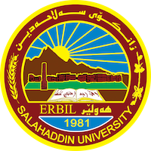
Academic Curriculum Vitae
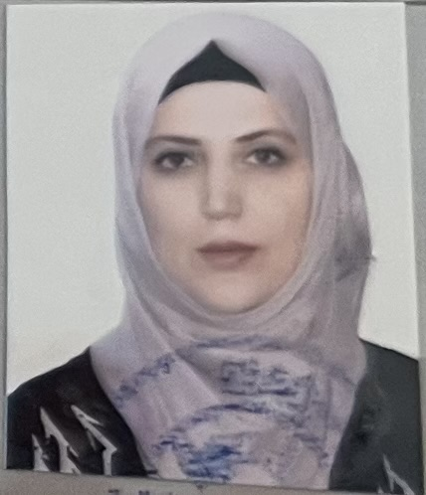
Personal Information:
Full Name: Ashna T. Abdulqader
Academic Title: Assistant lecturer
Email: ashna.abdulqader@su.edu.krd
Mobile: 009647507768838

Education:
2012-2013 Master of Science (Master) in Food technology (Dairy technology), Salahaddin University, College of agriculture, Food technology department, Erbil.

Thesis Title: Effect of Microbial Transglutaminase on some properties of Goat Milk Yogurt and cheese

Modules includes: Advance biotechnology, Advance food chemistry, Advance human nutrition, Food instrumentation, Advance biostatistics, Advance dairy chemistry, Advance dairy technology, food enzymology, seminar

2004 – 2007- University of Salahaddin – College of Agriculture – Erbil– Iraq, BSc. in Food technology (2007, Erbil).

Modules includes: organic chemistry, food technology, microbiology, biochemistry, food microbiology, meat technology and other modules.

Employment:
2007/ became teaching Assistant\ food technology department/ College of Agriculture/ Salahaddin University.
2014 became an assistant lecturer in Diary chemistry

Qualifications
IT qualifications
I have a general knowledge of MS Office; MS excel programs and MS power point, data collection, and quality assurance process. My experience includes monitoring design projects, training new staff and coordinating with the staff.

Language qualifications such as TOEFL, IELTS or any equivalent

mother tongue(s) | Kurdish
English language | understanding |  | speaking |  | writing
 | listening | reading | spoken interaction | spoken production
replace with language | good | very good | good | good | good
Arabic language | understanding |  | speaking |  | writing
 | listening | reading | spoken interaction | spoken production
replace with language | very good | very good | very good | very good | very good

Teaching experience:
Food chemistry \third stage /
Dairy chemistry

List of teaching Subjects
Liquid milk practical /second stage of Food technology department
Principle of dairy sciences practical /second stage of Food technology department

Lab supervision
I have 6 years lab experience to give assistance for postgraduate and undergradute students for using tools and machines such as kjldahel, pHmeter texture analyzer, oven ect.

Research and publications
 |  | Title of publications | year
 |  | The Effect of soymilk addition with different concentrations on some properties of cow milk yogurt  AT Abdulqadr, RS Qader, NH Sebo  Polytechnic Journal 12 (1), 30-39 | 2022
 |  | Comparative Study of some Characteristics for Whey Cheese Produced by Heat Acid Coagulation ()  RS Qader, AT Abdulqader, NH Sebo  Al-Qadisiyah Journal For Agriculture Sciences (QJAS) | 2023

Conferences and courses attended
List of Conferences
- First International Conference of Agri. Sciences and Agricultural Exhibition
- International Collaborative Conference of Modern Agricultural Technology (ICCMAT)
- 4th international Conference on Applied Sciences Energy and Environment (ICASEE)
- Regulations of Scientific Promotion
- Biology (cancer, secrets of signaling, applications and treatment challenges) International Symposium 2021,

Training Courses
- How to write an academic C V
- Statistical analysis by SPSS
- Atmospheric pollution
- Local scientific journal: concerns and insights for future improvement

Seminars presented

Funding and academic awards
- List any bursaries, scholarships, travel grants or other sources of funding that you were awarded for research projects or to attend meetings or conferences.

Professional memberships
- Kurdistan Agriculture Engineers syndicates
- Kurdistan Teachers Union syndicates
- Durbeen organization.

Professional Social Network Accounts:
https://scholar.google.com/citations?hl=en&user=Rv9-0ooAAAAJ&view_op=list_works&gmla=AJsN-F70Tat5MszbUdEbNVa7QXMVdp5bqLF9pnL106x-I4ouG-T__1_CqXv7hQBFEGvB6ZmBs20TJn9hmkbuiU_5C75nPnWX_w
https://www.researchgate.net/
https://orcid.org/0000-0002-4371-5220
Academic cover
My research and teaching interests fit particularly well with the requirements of this post and with existing members of staff. I have extensive teaching experience in the department of Food technolgy at university of Salahaddin, most of it paying attention on dairy chemistry sectors to this job. I have 13 years of teaching experience on forestry sciences subjects. As required I would be happy to contribute to undergraduate and postgraduate modules of both a research-led and a methodological dairy product is one of interesting subject especially for producing a healthy milk production.. I am also responsive of the taking care of the pastoral be concerned of students and take the role of tutor very seriously. I am experienced in liaising with colleagues to help students with a variety of problems.

