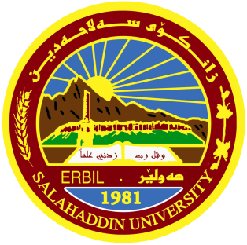
Salahaddin University-Erbil
College of Agricultural Engineering Science
Department of Food Technology

Title

Fortification of dairy products by Iron

Research Project
Submitted to the department of (Food Technology) in partial fulfilment of the requirement for the degree of BSc. in (Food Technology)

By
Esra Hazim Hamed
Supervised by
Mrs. Ashna Tahseen

