***Practical (1) Liquid milk Second class Miss. Ashna***

**Milk Pasteurization**

Foods may have their life extended if sufficient heat is applied to kill micro-organisms and inactivate the enzymes present in the food. There are two main kinds of heat processing:

1) Pasteurisation 2) Sterilization

* Milk is an excellent medium for microbial growth and when stored at ambient temperature bacteria and other pathogens soon proliferate (multiply).
* **Definition**

**Pasteurization** refer to the process of heating every particle of milk to below the boiling point at least 63°C (145F) for 30min, or 72°C (161F) for 15sec. to destroy **all** pathogenic and **some** other microorganisms.

-Or a process of heating every particle of milk and milk products to the minimum required **TEMPERATURE**  (for that specific milk or milk product), and holding it continuously for the minimum required **TIME** in equipment that is **PROPERLY DESIGNED** and **OPERATED**.   
-Today the process of pasteurization is used widely in the dairy and food industries for microbial control and preservation of the food we consume.

-The time, temperature and pasteurisation method used differ according to the product being pasteurised in order to minimise chemical, physical and organoleptic changes (e.g. flavour and colour).

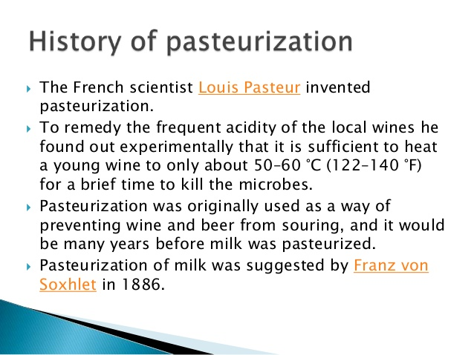

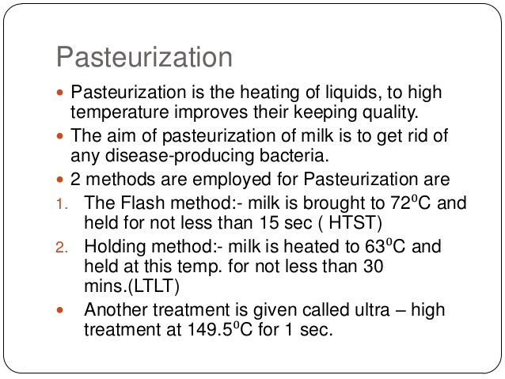

**Pasteurization conditions used for milk products**

|  |  |  |  |  |
| --- | --- | --- | --- | --- |
| ***Pasteurization Type*** | ***Product*** | ***Typical Storage*** | ***Temperature*** | ***Holding Time*** |
| **Batch, vat(LTLT)** | Milk | Refrigerated | (62.8°C) | 30 min |
| **Continuous, (HTST)** | Milk |  | (71.7°C) | 15 sec |
| **Continuous, higher heat shorter time (HHTST)** | Milk - cream |  | (88.3°C) | 1 sec |
| **Continuous, Ultra pasteurization** | Milk and cream | Refrigerated, extended storage | (137.8°C) | 2 sec |
| **Aseptic, ultra high temperature(UHT)** | Milk | Room temperature | (135 150°C) | 4-15 sec |
| **Sterilization** | Canned product |  | (115.6°C) | 20 min |

**Three types of heat exchangers are the most widely used**

**Nowadays**:-

• Plate heat exchanger

• Tubular heat exchanger

• Scraped-surface heat exchanger (Products which are semi-solid, or contain lumps or particles over 12mm in size, microwave or direct steam injection.

**Purpose of pasteurization**

1- To provide milk safe for human consumption by destruction of **all Pathogenic** organisms especially ***coxiella burnetii*** caused Q-fever diseases.

2- To improve keeping quality-by destruction of almost all spoilage organisms (85-99 %).

**Factors affecting pasteurisation**

• Food type

• Viscosity of the product

• pH of the product

• Particle size

• Equipment used

• Method used

**Thus the standards for pasteurization are such as to ensure**:

1- Complete destruction of pathogens.

2-Negative phosphates test.

---Pasteurization is an essential process in the production of milk which is safe and free from pathogens. Alkaline Phosphates is an enzyme which is naturally present in milk, but is destroyed at a temperature just near to the pasteurization temperature. Alkaline Phosphates test is used to indicate whether milk has been adequately pasteurized or whether it has been contaminated with raw milk after pasteurization.

**Disadvantage of pasteurization**

1- Millard reaction

2- Milk stone

3- Precipitate of whey protein

4- Cooked flavor

5- Caramelized of lactose

**Plate heat exchanger**

 

**Tubular**



**Scraped-surface heat exchanger**