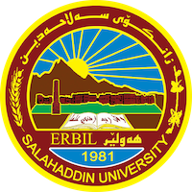
Academic Curriculum Vitae

Personal Information: 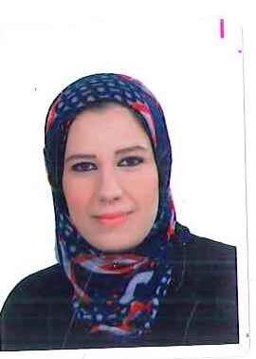
Full Name: Ashna Ibrahim Ahmed
Academic Title: Assistant instructor
Email: ashna.ahmed@su.edu.krd
Mobile: 07503856867

Education:
- High school in (Hawler) preparatory school in (2000-2001)
- BA in English department, college of languages, Salahaddin University. 2004 – 2005
- MA in English department, college of languages, Salahaddin University. In 2006 – 2008
- Continuous Education in Salahaddin University in 2009-2010 .

Employment:
- Worked as an employee in (college library) at college of Basic Education, Salahaddin University in 2003-2004 .
- Worked as an English trainer at a German Organization in 2009 .
- Currently I work as an assistant Instructor at English department, college of languages, Salahaddin University.

Qualifications
- Junior employee at college of Basic Education, Salahaddin University.
- English trainer at GCES German organization
- Assistant Lecturer at English department, college of languages, Salahaddin University, from 2008 till now.
- Participating in (Teaching Training course) in 2009 .
- Teaching different topics in different stages at English, Kurdish, Arabic and German Departments at college of Languages.
- Presenting seminars in different departments such as English and Kurdish , at college of Languages.

Teaching experience:
- Teaching different topics at English Department, college of Languages, like:
(Composition , Syntax , Grammar , Conversation , Vocabulary , Comprehension , Reading & Writing , Speaking & Listening ).
- Teaching (General English for University Students) at Kurdish , Arabic and German Departments.
- Training governmental employees at GCES German Organization.

Conferences and courses attended
- Salahaddin University Conference on ( Mass Media in the Century of Artificial Entelligence Technology. In 19-20 Jan 2023.
- Salahaddin University Conference on ( Best Research Projects and Academic Posters) in 2 Feb 2023 .

Professional memberships
- Member of Examination Committee at college of Languages for many years and the latest membership was in 2021 – 2022 .
- Member of Board Committee in 2022 – 2023 .
- Member of supervising graduation research paper.
- Member of evaluating graduation research paper.
- Member of several oral exams in : Conversation , Phonetics , Phonology , and Speaking & Listening.

Professional Social Network Accounts:

-https://academics.su.edu.krd/ashna.ahmed
-https://www.researchgate.net/profile/Ashna-Ahmed
-https://scholar.google.com/citations?hl=en&user=W2UFf5IAAAAJ

