Academic Curriculum Vitae
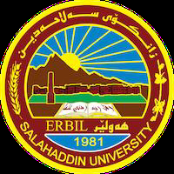

Personal information:
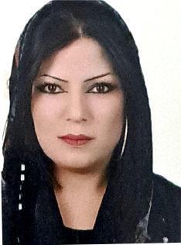

Full Name: Asia saleem salih
Academic Title: Assistant Lecture
Email: asia .salih @su.edu.krd
Mobile: 07504239164
Education:
B.A in kurdish language(2011)
MA in kurdish language (2017)
Employment:
2011-11-1
Qualifications
- Work in Salaheddin University since 2016 as researcher assistant
- teaching in salahadin university in basic edugation colage since 2021

Teaching experience:
- Theorical linguistics
- Morphology
-kurdology
- dictionary and tearms
Professional Social Network Accounts:
-google scholar
facebook
-LinkedIn

