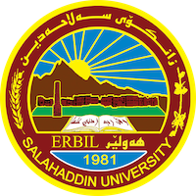
Academic Curriculum Vitae

Personal Information:
Full Name: aumed abdulkhaleq ismael
Academic Title: Assistant Lecturer
Email: aumed.esmael@su.edu.krd
Mobile: 07504828829

Education:
Graduate of the Islamic Religious School at Mulla Abdullah Al-Bilbitani High School for Islamic Endowments: 1999-2000.
Graduated from Dohuk University / Dohuk. College of Sharia and Islamic Studies/ Department of Islamic Sharia 2004-2005.
Master of Islamic Education and Qur’anic Sciences at Tikrit University, College of Education, Department of Qur’anic Science: 2013-2014.
Employment:
Imam and preacher.
Head of the Department of Islamic Education at the Evening Institute of Islamic Sciences / Erbil.
Currently an assistant teacher at the College of Education - Makhmour.
Director of Registration in the College.

