Academic Curriculum Vitae

Personal Information:
Full Name: Aveen Abdulqahar Abdulmajed
Academic Title: Assistant Lecturer
Email: aveen.abdulmajed@su.edu.krd
Mobile: 07504054096
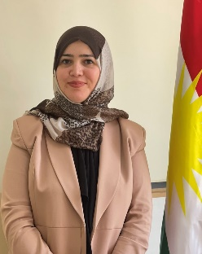
Education:
- Salahaddin University-Erbil, Collage of Administration and Economics, Iraq-Erbil
Master's Degree in Economics. Apr. 2016
- Salahaddin University-Erbil, Collage of Administration and Economics, Iraq-Erbil
Bachelor's degree in Economics. 2008-2009

Employment:
-Assistant of Research at Salahaddin University-Erbil. Oct. 2009
-Salahaddin Uni. College of Admin. & Eco- Finance and banking Dept. Assist. Lecturer. Oct.2019

Qualifications
- As an Assist. Lecturer in Banking and finance department I am responsible for: -
Teaching theoretical lecture to the students in principles of microeconomics, principles of macroeconomics, money and central bank, bank operation, electronic banking.
- IT qualifications
Word Microsoft, Excel, Access, Powerpoint, Spss.
- Language qualifications such as TOEFL, IELTS or any equivalent
English such as IELTS (4.5), language center- salahaddin university (Intermediate)

Teaching experience:
- Teaching theoretical lecture to the students in principles of microeconomics, principles of macroeconomics, money and central bank, bank operation, electronic banking.

Research and publications
1- تقدیر نموذج الطلب شبه الامثل على البنود الغذائية الرئيسة في محافظة اربيل لعام 2012
Accepted: گۆڤارى زانکۆ بۆ زانستە مرۆڤایەتییەکان 12/9/2018
2- تقدیر نموذج الطلب شبه الامثل للانفاق الغذائي في محافظة اربيل لعام 2012
Accepted: گۆڤارى قه‌لاى زانست- زانكوى لوبنانى فه‌ره‌نسی 12/1/2020

Conferences and courses attended
- Best student research conference

Funding and academic awards
- List any bursaries, scholarships, travel grants or other sources of funding that you were awarded for research projects or to attend meetings or conferences.

Professional memberships
- Kurdistan Teachers Union, july.2010
- Kurdistan Economist Syndicate

Professional Social Network Accounts:

- List your profile links of ReserchGate, LinkedIn, etc.

