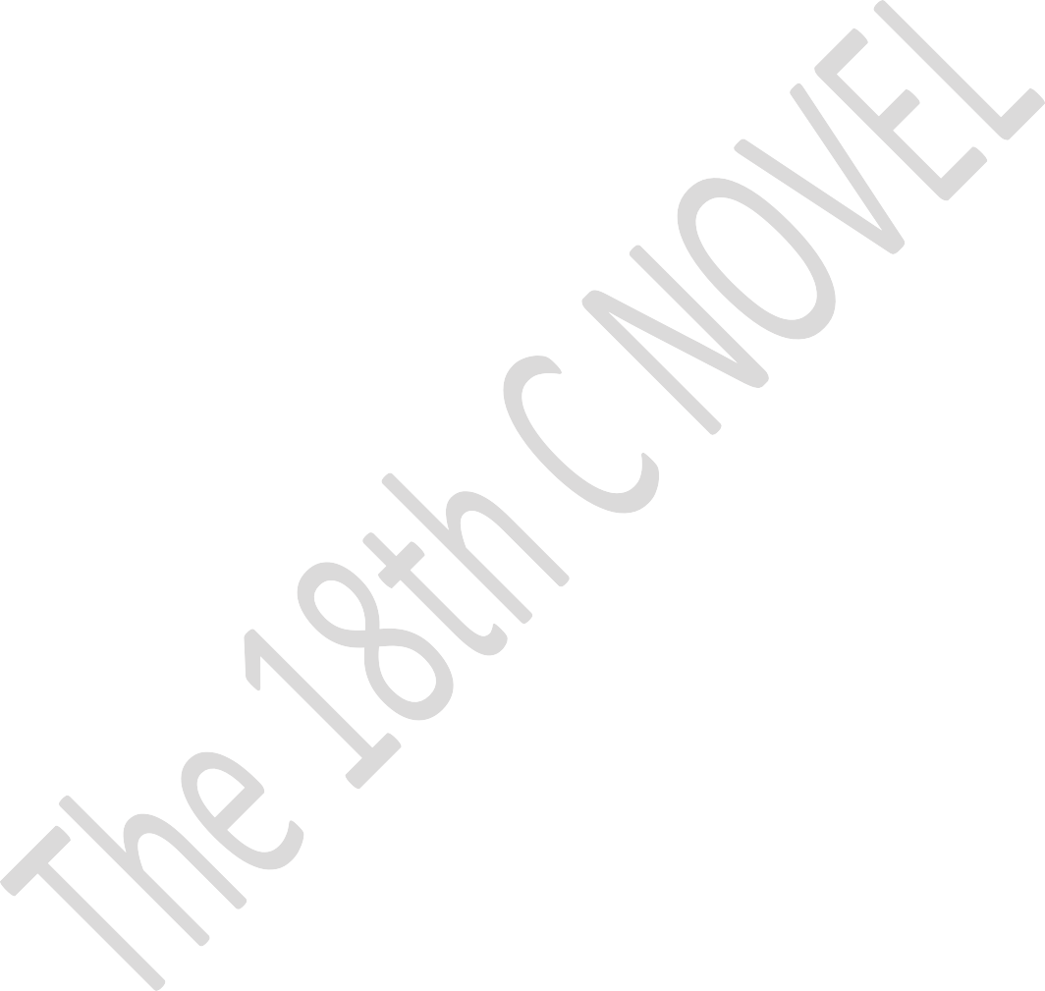
Department of: English College of: Languages University of: Salahaddin, SUE Subject: Novel 18C.
Course Book – Year 2, Second Semester Lecturer's name: Aveen Arshad Frais (assistant lecturer) under the supervision of professor Dr. Juan Al-Banna’
Academic Year: 2023/2024

Course Book

1. Course name | 18Th Century Novel
2. Lecturer in charge | Aveen Arshad Faris
3. Department/ College | English Department, College of Languages
4. Contact | e-mail: aveen.faris@su.edu.krd
5. Time (in hours) per week | 4 hours
6. Office hours
7. Course code
8. Teacher's academic profile | M.A in English Literature from Univrsity of Zakho, 2016.  Interested in reading, and learning Tolkien’s Elvish Language.
9. Keywords | 18th century Novel, Daniel Defoe, Robinson Crusoe, Realism, Realistic novel, journalism.  .
10. Course overview:
Daniel Defoe, whose best-known book, Robinson Crusoe, appeared in 1719, was an important originator of realism in English Fiction. He had to be realistic because while creating fiction , he was pretending to offer his readers memoirs and autobiographies as it is stated in Adventures in English Literature (1996, p.449).
This course is designed to present 2nd-Year students the form of realistic novel. Within fourteen weeks, the students are supposed to cover the material of the text being introduced to many literary techniques and the terms that are used for analysis. It will first start shedding light on realistic novel, realism and the novel form emergence in the 18th century. Then every chapter will be looked into with details and topics related to it. Robinson Crusoe, the main character in the novel, how is described and characterized by the author, the main topics are discussed through his character development. Then many conversions took place while he is cast upon an island away from home of many years. Such character development is highlighted with its didactic messages and other issues as well.

- Course objective:
(At the end of the course, students should be able to…)

  - To know what are characteristic features of realistic novels.
  - Be able to study novel as a form and pinpoint imp issues in the text.
  - Getting introduced to definitions concerning the aspects of the novel and its application on the text.
  - Showing aspects of didacticism in the novel and getting benefit from.
  - Be able to characterize the main characters
  - Showing imp features in the novel back to the actual events taken place on the island
  - Showing the tricks of the author in creating suspense while moving from one point to another during the incidents.

12. Student's obligation
Students are expected to attend the classes and participate actively in the group discussions and present seminars also. They are also required to be prepared for any quizzes they would have in the class. They are also demanded to present some materials to expand their knowledge of the module. Students are supposed to have training in writing to rise their creativity in understanding the main thoughts in the novel.
13. Forms of teaching
Various equipment will be utilised to deliver the lectures such as projector to show slides,
white board, and some handouts might also be circulated.
- Assessment scheme
Breakdown of overall assessment and examination will be as follows:
  - Monthly examination: 20 points
  - Daily participation and, semirars! 5 points
  - Quizzes: 5 points
  - Assignments: 10 points
  - Final exam: 60 points
- Student learning outcome:
By the end of the course, the learner should be able to:

  - Explain the characteristics of 18th entry English novel.
  - Analyse and comment on excerpts of literary texts.
  - Outline the techniques used in the novels of the 18th century.
  - Be more focused in highlighting the significant events and aspects that are necessary to understand fiction.
  - Draw their own conclusion of the writer’s style, language and techniques.
  - Enhance their way of telling and showing used in any kind of fiction which increases their awareness of the language and style of fictional texts
16. Course Reading List and References:
Sources
Adventures in English Literature .1996 by Holt, Rinehart and Winston.
Cuddon, J. A. (1979). A Dictionary of Literary Terms.Pengiuin Books, Great Britain.
Forster, E.M. (1927), Aspects of the Novel, Trinity College, Cambridge..
https://www.youtube.com/watch?v=F_oP2Kc88W4

Watt, I. 1957. Rise of the novel. London: Chatus and Windus. (Main Source)

Shinagel, M. 1994. Robinson Crusoe: An authoritative text, contexts, criticism. [2nd edn.]. New York: Norton & Company.
17. The Topics:  Week One: Background to the Definition of the Novel  Week Two: Realism and the Novel & Introduction to Robinson Crusoe  Week Three: Chapter 1,2  Week Four: Chapter 3,4  Week Five: Chapter 5,6  Week Six: Chapter 7,8  Week Seven: Chapter 9,10  Week Eight: Chapter 11, 12  Week Nine: First Exam  Week Ten: Chapter 13, 14  Week Eleven: Chapter 15,16  Week Twelve: Chapter 17, 18  Week Thirteen: Chapter 19, 20  Week Fourteen Second Exam | Topics in 18th century English Novel. Background to the Rise of the Novel  Typical Feature of the Age,  Realism and the novel form  The reading public and the rise of the novel  Robinson Crusoe, individualism and the novel
18. Practical Topics (If there is any)
N/A
19. Examinations:
- Compositional: In this type of exam the questions usually start with
  - Analyse, how, what are the reasons for……? Why…...? How ?-
  - identify and discuss the subject of . . . .

  - Essay type questions
  - Elaborate on the following
20. Extra notes: The topics and assessment criteria may be subject to change according to unexpected circumstances and student’s needs.

